
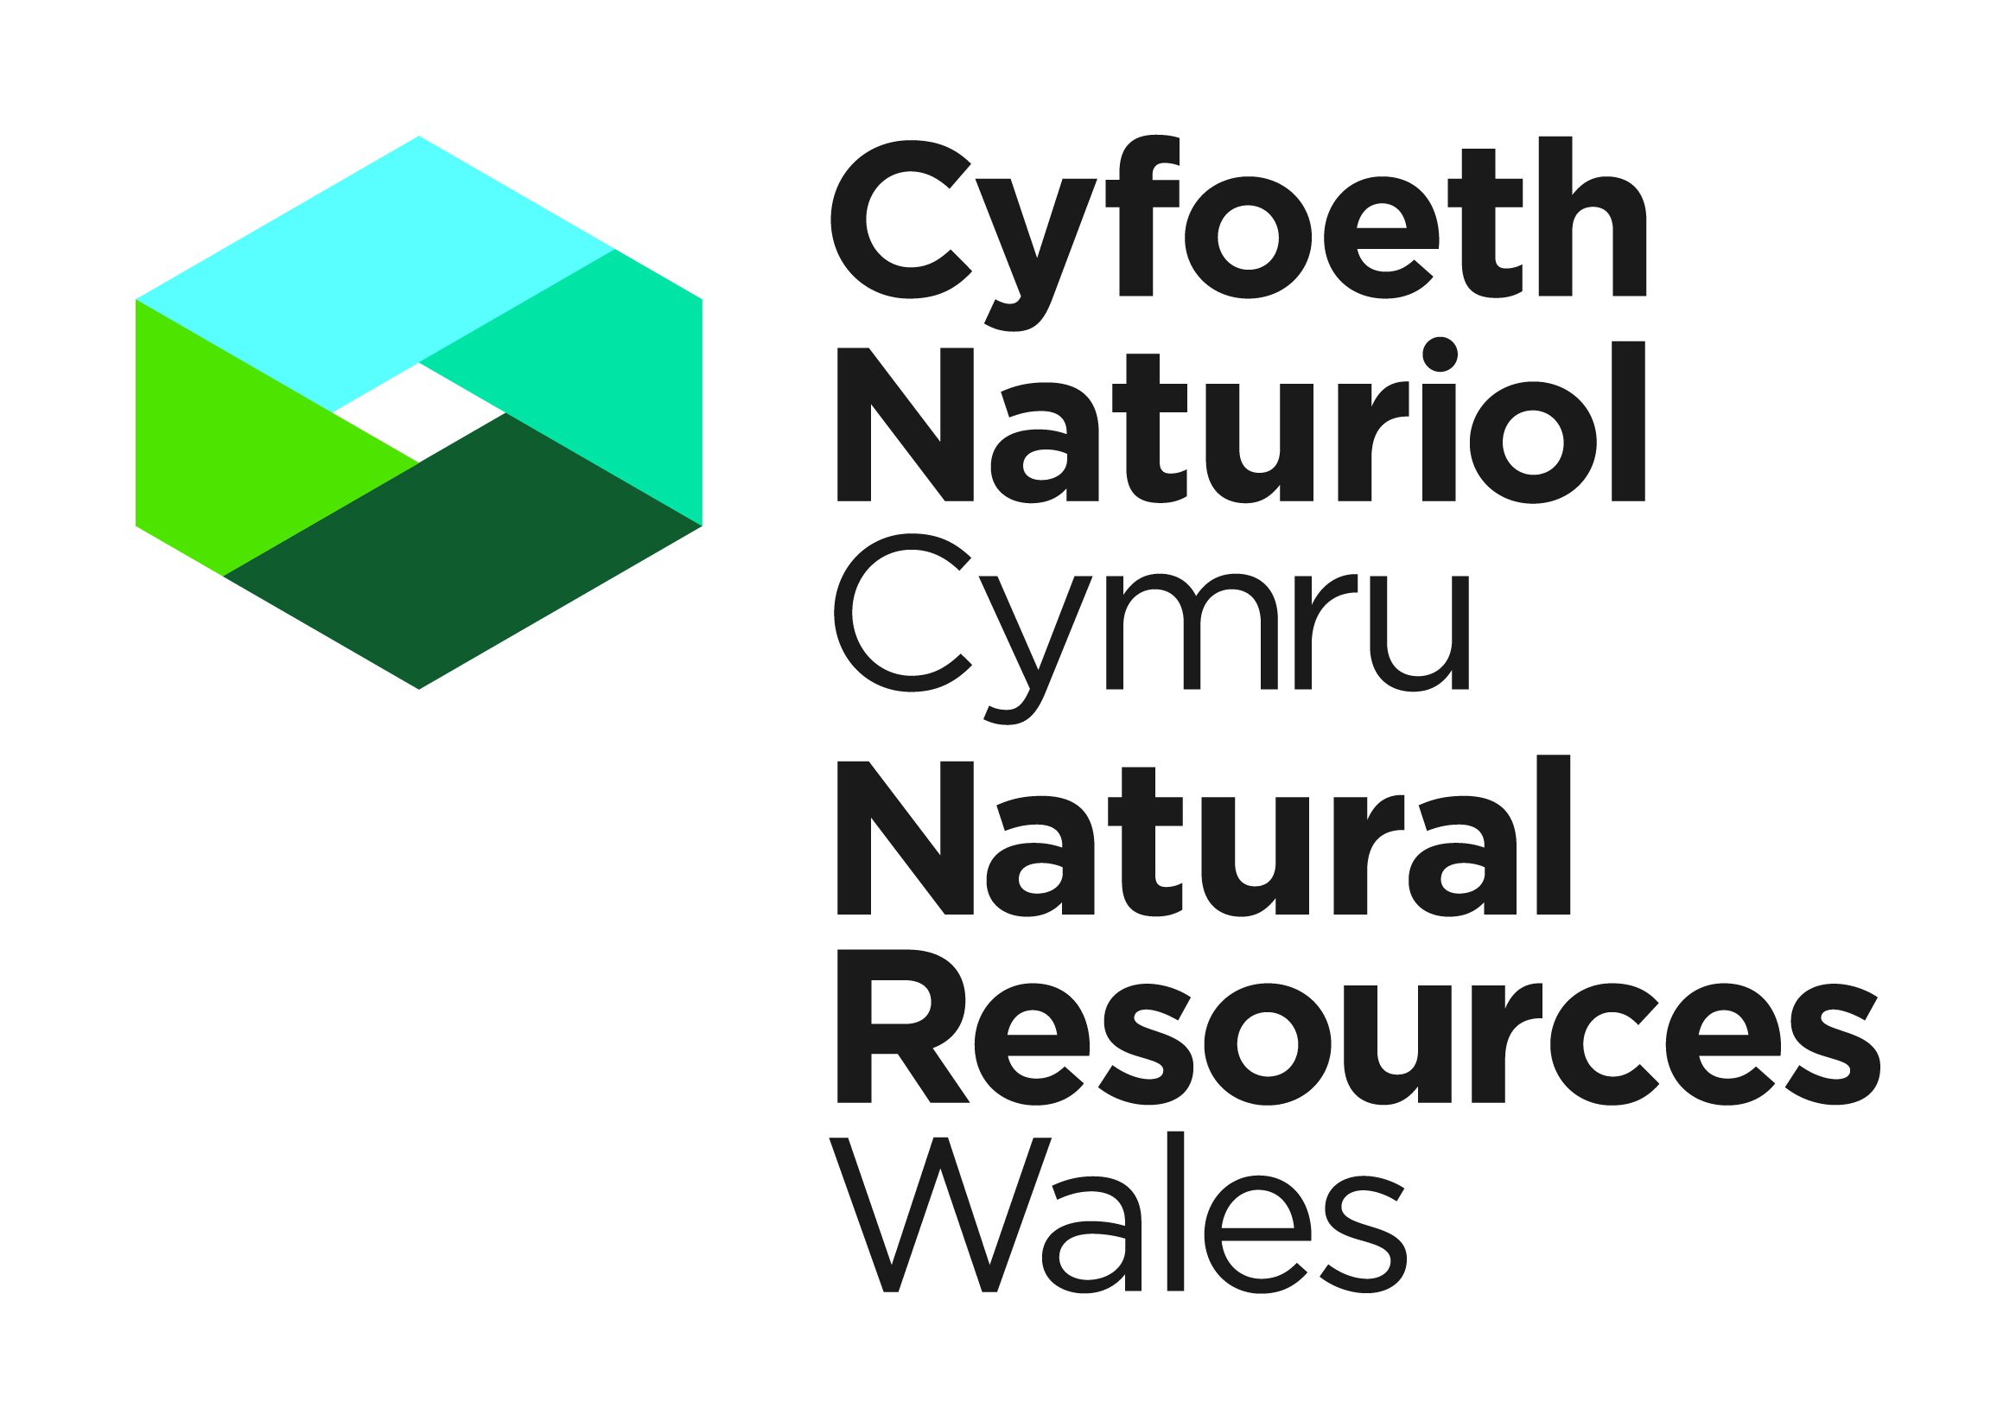

APPLICATION FOR A LICENCE TO KILL OR TAKE SEALS

SEALS ACT 1970 (AS AMENDED) (WCA) AND THE CONSERVATION OF HABITATS AND SPECIES REGULATIONS 2017

NOTES FOR GUIDANCE
Please read the following notes carefully.

a. | - This is an application form to kill take or possess seals for science or education, protection of a zoological collection, protection of flora or fauna, management purpose or resources purposes. Licences can be granted to allow people to carry out activities which would otherwise be illegal. Applicants must be able to demonstrate that they have a suitable amount of expertise to achieve the objectives of the proposed work.  - Licences to prevent damage will be issued only where all three of the following apply:-  - other methods of control have been shown to be ineffective or impractical,  - the licensed activity is likely to be successful in solving the problem.
b. | All questions in this application form must be completed in detail unless otherwise stated: failure to provide adequate information will delay the processing of your application. Any further information you wish to provide should be appended on additional sheets. We aim to determine applications within our service level agreements of receipt of all the information requested. We cannot guarantee an earlier response.
c. | It is a condition of any licence issued that a report of the work carried out under licence is submitted within four weeks of the expiry of the licence. The Licence Report Form can be found on our website. Failure to do so may constitute an offence. Information from these reports is required to provide summary information to NRW and others on the number of licences issued the purpose of the licence and which species are covered. None of these summary statistics includes personal information about licensees. The information may also be used for conservation purposes and shared with other organisations.
d. | Please note that we will not process your application until we have received all the requested documentation. Please make sure that if you are sending documents or plans to us in hardcopy that the print on these can be clearly read. All copies must be identical to the original document, and in colour as appropriate.
e. | The information provided by you will be processed by Natural Resources Wales under the General Data Protection Regulation. This will enable us to process your application; to monitor compliance with any permit conditions and to process renewals.  We will use the information you provide in connection with the following:  - Consultation with third parties who are relevant and responsible for responding to consultation requests from NRW to enable us to process your application  - Carrying out statistical analysis, research and development on environmental issues  - Preventing and investigating possible breaches of environmental law and taking any resulting action  Responding to requests for information under the Freedom of Information Act 2000 and the Environmental Information Regulations 2004  Note that the above is not an exhaustive list and NRW may use the data provided in connection with the application in other ways, as considered appropriate  We would also like to send you details about other topics we think may be of interest to you such as NRW news; services relating to environmental matters; asking for your feedback on our service; and more useful information.  If you consent to receiving further information from us, please tick the relevant box in the declaration the end of this form.  Please note we may pass the information on to our agents or representatives to carry this out for us  If you have any further queries or concerns, please contact dataprotection@naturalresourceswales.gov.uk. For further information on the processing of your personal details please see our Privacy Notice page
f. | Any information included in the application which the proposed Lead Licensee considers to be confidential for commercial reasons or affecting the proposed Lead Licensee’s intellectual property rights must be clearly marked as such.

Information for completing an application form

1. | If the document is being handwritten please complete in BLOCK CAPITALS
2. | Please answer ALL questions in detail. Incomplete answers will mean delays in your application  being processed.
3. | Applications can be accepted either electronically or by post (electronic is our preferred option).  Electronic Applications  E-mail Applications to: specieslicence@naturalresourceswales.gov.uk. Please DO NOT also send the application by post. When sending in electronic applications, please ensure that all documents are clearly named.  Postal Applications  The application form must be originally signed by both the proposed Lead Licensee and the proposed Licensed Nominated Ecologist. Please post to: Species Permitting Team, Natural Resources Wales, Maes y Ffynnon, Penrhosgarnedd, Bangor, Gwynedd, LL57 2DW
4. | This application must be supported by a Method Statement. The Method Statement must include contingency plans if any species are found on-site whilst works is underway
5. | We aim to send an acknowledgement of receipt of your application within 5 working days.
6. | NRW aims to determine applications within our service level agreements from date of receipt of a completed application form and the required associated information. Please refer to the check list at the end of this form for further guidance. If we require further information from you during the determination period, for whatever reason, this will delay the determination period. Our service level agreements can be found at:  https://naturalresources.wales/permits-and-permissions/species-licensing/our-service-level-agreements/?lang=en
7. | All correspondence sent to you from NRW will be via e-mail. If an e-mail address has not been provided, we will contact you in writing through the post. Please note that this may delay your application due to postal delivery times

Part A. Proposed Lead Licensee Details or Company Representative:

This section applies to the person who will be the ‘Lead Licensee’ or ‘company representative’. This must be a named individual; company information is to be provided in 1b. As the ‘Lead Licensee’ or ‘company representative’, you will be responsible for ensuring compliance with the licence and all licence conditions. Please provide your full name, not initials.

1. Applicant Details

1a. Are you applying as an individual or on behalf of an organisation?
Individual (please complete 1b) ☐ Organisation (please complete 1c) ☐

1b. Individual Personal Details

Title | Forename(s) |  | Surname
Address
Town
County
Postcode
Primary Contact Number
Secondary Contact Number
E-mail address

1c. Organisation Details

Organisation Representative (full name)
Organisation Name
Organisation Address
Town
County
Postcode
E-mail address
Primary Contact Number
Secondary Contact Number
Position within the organisation (Director, CEO, Regional Manager etc…)
Legal Status of Organisation (Limited Company, Local Authority, Charity etc..)
Please tick to confirm you acknowledge that, as company representative, you are the primary contact for queries relating to this application.

2: Please state who will provide the expertise during the licenced work

 | Applicant |  | Other (please provide details)

The individual providing the expertise should complete section 3 with details of their experience.

Part B. Proposed Licensed Nominated Ecologist: Personal details and experience

3. Proposed Licensed Nominated Ecologist contact details
This section relates to the person providing ecological expertise in relation to the species concerned. This person, referred to as the ‘nominated ecologist’ will be responsible for delivering specific elements of any licence granted.

Title | Forename(s) |  | Surname
Address
Town
County
Postcode
Primary Contact Number
Secondary Contact Number
E-mail address

4. Proposed Licensed Nominated Ecologists Experience and Qualification in relation to the requested species

a. | Is the Proposed Licensed Nominated Ecologist a member of a relevant professional organisation (e.g. CIEEM, IEMA)?
a. | Yes ☐ | No ☐ | Details:
b. | Has the proposed Licensed Nominated Ecologist been named as the nominated ecologist on any other seal licence issued by Natural Resources Wales?  Yes ☐ No ☐
c. | If the answer above is YES, please provide:
c. | Most recent licence reference number:
c. | Year in which licence was issued:
c. | Species covered by the licence:
c. | Details:
If the answer to 4b is NO, please complete questions d, e and f. (you do NOT need to answer 4d, 4e and 4f if you have been named as the nominated ecologist on another NRW licence for the species in question)
d. | Please give details of your experience and qualifications relevant to the species and type of work to which this application applies:
e. | Please give brief details of any experience and/or qualifications that you have gained with other species and you think is relevant to show your suitability and competence for the proposed works in this application.
If your answer to 4b is NO, you will need to provide two references from ecologists who are familiar with your work on NRW’s ‘Reference Template Form for licence applications’. They must be able to comment on your experience of working with the relevant species and your ability to use the methods and equipment you have proposed within your licence application. Your referees must be suitably qualified themselves. Please note that we can only accept one reference from the company you currently work for. We may contact your referees to verify their statements.

All references need to be completed on the reference form and must be able to confirm the following:

Their knowledge of the extent of the person providing the expertise’s experience in this type of work, including the use of any equipment

Any knowledge they may have of the care taken by the person providing the expertise while engaged in this type of work, to avoid undue harm or disturbance to wildlife

Their own experience in this field.

The number of years they have known and worked with the person providing the expertise.

f. | Please put an ‘x’ in this box to confirm that you have provided two references: ☐

5. Proposed Licenced Accredited Agents

Any proposed Licensed Accredited Agent should be a suitably qualified, experienced person who is able to carry out works under a licence without the personal supervision of the Lead Licensee or Licenced Nominated Ecologist. The Licensed Accredited Agent must be named on the application form and the licence.

a. | Does the applicant or proposed Licensed Nominated Ecologist wish to employ Licensed Accredited Agents? |  |  | Yes ☐ | No ☐
b. | If the answer to the above is ‘yes’, please provide:
Accredited Agent Name |  | Postal Address | E-mail Address
A Licensed Assistant is employed by the Lead Licensee to work under the direct personal supervision of any of the named Licensees at all times. Licensed Assistants do not need to be named on the application form/licence. However, the Lead Licensee must keep a log of all Licensed Assistants who have worked under a particular licence, as they may be asked to provide this at a later date.

A breach of the licence conditions by any named Licensee may result in the revocation of your licence.

Part C. The Application

Please complete the table below to show all licensable actions that the project will involve. Please read the note at the bottom of this page.

Species | Activity (1) | Method or field technique (2) | Number (3) | Sex (3) | Age or life stage (3) | Time period in which the activity will be carried out. (4) | Location (5)

NOTES
 | 1. | Activity. List all the activities you wish to carry out. Start a new line if it helps to distinguish between different activities at different places. Choose from:  Kill  Take
 | 2 | Method or field technique. Please state all the methods that you propose to use for each licensable activity. State whether your methods involve ringing or marking and if so by what means.
 | 3 | Number, sex and age. This only needs to be completed where applicable. In many cases this will not be known. Where appropriate give an estimate of the number of animals or derivatives involved.
 | 4 | Time period. Please give details of the period over which you wish your licence to be issued. You may be issued with a licence for up to two years.
 | 5 | Location. Please state specific sites and counties where the work will occur including 6 figure grid references if possible. You may specify that you wish your licence to cover all of Wales. Please also state whether the site is a Site of Special Scientific Interest (SSSI). Consent may be required to work within an SSSI. If any of the work you propose will take place on a National Nature Reserve please provide the name of that reserve.

PART D: Details of work

6. Will you/do you have the owner or occupiers’ permission to carry out this work?

7. NRW may wish to monitor the work you carry out. Is the owner or occupier willing to allow NRW staff access to the site of your works for this purpose?

8. Please tick the main purpose behind the licensable elements of your work.

☐ | Science or education
☐ | zoological gardens / collections
☐ | reduction of population surplus for management purposes
☐ | protection of flora or fauna within protected areas

9. Please provide a signed and dated Method Statement for the proposed project. This must include a project summary, the target species, locations for all works, if you are including a location map a scale of 1:10,000 would be advisable and / or a GIS layer such as Shapefile if available, timings and a list of individuals that are to undertake work on the project.
10. Please state whether the work is likely to extend into future years so that NRW is aware of the scale of the proposed work.

11. Please explain the need to carry out the proposed work and the object of your activities. State if the work involves translocations (introductions, re-introductions or moving species in any way).

12. Where licences are issued for scientific purposes it is important that the data collected is used to increase scientific knowledge. Please state how the data you collect will be used and where it will be lodged.

Part E. Declarations

13. Proposed Lead Licensee Declarations

a. | Have you ever been convicted of a wildlife offence? |  |  |  | Yes ☐ |  | No ☐
b. | If the answer above is yes, please provide details:
c. | I authorise employees or representatives of Natural Resource Wales to enter the site that is subject to this application for the purpose of monitoring and inspecting the permitted works (please place an x in the box opposite). |  |  | ☐
d. | I have read and understand the guidance provided in this application form. I declare that the particulars given are correct to the best of my knowledge and belief, and I apply for a licence in accordance with these particulars. If a licence is granted I agree to send to NRW a written report of the licensed activities within four weeks of the expiry of the licence.  NB. Applicants should note that it is an offence under regulation 59 of the Conservation of Habitats and Species Regulations 2017 to knowingly or recklessly provide false information in order to obtain a licence. |  |  | ☐
e. | I understand that the licence holder is legally responsible for all works undertaken under this licence |  |  | ☐
f. | Do you give permission for your proposed Licensed Nominated Ecologist to correspond with NRW on your behalf, including applying for any amendments or alterations to the licence? |  |  | Yes ☐ |  | No ☐
g. | Signature of the proposed Lead Licensee or company representative |  |  | Date
g. | For electronic applications please insert an electronic signature in the box above, or place an x in the box opposite to confirm agreement with the declarations. |  |  | ☐
h. | Full name in BLOCK LETTERS
14. Proposed Licensed Nominated Ecologist Declarations

Have you or any of your proposed Licensed Accredited Agents ever been convicted of a wildlife offence?  A wildlife offence is an offence under the Wildlife and Countryside Act 1981, the Conservation of Habitats and Species Regulations 2017, the Protection of Badgers Act 1992, the Deer Act 1991, the Hunting Act 2004, the Wild Mammals (Protection) Act 1996, the Animal Welfare Act 2006 and the Protection of Animals Act 1911 (all as amended).  You do not have to declare a previous conviction if you are:  (1) a rehabilitated person for the purposes of the Rehabilitation of Offenders Act 1974 and your conviction is treated as spent; or  (2) in respect of such an offence, a court has made an order discharging you absolutely. |  | Yes ☐ | No ☐
If the answer is yes, please provide details below.

☐ | I confirm that any proposed Licensed Accredited Agents listed on this licence are suitably qualified and experienced to undertake the relevant ecological works.
☐ | I have gained the permission of all proposed Licensed Accredited Agents listed on this application form to provide NRW with their name and basic contact details for the purpose of this application.
☐ | I understand that failure to comply with any conditions included on any licence granted in respect of this application may constitute an offence.
☐ | I have read the notes for guidance at the front of this form.
☐ | I declare that the particulars given in this application and accompanying documents are correct to the best of my knowledge and belief, and I apply for a licence in accordance with these particulars.
☐ | If a licence is granted I agree to send to NRW a written report of the licensed activities within four weeks of the expiry of the licence.
☐ | I give permission for NRW to consult species or conservation groups for their view on my application.
☐ | I would like to receive additional information from NRW relating to environmental matters.

Signature: | Date:  Click or tap to enter a date.
For electronic applications please insert an electronic signature above or place an X in the box opposite to confirm agreement with the declarations above. |  | ☐

Name in BLOCK LETTERS:

Part F. Checklist

 | Please return your completed application to the following Natural Resource Wales contact details. We would prefer an electronic submission if this is possible.
 | Species Protection Team,  Natural Resources Wales,  Maes y Ffynnon,  Penrhosgarnedd,  Bangor,  LL57 2DW  E-mail: specieslicence@naturalresourceswales.gov.uk  Tel. 03000653000 | Checklist before submitting your application:
 |  | 1. Completed Application Form signed and dated | ☐
 |  | 2. Two references | ☐
 |  | 3. Method Statement | ☐
 |  | 4. Specification for Research Project | ☐
 |  | 5. Survey / Monitoring Report | ☐

