FINAL ASSESSMENT OF PROPOSAL TO RESTRICT THE RIGHT OF ACCESS FOR THE PURPOSE OF AVOIDING DANGER TO THE PUBLIC FROM UNEXPLODED ORDNANCE

- SUMMARY

APPLICANT: Mr Robert Williams, NRW
AGENT: Not Applicable
SITE NAME: Trawsfynydd Ranges
APPLICATION NUMBER: AP180171

APPLICATION: To exclude the right of access completely from the site for 5 years minus 1 day.

- PURPOSE

  - This note explains how Natural Resources Wales (NRW) have assessed whether or not it is necessary to exclude or restrict the right of access to land known as Trawsfynydd Ranges, using powers under section 25(1)(b) of the Countryside and Rights of Way (CRoW) Act 2000, for the purpose of avoiding danger to the public from the presence of unexploded ordnance on the land.

  - This assessment is in addition to the last assessment carried out in 2013. The purpose of this assessment is to look at whether anything has changed on the site in the past 5 years in order to determine whether the original restriction is still required.

- LOCATION

3.1 The site is known locally as Trawsfynydd Ranges and covers an area of 365.5 hectares. National Grid Reference (NGR) at the centre of the plantation is SH760326 and it is situated approximately 350m above sea level. Please see the map in Appendix 1 for it’s location.

3.2 The land is owned by Welsh Government and managed on their behalf by NRW.

- BACKGROUND

  - To date NRW (formerly FCW) have applied 5 consecutive restrictions on this site exclude access, including the present one which expires on the 28th of August 2018:

(1) AP1002 106 for 9 months plus 1 day, which expired on 10 March 2006.

(2) AP 1004 727 for 6 months minus 1 day, which expired on 7 September 2006.

(3) AP1005 767 for 3 years, which expired on 4 September 2009; and

(4) AP1273 520 for 4 years, which expired on 30 August 2013.

(5) AP 1861 965 for 5 years minus 1 day which expires on 28 August 2018

4.2 Previous land use: Between 1903 and 1950 this land was used as a military firing range. This land was sold by the War Department to the Ministry for Agriculture, Fisheris and Food in 1964 and makes up roughly half the land contained with the same title deed. The area was ploughed using specially armoured tractors and subsequently planted withSitka Spruce. Regarding the ploughing, former FCW records state ‘ As they completed the work they unearthed in the region of 900 live items and about 20 tons of expended pieces of ordnance’.

4.2.1 Between 2002 and 2003 the former FCW undertook a tree felling programme across the entire site to remove the Sitka Spruce and begin the process of conversion to a naturally regenerated mixed broadleaved woodland type. An operational risk assessment was undertaken and it was decided to employ BACTEC , a leading Explosive Ordnance Disposal (EOD) and mine action company to clear the site of ordnance.

4.2.2 The trees were felled using a system where the harvesting and extraction machinery only travelled on mats created from the tops of the felled trees. Therefore it was only necessary to clear ordnance on the area where these mats would lie and in total accounted for approximately one third of the entire site i.e. approximately 120 hectares. The results of the clearance work were a further 67 live items and 620 expended pieces of ordnance.

4.2.3 Between 2009 and 2013 further operational risk assessments were carried out to allow upkeep of the Irish bridge and permission for a local clay pigeon shooting club to use a length of internal forest road. BACTEC carried out this work, uncovering further and used advanced equipment to estimate that one ‘anomaly’ could be expected in every 100 square metre piece of land.

4.2.4 When this figure is interpolated for the remaining 245 hectares it equates to approximately 24,500 pieces of ordnance, which at that time was estimated to cost at least 2 million pounds to remove.

4.3 Present Land Use: Due to the risk from unexploded ordnance a mimimalist non intervention approach has been adopted to this area and it has been left to regenerate as mixed broadleaved woodland.

4.3.1 This area is covered by NRW’s Coed y Mynydd Forest Design Plan. The lifespan of this plan was extended in 2013 for 5 years and it will be reviewed and replaced with a Forest Resource Plan in 2022-23.

4.3.2 This area has reverted to broadleaved woodland, mostly birch willow and alder however there is increasing conifer regeneration covering approximately 20% of the site.

4.4 Environmental Designations: The site is located in Snowdonia National Park and includes the Nant y Graen a Nant Ganol Site of Special Scientific Interest. Different parts of the site are noted for their special interest in:

(a) Afforested peat types notably deep peaty soils, modified deep peaty soils, shallow peaty soils and soils with peaty pockets.

(b) Archaeological features including Defeidiog Ishaf, Defeidiog Isaf building and the Defeidiog Ishaf landscape.

(c) Geological features notably the presence of small prehistoric sea animal trilobite fossils.

- PUBLIC ACCESS

5.1 Access land designation: Since 9 June 2005 the area has been designated as access land having been dedicated in error by NRW (formerly FCW) on 9 December 2004 under Section 16 of the CRoW Act 2000. Had the name of the title deed indicated any association with its past use as a firing range the dedication in 2004 would not have taken place.

5.1.2 There are no existing provisions with the Countryside & Rights of Way Act to de-dedicate access land. NRW recommended, as part of its response to Welsh Government’s 2017 Sustainable Mangement of Natural Resources consultation, that Welsh Government could consider including provision within the regulations to de-dedicate land. Such a provision would apply where it could be retrospectively shown (with information that was not available at the time of dedication) that a dedication made in good faith was made in error.

5.2 Public rights of way: There are 2 footpaths on site, notably footpath 4 Trawsfynydd to the west and footpath 2 Trawsfynydd to the east. Since 2009, the route of both footpaths have been realigned on to internal forest roads for safer use by the public.

5.3 Sustrans route: The area is bisected on a west to east axis by a minor unclassified public road which forms part of Sustrans regional cycle route between Llanuwchllyn and Trawsfynydd.

5.4 Usage levels: The site is in a remote area of the National Park and although there are seasonal variations, usage is generally low. A local clay pigeon shooting club has an access permission with NRW onone of the forest roads.

6. ASSESSMENT

6.1 This assessment is made against relevant assessment criteria in the Statutory Guidance to Relevant Authorities on their functions relating to local access restrictions – Wales Edition 2 - 2010. The assessment criteria set that relates to this site is Criteria set 20: Risks arising from unexploded ordnance

6.2 Is it necessary to do anything?

6.2.1 The Statutory Guidance to Relevant Authorities states:

- ‘Because of the danger of serious injury or death, intervention is likely to be necessary where there is a verified risk from unexploded ordnance’

6.2.2 The verified risk from unexploded ordnance is still present as there has been no intervention in the site to remove that risk in the last 5 years.

6.3 Is a statutory restriction necessary?

6.3.1 The Statutory Guidance to Relevant Authorities states:

- ‘Restrictions will only be necessary in exceptional circumstances’

6.3.2 NRW considers that these circumstances are exceptional because of the verified risk from unexploded ordnance uncovered during partial clearance of the site to allow previous operations to take place.

6.4 What is the lowest level of restriction necessary?

6.4.1 Criteria set 20: Risks arising from unexploded ordnance states:

- ‘Exclude people from any area where there is a significant confirmed danger until it has been neutralised or removed.’

- ‘Leave residual routes or areas open to the public if it is safe and practicable to do so’.

6.4.2 Following submission of an application from the local area manager to renew this exclusion and because the ordnance that was present 5 years ago has not been cleared, NRW as a relevant authority determine that the land continues to pose a significant risk to the public.

6.4.3 NRW therefore intend to issue a long term direction excluding public access as detailed in the attached draft direction.

    - The public rights of way on site are unaffected by this exclusion.

7. CONSULTATION

7.1 NRW will submit the draft direction for consultation to the Local Access Forum and statutory consultees as specified in the Countryside Access (Exclusion or Restriction of Access) (Wales) Regulations 2003

-------------------------------------------------------------------------------------------------------
Assessment by:
Lucy Swannell (Access Advisor)

Approved by:
Jont Bulbeck (Access Team Leader)
-------------------------------------------------------------------------------------------------------

25th May 2018

Appendix 1 – Map of Trawsfynydd Ranges

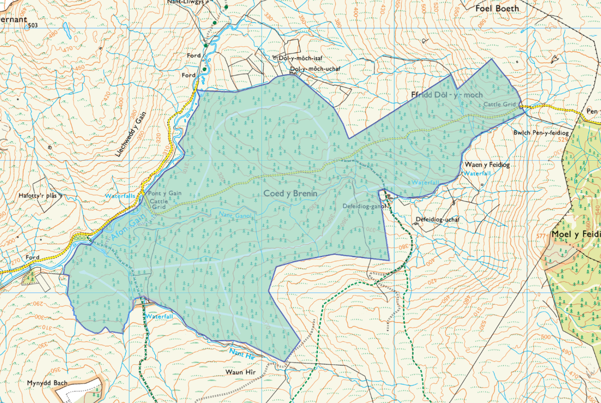

‘Anomaly’ refers to a metallic object that has a high probability of being a piece of ordnance that is more than likely to still be a live state.
This statutory guidance under CRoW section 33 was issued by CCW and applies to NRW and National Park Authorities on the discharge of their functions as ‘relevant authorities’ in relation to the restriction of open access rights in Wales.

