NRW Sensitive Habitats and photographic evidence required for identifying these habitats

March 2016

Introduction
UK Forest Standard states that ”Appropriate protection and conservation must be afforded where sites, habitats and species are subject to the legal provisions of EU directives and UK and country legislation.” NRW sensitive habitats are Biodiversity Action Plan priority habitats. NRW Biodiversity species include grassland fungi habitats and some individual species which are on the Section 42 habitats and species list.

Photographic evidence is needed on new planting sites where NRW sensitive habitats are shown on the Lle Glastir Woodland Creation opportunities map:- http://lle.gov.wales/apps/woodlandopportunities.

- Biodiversity Habitats: Geo-referenced photographs are needed to demonstrate that the site is not a Biodiversity Action Plan priority habitat. Outside the main growing season from mid-May to September, photos are likely to be misleading and can fail to show important species so extra care must be taken.

- Biodiversity Species
Fungi: Geo-referenced photographs to demonstrate a site is improved grassland (grassland fungi grow in unimproved grassland)
Arable Plants: Geo-referenced photographs to demonstrate a site does not have arable plants. These must be taken between May and harvest and be taken within the 5m boundary around the edge of the field and in each corner of the field.

NRW Sensitive Habitats
Below is a description of priority habitats which may be in a Glastir Woodland Creation Expressions of Interest.

Lowland dry acid grassland

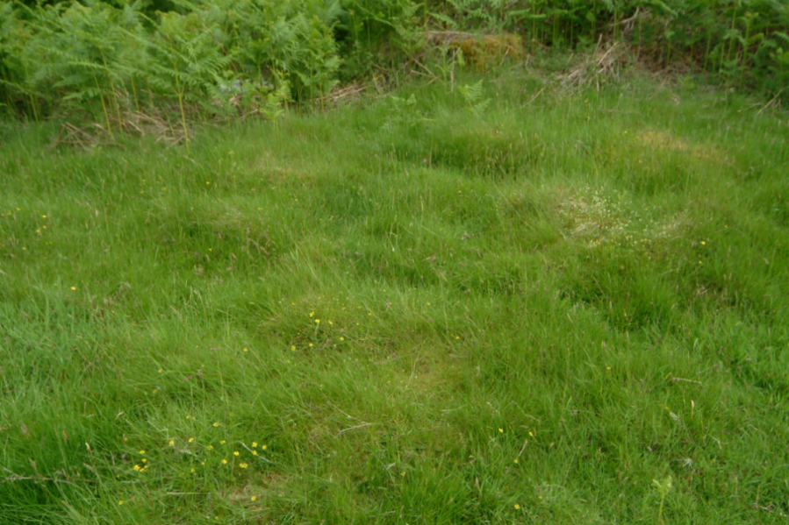

These are grasslands on well-drained acid soils with low fertility in the lowlands (below the upper limit of enclosure). This type of grassland is generally dominated by sheep’s fescue, bent grasses and wavy hair-grass. Low-growing flowering plants such as heath bedstraw and tormentil are usually present with sheep’s sorrel in drier places. There may be scattered plants of heather or bilberry but at less than 25% cover. There may be clumps of rushes in damper areas but not at the continuous cover often found in marshy grassland.

Unimproved Neutral Grassland

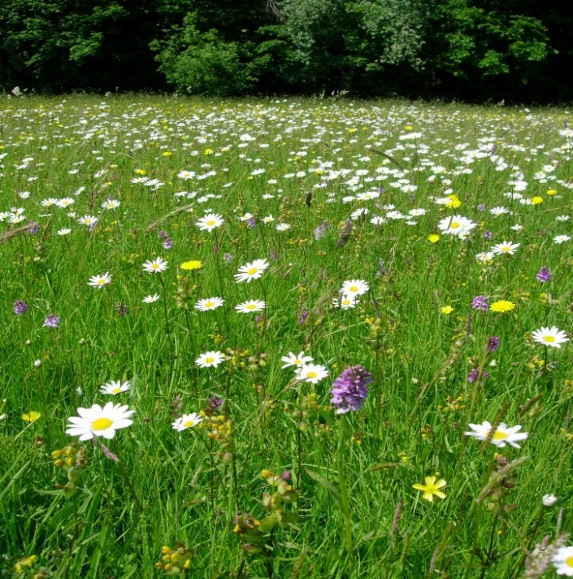

This category includes flower-rich hay-meadows and pastures below the upper limit of agricultural enclosure on soils that are neither strongly acidic nor alkaline. Characteristic species include crested dogs-tail, red fescue, birds-foot trefoil, common knapweed and great burnet. There may be scattered clumps of rushes in damper areas but not the continuous cover sometimes found in marshy grassland. This type of traditionally managed grassland is now extremely scarce in Wales and usually occurs as isolated fields or small clusters of fields.

Unimproved Limestone Grassland

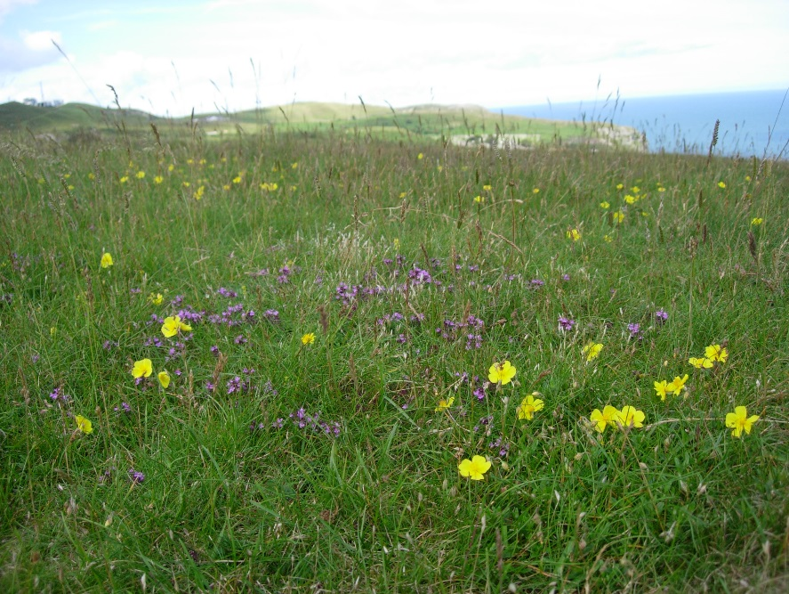

This type of flower-rich grassland occurs on soils that have a relatively high lime content. Typical flowering plants include sheep’s fescue, wild thyme and common rock rose. The habitat occurs both above and below the upper limit of agricultural enclosure. It is particularly associated with limestone rocks in north and south Wales but also occurs on other lime-rich rocks elsewhere in the uplands.

Rush pasture & Purple moor grass
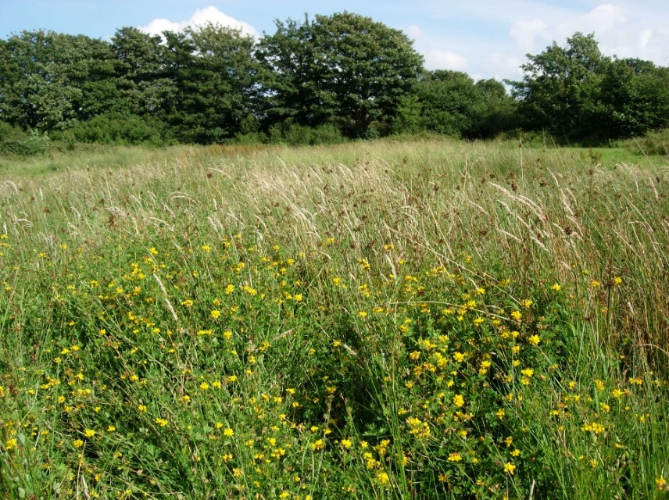

Rush pasture

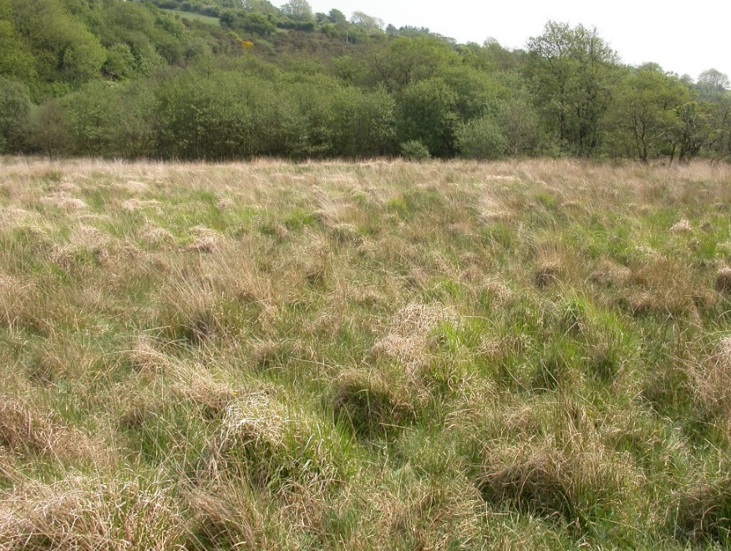

Purple moor grass pasture

These wet grasslands are typically dominated by purple moor-grass, rushes, meadowsweet or iris (yellow flag). They may have a tussocky or smooth texture and often have a taller sward structure than the drier grassland habitats. They are most extensive in the uplands and upland fringes and are locally prevalent in the lowlands on soils with impeded drainage. They may occur on peaty soils but never on deep peat.

Lowland Heath

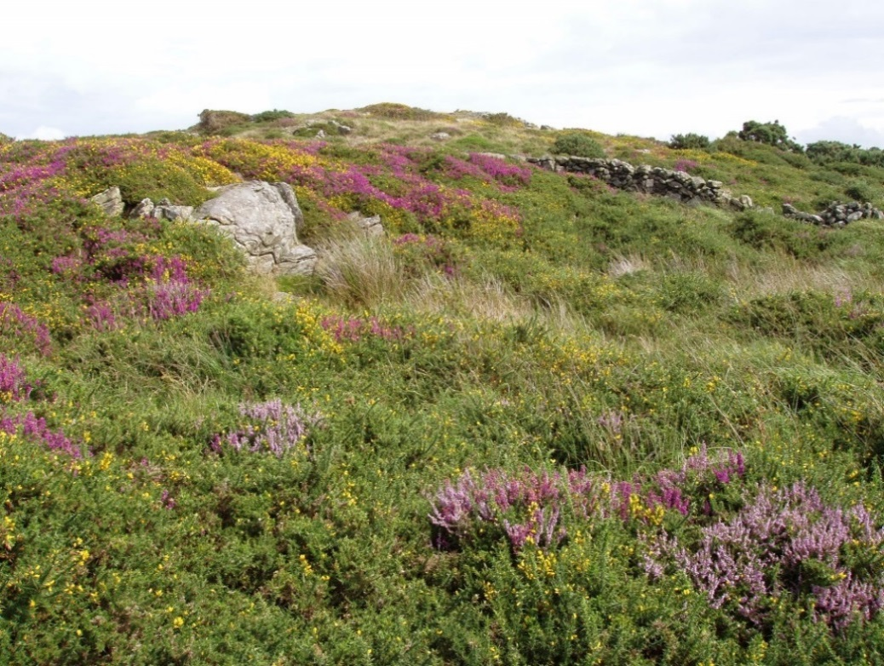

Lowland heath includes both dry and wet heathland types that occur below the upper limit of agricultural enclosure. Lowland heath usually consists of at least 25% cover of dwarf shrubs such as heather, bilberry and western gorse, Variable amounts of grasses, such as sheep’s fescue (dry heath) or purple moor-grass (wet heath) are also typically present.

Upland Heath
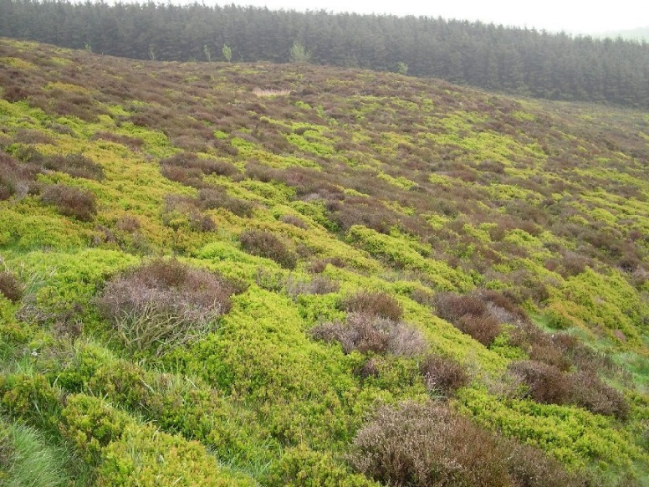

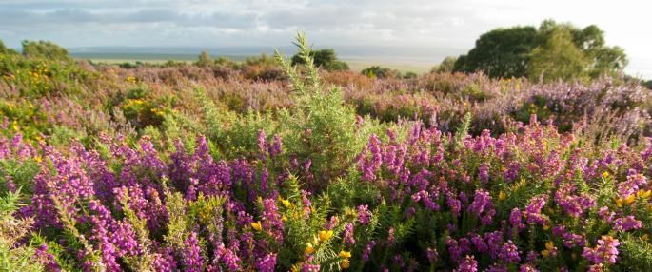

Upland heath is found above the limit of agricultural enclosure, upland heath consists of vegetation with more than 25% cover of heather, bilberry and western gorse. Variable amounts of grasses such as sheep’s fescue, mat grass and purple moor-grass, are also typically present. This habitat is found throughout the uplands, and is often associated with other moorland habitats, such as blanket bog, acid grassland and bracken.

Fens, swamps and reedbeds

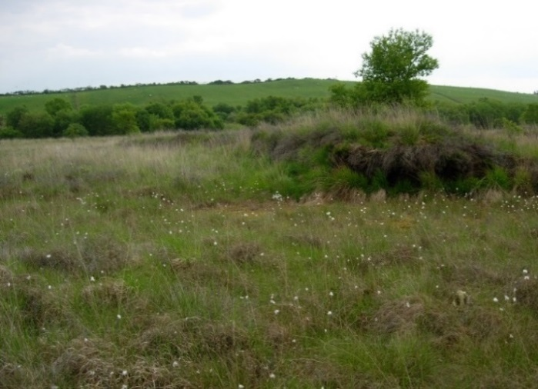
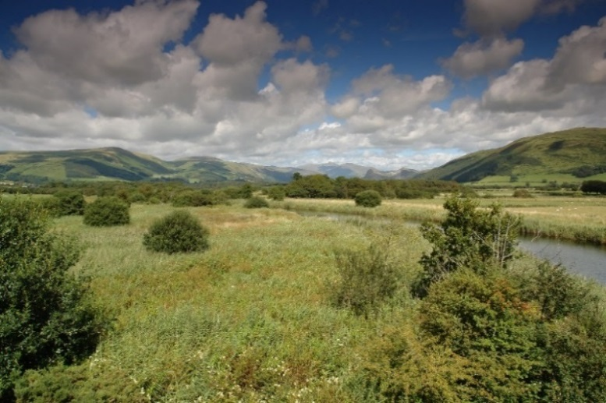
Reedbeds Lowland fen
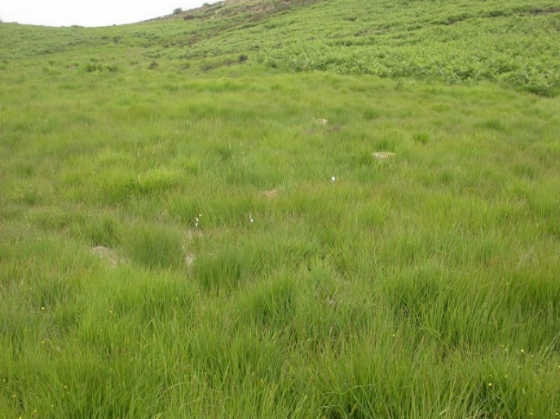
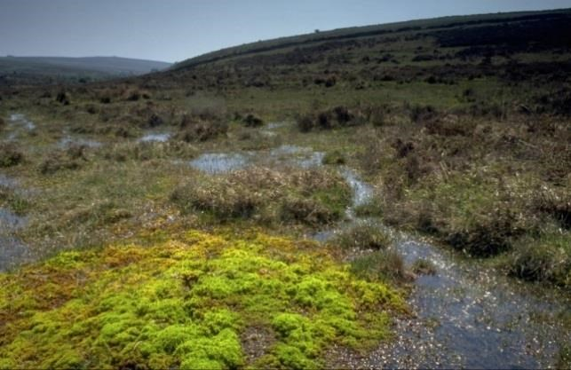
Upland flush Upland mire

This category covers a range of wetland habitats both above and below the upper limit of enclosure. They occur on poorly drained hill and valley slopes, valley bottoms, wet hollows and along the margins of rivers, streams and ponds.

Swamps and reed beds (swamps where common reed is the dominant plant) usually occur at locations where water lies above the surface of the ground for much of year, even during the summer. Fens are generally drier and without summer flooding, although the peaty soil usually remains waterlogged throughout the year. Tall grasses (especially reeds), sedges and rushes are usually dominant in swamps, but fens may bear a lower-growing and more diverse vegetation with many different flowering plants.

Small areas of fen vegetation on hillsides and valley slopes associated with springs and flushes are mostly recognisable by their high cover of bog mosses under a covering of rushes or sedges, and should be included in this category. Some types of fen can appear similar to marshy grassland, but fens only occur on peat more than half a metre deep.

Wood pasture and parkland

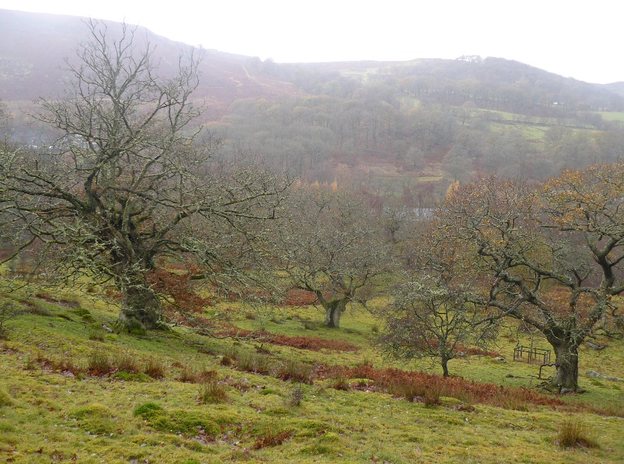

Wood pasture and parklands are habitat complexes having a tree cover of less than 30%, and occurring as scattered individuals over grassland, heath or bracken. In both habitats the trees are of open grown character with wide deep crowns and short trunks. The woodland understorey is sparse or absent as a result of grazing. Wood pasture often occurs in the upland fringes with mature hawthorn and rowan as the dominant tree species. Parkland is essentially wood pasture that has been established as part of a designed landscape.

Traditional orchards

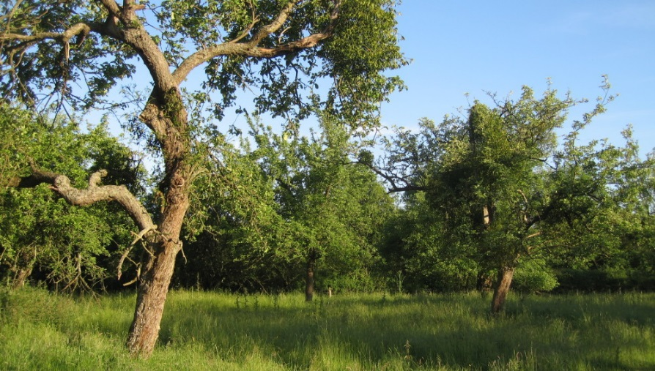

Traditional orchards are plantations of tall, widely spaced fruit trees, typically apple, pear, cherry, plum or damson. Tree density when fully stocked may be 120-150 trees per hectare, down to a minimum of seven trees per hectare. Traditional orchards contain standard or half-standard fruit trees and do not include modern dwarfing varieties.
3. What photographic evidence is required in NRW sensitive habitats?

- Photographs must be numbered, in colour and in focus. Sufficient photographs are needed to demonstrate that the site is not a priority habitat or deep peat.
- The recommendation for habitat photographs is to take a general photo of the whole area and detailed photos showing approximately two square meters of vegetation. Take one oblique and one ‘straight down’ photograph for each different vegetation type.

Example of a photo taken looking vertically down

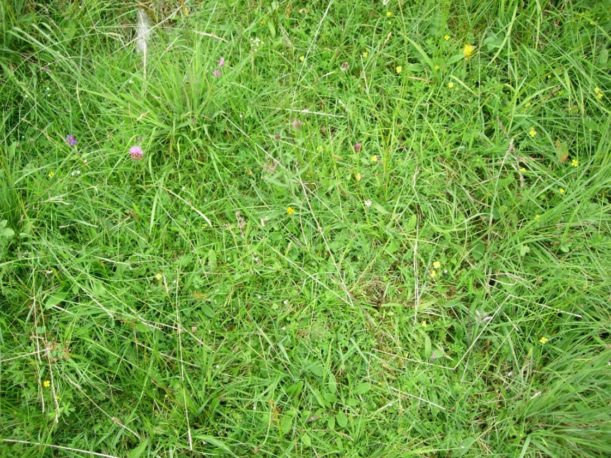
Example of a photo taken at an oblique angle

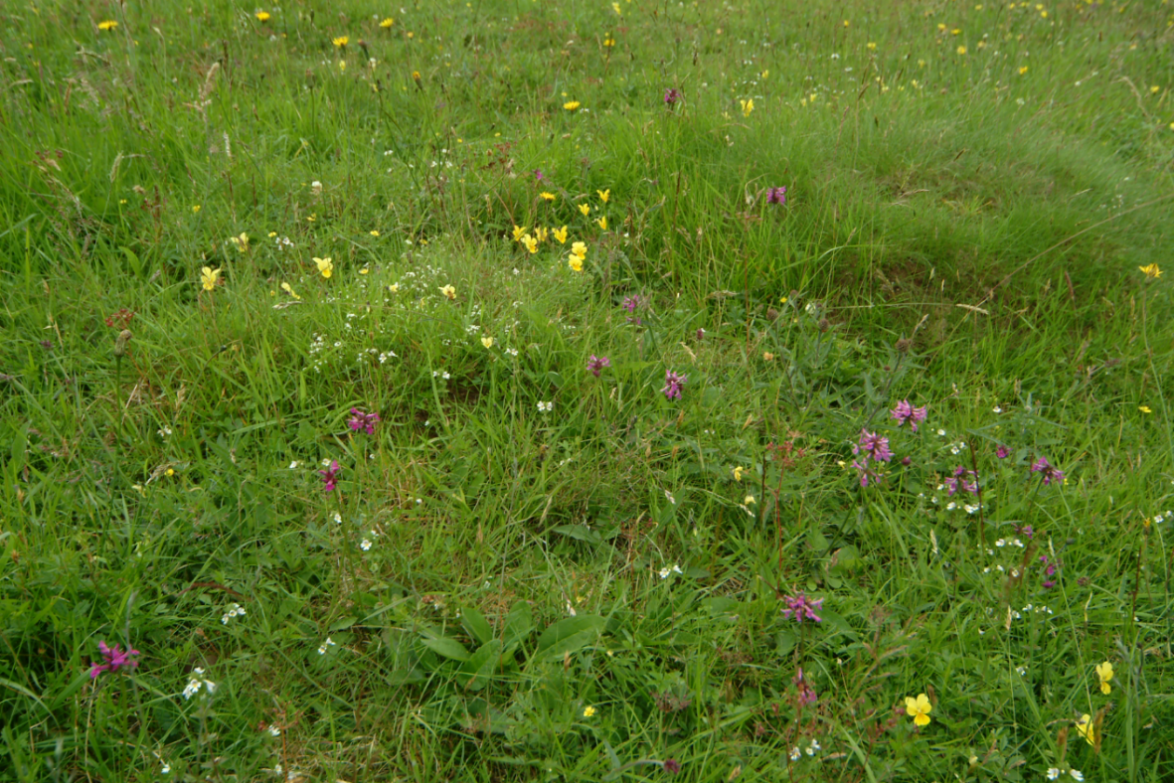

In this example woodland planners could use photographs below as evidence that this area is not a priority habitat.

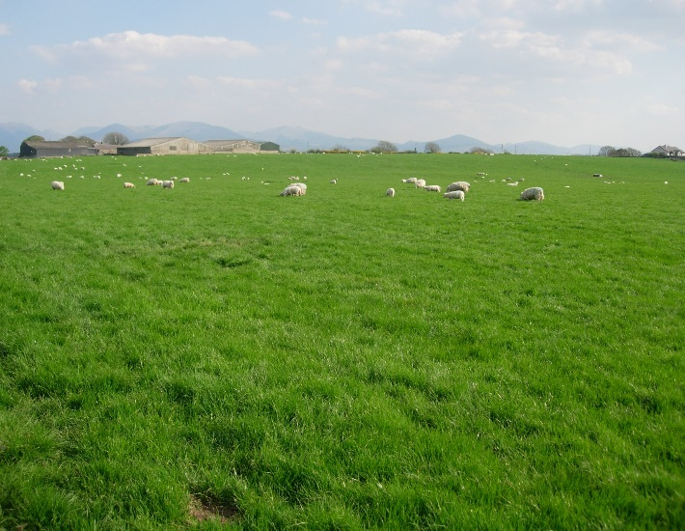
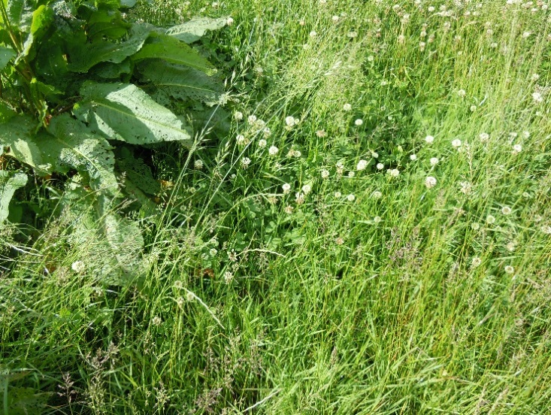
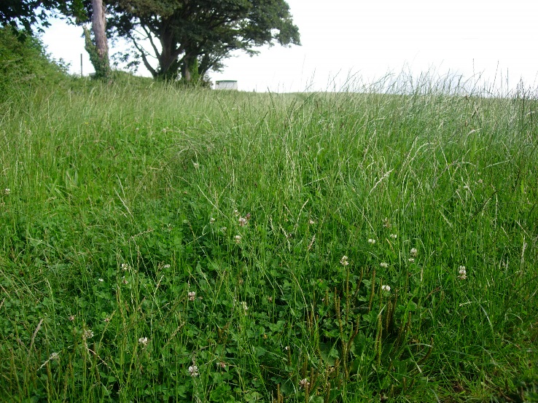

How to present the photographic evidence for GWC verification

- The photographs should be supplied as a JPEG file. They need to be clearly labelled and dated. Digital images should be saved with an appropriate file name ‘Customer Reference Number’ photo number date taken’ eg A0001111 ‘_NO1_Aug 2015’.

- Identify the location from which the photographs were taken. Geo-reference the photographs, which assigns latitudinal and longitudinal references to the image. This is most commonly carried out using a camera with a built-in GPS receiver. This function is available on many smartphones using a downloadable app.

- Mark the number of the photographs on an accompanying Ordnance Survey map, note the direction in which it was taken and provide an 8 figure grid reference (example provided below).

- Submit the photographs, location map for the georeferenced photographs along with the GWC plan, GWC maps and consultation responses to RPW online.

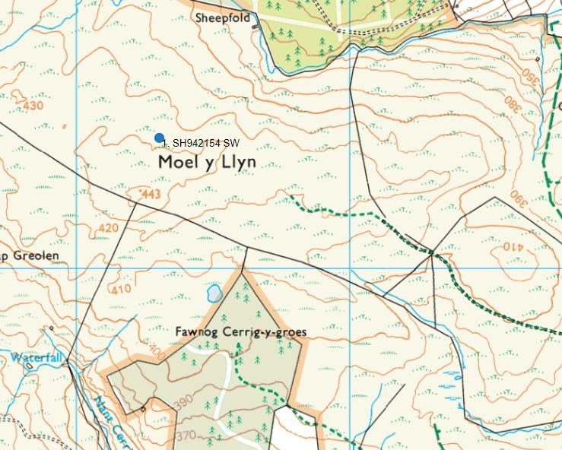

Map showing the location of the photographs

