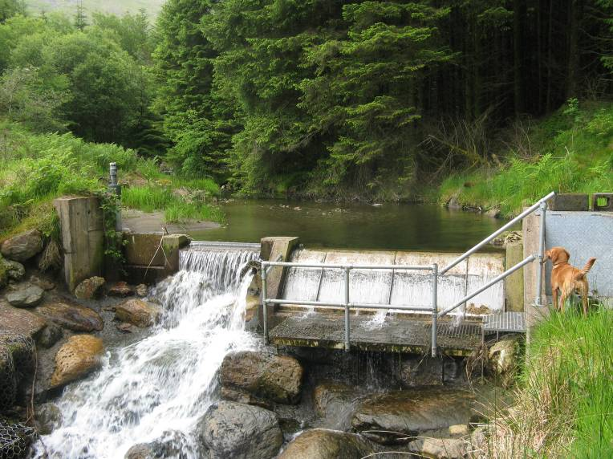

Contents Page

Section A: About you/your group/organisation 2

Section B: About your proposal 3

Section C: Community involvement/benefit 7

Section D: Declaration and checklist 8

BEFORE SUBMITTING THIS FORM PLEASE ENSURE YOU HAVE:
- Spoken to the Hydro Energy Programme team
- Read the accompanying Guidance on making an application

Enquiries: please contact hydrowales@cyfoethnaturiolcymru.gov.uk

Section A: about you/your group/organisation
You must complete all of this section or your proposal will be rejected. Please state ‘not applicable’ if that is the case. Do not leave any questions blank. Please provide as much information as possible to assist your application.

NRW hydro project reference (e.g. 418/19/07)
(You should have a record of this from previous correspondence with us)
A.1. Are you submitting this proposal as: |  |  |  |  | Tick
a. An individual?
b. A representative of an organisation, club or a business/enterprise?
A.2. Main contact details for this application. This should be the lead organisation, whose name will appear on the lease, if granted (if you have authorised a representative to act on your behalf or are working with partners please give their details separately.)
Your title (Mr, Mrs, Ms, Miss, Other)
Your name
Organisation Name (if you’re a company- as it appears on your governing document)
Address (registered address if you’re a company) |  |  | Postcode
Telephone |  |  | Mobile
Email
Website
A.3. If you represent an organisation, group or enterprise please tell us what sort of organisation, group or enterprise it is. (Individual applicants enter ‘N/A’ and go to question A4.)
Type of organisation |  | Registration Number |  |  |  | Date formed
Sole Trader
Private Company Limited by Shares
Public Limited Company
Registered Charity
Company Limited by Guarantee
Industrial and Provident Society
Community Interest Company
Public Body (e.g. school, community or town council, Local Authority)
Club, Institute or Association– please give details
Other– please give details

Section B: About your proposal
You must complete all of this section or your proposal will be rejected. Do not leave any questions blank. Please submit your feasibility study and business plan as supporting documents, but not instead of completing this section. Where the detailed answer to any of these questions is provided in a supporting document, please indicate clearly where the information can be found. For example, your answer to a question may be expressed as:“Please see section 3 of the attached feasibility report” or “Please see Figure 4 in the attached feasibility report”.

B.1. Location of your project
a. Attach a map of your scheme showing the intake, pipe route, turbine house, grid connection, cable route (see section 5 of Guidance)
 | Letters | Numbers
Intake National Grid Reference (10 figure- see section 5 of Guidance)
Discharge point National Grid Reference
Turbine house National Grid Reference

b. Please indicate clearly on a plan the route of your penstock pipe and show where you expect the pipe to be buried or run over ground. If you intend to run the pipe along a forest road please indicate whether you expect the pipe to go under the road or along the side of the road.
c. Please indicate whether any trees will need to be felled to build your scheme. Please express this as an approximate number of trees (e.g. 5) or an area (10m x 100m). Please also clearly mark this on your map.
d. If you require new access tracks for construction purposes please explain where they will be located. Please also clearly mark this on your map.
e. Please explain how you will access the site for the purposes of construction and future maintenance. Include a map showing which roads/tracks you intend to use. If you are likely to need to close any existing roads/tracks please indicate points of closure. All vehicle access, surveying and works must be arranged in advance with NRW. Before we can approve a planning application an Access Statement will be required from you. Your Energy Delivery Account Manager will work with you to agree the content of this.
B.2. Impact on future forest operations.
a. Please describe whether the proposal will impact on access to forest blocks for the purposes of future management. Describe how the impact will be mitigated in order to allow continued management of the forest as well as protection of the hydro scheme from potential damage by forest operations.
B.3. Environmental and social Assessment for your project.
a. Please explain how you intend to construct your scheme to avoid creating any negative environmental or social impact on the site, taking into account any site-specific issues including environmental designations and access and recreation infrastructure. If you are intend providing mitigation please explain what you intend to do.
B.4. Technical and Financial Assessment for your project.
a. Please give your estimates for output of the scheme and the capital and running costs. Please provide any supporting documents which show how these estimates have been determined.
Installed Capacity (kW or MW)
Estimated annual energy generated (MWh)

Assumed abstraction regime

Total capital cost (£):

Please break this down (for example civils, mechanical and electrical, other):

Total running costs (£/a):

Please break this down: (for example rates, maintenance, insurance)

b. Estimated income from the FiT
(total per year and in pence per kWh)
Forecast gross income generated
(total per year and in pence per kWh)
c. Who will be the beneficiary of any income generated?
I/We will retain all income |  |  | Yes/No
Income will be donated/shared |  |  | Yes/No
Please give details below
Beneficiary Name |  |  | % of income to be received
How were these beneficiaries selected?
d. Please indicate whether you have an agreement or have been given a cost for grid connection. (Projects have been withdrawn in the past due to developers underestimating grid costs)
e. Please explain your sources of funding to pay for development and construction (including whether they are secured or not)
B.5. Development Timeline.
Please provide an anticipated Development Timeline. We understand that this may only be indicative at this stage.

Key project milestones/stages |  |  |  | Start date |  |  | Expected end date
Submit pre-application for water abstraction
Formal abstraction licence application
Formal planning application
Construction
Commissioning
B.6. Other land owners.
If other land owners are involved in this scheme, have you secured their permission to use their land? (Please provide evidence (e.g. agreements & letters) in supporting documents)
Land owner name & address |  | Verbal agreement |  |  | Permission letter | Legal agreement |  | No permission
B.7. Existing consents  Please indicate which (if any) of the following you already have (please provide copies of all permits/pre-apps. & responses in supporting documents) |  |  |  |  |  | Issue date |  | Expiry date
Abstraction licence pre-application response
Full abstraction license
Impoundment license
Flood Defence permit
Planning Consent

Section C: Community involvement and benefit
For schemes above 50kW where Natural Resources Wales manages all, or the majority of land we will require you to have a community benefit package of the equivalent of £5000 per MW installed per year (see Section 2.2.2 of Guidance).
If the scheme is to be owned by a community group please explain how income generated by the scheme will be used.

C.1. Please provide details of how your hydro project will benefit the local community or what community benefit package you will set up (max 250 words). If you require further guidance on what might be acceptable in terms of community benefit please contact the project team.

Section D: Declaration & checklist

D.1. NRW Heads of Terms
Please read carefully the standard NRW Heads of Terms and identify any specific issues that need to be taken into account for your project.
D.2. If you have anything else to tell us in support of your proposal, or that you think we need to know, please tell us here (max 100 words, no external links please).

You must complete all of this section or we may not be able to accept your proposal

D3. Checklist: These documents/information must be submitted with your application (if they are currently available). Tick each box and if you are unable to supply one or more at this time, please tell us why.
1:10,000 OS map showing the intake, pipe route, turbine house, grid connection, cable route and any intended signage  (see Section 5 of Guidance) |  | Copies of legal consents obtained
Relevant correspondance re. consents etc. |  | Letters and evidence of local support (including other land owners involved)
Feasibility study/technical and financial proposal
If you have not supplied any of these, please tell us why here:

D4. If you are applying on behalf of a group, organisation or consortium please tick this box to confirm you are authorised by the lead organisation/enterprise (detailed in Question A2) to send this Project Proposal to us and that you understand our obligations under the Data Protection Act 1998, the Freedom of Information Act 2000 and the Equality Act 2010.

Please tick to confirm that you have read and understood the Project Proposal Form Guidance for hydro schemes.

D5. Please provide 2 signatures in support of the information in this form.

One signatory must be the Lead Contact, the other could be the Chair, Secretary, or Director of your organisation. If you are applying as an individual you only need to sign it yourself.

We declare the information in this application to be true to the best of our knowledge, at the time of submission.

Name (please print)
Position in organisation
Date
Signature
Name (please print)
Position in organisation
Date
Signature

Please submit the completed form marking your envelope with the words ‘Woodland Hydro Energy Programme Application’, to the following email address or postal address:

energydeliveryprogramme@cyfoethnaturiolcymru.gov.uk

Programme Office Manager
Energy Delivery Programme
Natural Resources Wales
Welsh Government
Rhodfa Padarn
Llanbadarn Fawr
Aberystwyth, Ceredigion
SY23 3UR

v. February 2016

