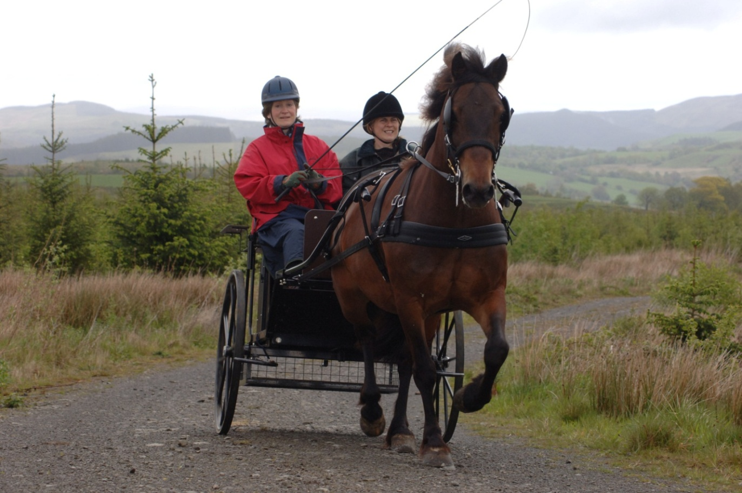

READ THE GUIDANCE NOTES

TO HELP YOU COMPLETE THIS FORM

You can get this publication in large print and other forms (e.g. Braille, audio tape) or arrange for a member of Natural Resources Wales staff to contact you:
Tel: 0300 065 3000


Email: enquiries@naturalresourceswales.gov.uk

!!!PLEASE READ BEFORE COMPLETING THE FORM!!!

This form is for individuals wishing to undertake an activity in woodland managed by Natural Resources Wales, where an Annual Permit and/or barrier key are required. You will need a different Form if you are organising an event, survey, or are planning a longer term project - please contact us.

Please send all supporting documents (see page 4 for details) with your fully completed application. When we have these it will take us 12 weeks to carry out an assessment. We cannot start considering your application until we’ve received everything and will stop if we need to come back to you with queries.

All Natural Resources Wales managed woodlands are working forests and are used by many different groups and individuals. We need to make sure that any activity is going to be safe and will not affect any other activities.

Your activity must not start until you have received a signed Permit Document from us. This applies to new and repeat applications.

Before filling in this Application Form,

- Please talk to a member of Natural Resources Wales Staff in your local Area Office. Contact details are on the website.

- Read the Guidance Notes!

All questions must be answered – please state ‘not applicable’ if that is the case. Do not leave any questions blank. Please provide as much information as possible to assist your application.

1. | Is this a repeat application? | Yes | No

2. | Your Contact Details: | Mr Mrs Ms Miss Other:
Name
Address
Postcode:
Tel:
Mobile
e-mail:
Website:

- 3. When will you be undertaking your activity?
Start Date: |  | End Date:
How often will your activity take place? |  | Daily  Weekly  Other, please state

- 4. Tell us about your proposed activity:
Activity type: | Horse riding  Husky Training  Other
If other, please describe your activity:

5 | Do you have any previous experience of or formal training in your proposed activity. | Yes | No
If Yes please provide details and include any relevant certificates with your application

6a. | Will you be harvesting and selling any produce from the woodland? | Yes  No  If no, please go to question 7
b. | If yes what?
c. | Who will be the beneficiary of any income generated? | I will retain all the income
c. | Who will be the beneficiary of any income generated? | Income will be donated or shared

d. If the income will be donated or shared how will it be distributed?
Beneficiary Name | % of income
 | %
 | %
 | %

7. | Do you require a key to Natural Resources Wales barriers? | Yes No
 | If yes and not for vehicle access please explain why.

8. Do you need vehicle access for your activity? (Other than in public car parks) |  | Yes No
Normally a maximum of two vehicles are allowed.
Make | Model | Registration

9. Where will your activity be taking place?
Please let us know the name of the woodland and supply a grid reference and marked up map

10. Please provide the following with your application

Map – With locations clearly marked

Risk Assessment
Certificate of Public Liability Insurance | (if applicable)
Cheque for barrier key deposit | (if applicable)
Copies of any relevant qualification and certificates | (if applicable)

ALL APPLICANTS TO SIGN AND DATE HERE

Please tick to confirm that you have read and understood the Guidance

Please help us to improve Woodlands and You. We welcome feedback and may contact some applicants to ask what they think of the service. Tick if you DO NOT wish to be contacted.

Name (Please Print)

Signature:

Date:

Data Protection

The information provided by you will be processed by Natural Resources Wales in line with the Data Protection Principles and our Privacy Notice to enable us to process your application. NRW will not publish personal information from your application, but your application in full will be shared internally with our staff in order for us to process it. Your e-mail address and telephone number(s) may be supplied to an external third party (e.g. other event organisers or forest contractors) so that they can contact you if there is a conflict between your and other activities on the land we manage.

Freedom of Information
Under the Freedom of Information Act 2000, anybody may request information from a public authority. The Act confers two statutory rights: to be told whether or not the public authority holds that information; and if so, to have that information communicated to you.
The Data Protection Act 1998, which covers both the public and the private sector throughout the United Kingdom, gives you the right to find out what information, including personal information, is held about you on computer and in some paper records. This is known as the right of subject access. You also have a right to have inaccurate data corrected, blocked, erased or destroyed, and to seek compensation through the courts for damage and distress caused by such inaccuracy. Natural Resources Wales would normally only pass on personal information to prevent or detect crime. See our Open Information webpage for further details

