Estimating the Carbon Sink Potential of the Welsh Marine Environment

ABPmer

Report No 428

Date: 25 March 2020

About Natural Resources Wales

Natural Resources Wales’ purpose is to pursue sustainable management of natural resources. This means looking after air, land, water, wildlife, plants and soil to improve Wales’ well-being, and provide a better future for everyone.

Evidence at Natural Resources Wales

Natural Resources Wales is an evidence based organisation. We seek to ensure that our strategy, decisions, operations and advice to Welsh Government and others are underpinned by sound and quality-assured evidence. We recognise that it is critically important to have a good understanding of our changing environment.

We will realise this vision by:

- Maintaining and developing the technical specialist skills of our staff;
- Securing our data and information;
- Having a well resourced proactive programme of evidence work;
- Continuing to review and add to our evidence to ensure it is fit for the challenges facing us; and
- Communicating our evidence in an open and transparent way.

This Evidence Report series serves as a record of work carried out or commissioned by Natural Resources Wales. It also helps us to share and promote use of our evidence by others and develop future collaborations. However, the views and recommendations presented in this report are not necessarily those of NRW and should, therefore, not be attributed to NRW.

Report series: NRW Evidence Report
Report number: 428
Publication date: March 2020
Contract number: P21018-0072
Contractor: ABPmer
Contract Manager: Vye, S.
Title: Estimating the Carbon Sink Potential of the Welsh Marine Environment
Author(s): Armstrong, S., Hull, S., Pearson, Z., Kay, S., Wilson, R.
Technical Editor: Frost, N.
Approved By: Vye, S., Robinson, K.
Restrictions: None

Distribution List (core)
NRW Library, Bangor 2
National Library of Wales 1
British Library 1
Welsh Government Library 1
Scottish Natural Heritage Library 1
Natural England Library (Electronic Only) 1

Recommended citation for this volume:
Armstrong, S., Hull, S., Pearson, Z., Wilson, R. and Kay, S., 2020. Estimating the Carbon Sink Potential of the Welsh Marine Environment. NRW, Cardiff, 74p
Contents
1. Crynodeb Gweithredol 7
2. Executive Summary 9
3. Introduction 11
4. Methodology 14
4.1. Introduction 14
4.2. Literature and data review 14
4.3. Development of spatial model 15
4.3.1. Understanding / estimating carbon fluxes within WNMP area 15
4.3.2. Mapping of relevant habitats / features 17
4.3.3. Quantifying stores and sequestration 19
4.4. Monetising and contextualising carbon sequestration 19
5. Literature Review on Carbon in Marine Habitats 20
5.1. Introduction 20
5.2. Water 21
5.2.1. Water column 21
5.3. Intertidal habitats 22
5.3.1. Saltmarsh 22
5.3.2. Mudflat and sandflat 25
5.3.3. Vegetated rocky shores 28
5.4. Shallow subtidal habitats (with intertidal elements) 30
5.4.1. Seagrass beds 30
5.5. Subtidal habitats 33
5.5.1. Shellfish beds 33
5.5.2. Macroalgae 35
5.5.3. Brittlestar beds 38
5.5.4. Faunal turf 40
5.5.5. Sedimentary habitats (surficial sediment) 41
5.6. Summary 43
6. Carbon Storage and Sequestration in the Welsh Marine Environment 46
6.1. Introduction 46
6.2. Carbon flux into / Out of WNMP boundary 46
6.3. Carbon storage 47
6.4. Carbon sequestration potential 50
6.5. Welsh blue carbon – monetary value and context 52
7. Discussion, Conclusions and Recommendations 54
7.1. Discussion 54
7.2. Recommendations 55
7.2.1. Evidence 55
7.2.2. Policy and management 56
8. References 57
9. Acronyms 64
10. Appendix A – Full Carbon Rates Table 66
11. Appendix B – Datalayer Processing Summary 71
11.1. Introduction 71
11.2. Species specific datalayers processing 71
11.3. HabMap processing 71
11.4. JNCC combined map processing 72
11.5. Datalayer merge and clipping 72
12. Data Archive Appendix 73

List of Images
Image 1 Marine biological and physical pumps of carbon (dioxide) 12
Image 2 Schematic of Carbon model applied for this study 15
Image 3 ERSEM schematic showing how model components interact / influence each other 16
Image 4 Location of Welsh saltmarsh study sites investigated by Ford et al. (2019) 24
Image 5 Saltmarsh (in the Dee Estuary) 24
Image 6 Sandflat habitat (in the Dee Estuary) 27
Image 7 Intertidal macroalgae 29
Image 8 Depth profiles of the seagrass sediment cores taken by Green et al. (2018); organic carbon (OC) expressed as a percentage of the dry weight 31
Image 9 Seagrass 32
Image 10 Kelp 37
Image 11 Brittlestars 39

List of Tables
Table 1 Datalayers used to create combined carbon storage / sequestration maps 18
Table 2 Confidence criteria applied to carbon values used for calculations in Section 6 19
Table 3. Welsh designated sites where saltmarsh is a designated feature 23
Table 4 Sediment composition for Essex and Morecambe Bay intertidal flats 27
Table 5 Summary of carbon sequestration and storage values per studied habitat 44
Table 6 Carbon flux into / out of Welsh marine waters 47
Table 7 Carbon stored in Welsh marine sediments and habitats 48
Table 8 Water column carbon store as derived from ERSEM model 48
Table 9 Annual carbon sequestration in Welsh marine habitats 50
Table 10 Marine habitat carbon sequestration per unit area, compared with woodlands 53
Table 11 Applied carbon sequestration and storage values per studied habitat 66

List of Figures
Figure 1 Peak months for mass variables and air-sea flux total 49
Figure 2 Sedimentary and habitat areas as mapped for the WNMP area for blue carbon calculation purposes. 51

- Crynodeb Gweithredol

Er mwyn llenwi bwlch tystiolaeth pwysig, mae potensial carbon 'glas' cynefinoedd morol Cymru wedi cael ei amcangyfrif ar ran Cyfoeth Naturiol Cymru.

Carbon glas yw'r carbon sy'n cael ei storio a'i atafaelu gan gynefinoedd morol. Mae modd diffinio termau perthnasol fel a ganlyn:

- Cronfa ddŵr naturiol neu artiffisial yw sinc carbon sy'n cronni ac yn storio carbon;
- Mae storfa garbon yn cynnwys y carbon sydd wedi'i storio yn y golofn ddŵr, gwaddodion arwynebol a biomas fflora a ffawna. Gall y storio hwn fod yn storio tymor byr neu dymor hir. Lle caiff carbon ei storio yn y tymor hir, gellir ystyried ei fod yn cael ei atafaelu.

Er mwyn amcangyfrif potensial carbon glas dyfroedd Cymru, gan roi mwy o ddealltwriaeth o sut mae ecosystemau morol Cymru'n cyfrannu at wrthbwyso’r broses o ryddhau carbon drwy weithgareddau dynol, mae'r camau canlynol wedi cael eu cymryd ar gyfer yr astudiaeth hon:

- Mae'r haenau data gofodol gorau a diweddaraf ar gyfer cynefinoedd carbon glas wedi cael eu nodi a'u cyfuno fel y gellid pennu cwmpas cyfartalog yng Nghymru ar gyfer pob un;
- Mae'r llenyddiaeth berthnasol wedi cael ei hadolygu i gael y gwerthoedd storio ac atafaelu carbon mwyaf perthnasol a fyddai wedyn yn cael eu cymhwyso igynefinoedd morol Cymru;
- Mae model rhifiadol dynodedig wedi cael ei ddadansoddi i gael (1) amcangyfrifon carbon colofnau dŵr (gan gynnwys biomas plancton); (2) amcangyfrifon o lif aer-môr o ran carbon deuocsid (CO₂) (h.y. faint o CO₂ sy'n mynd i'r golofn ddŵr ac sy'n cael ei droi'n ffurfiau amrywiol ar garbon), yn ogystal ag (3) amcangyfrifon o lif carbon ar draws ffin forol Cymru (h.y. faint o garbon sy'n gadael dyfroedd Cymru ac sy'n cael ei gludo i ddyfroedd bas a dyfnach cyfagos);
- Mae allbynnau afonol carbon hefyd wedi cael eu hamcangyfrif yn seiliedig ar werthoedd llenyddiaeth a gollyngiadau afonydd cyfartalog a ddarparwyd gan hydrolegwyr Cyfoeth Naturiol Cymru;
- Mae gwerthoedd carbon wedi cael eu cyfrifo a'u rhoi yn eu cyd-destun gyda chyfraddau daearol ('carbon gwyrdd'), yn ogystal ag allyriadau CO₂ Cymru.

Mae canlyniadau'r astudiaeth wedi cael eu crynhoi mewn ffeithlun, sydd wedi'i ddangos isod. Mae hwn yn dangos bod llawer o garbon eisoes wedi'i storio mewn gwaddodion morol yng Nghymru, o leiaf 113 miliwn o dunelli (Mt) yn y 10cm uchaf. Mae hyn yn cynrychioli bron 170% o'r carbon a geir yng nghoedwigoedd Cymru.

Mewn unrhyw flwyddyn, mae colofn ddŵr moroedd Cymru yn dal o leiaf 48.7 Mt arall o garbon, yn bennaf ar ffurf carbon anorganig sydd wedi toddi. Wrth gymharu â'r gwerth hwn, mae'r biomas carbon sy'n gysylltiedig â chynefinoedd macroalgal ac angiosberm yn weddol fach mewn cymhariaeth, sef 69,000 o dunelli o garbon (neu 0.07 Mt C), a choedwigoedd gwymon a morfeydd heli yw’r cynefinoedd mwyaf cynhyrchiol.

O ran carbon sy'n cael ei ddal/atafaelu bob blwyddyn, amcangyfrifwyd bod cynefinoedd morol Cymru'n atafaelu o leiaf 26,100 o dunelli o garbon (neu 0.03 Mt C) bob blwyddyn, gyda morfeydd heli a fflatiau rhynglanwol yn cyfrif am ganran fawr o'r gwerth hwn. Pan gaiff ei fynegi mewn unedau CO₂ cyfwerth, sef yr uned a ddefnyddir yn fwyaf mynych wrth adrodd am atafaelu, mae hyn gyfwerth â 95,900 t CO₂e (neu 0.096 Mt CO₂e). Mae hyn yn cynrychioli oddeutu 7% o'r swm a atafaelwyd gan goedwigoedd Cymru bob blwyddyn (felly oddeutu 21,000 ha o goedwigoedd).

Fesul hectar o gynefin, morfeydd heli sy'n atafaelu'r mwyaf o'r holl gynefinoedd, er ychydig yn llai na hectar o goedwig Cymru (oddeutu dau draean). Fodd bynnag, mae hyn yn ymwneud â gwaddodi, gyda gwerthoedd gweddol unffurf ceidwadol yn cael eu defnyddio gan yr astudiaeth hon. Ystyrir y byddai morfeydd heli mewn aberoedd â llwythi gwaddod crog uchel yn y golofn ddŵr, megis Aber Hafren, yn atafaelu mwy na choedwigoedd, a hynny’n debygol o fod o leiaf 1.5 gwaith gymaint.

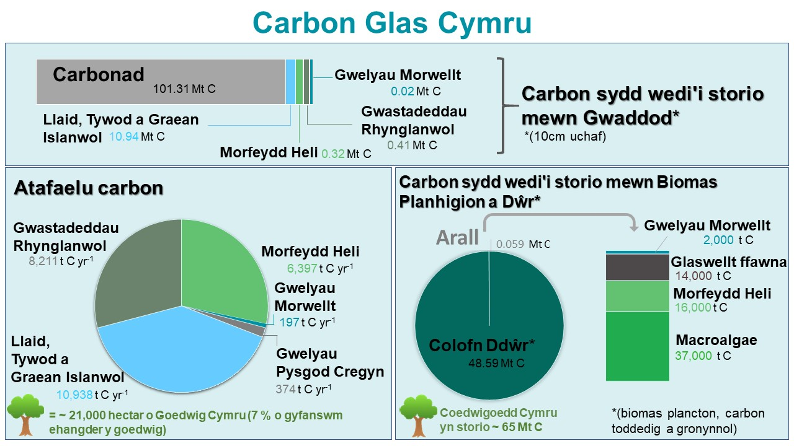
Llun: Ffeithlun ar storio ac atafaelu carbon morol Cymru

Mae cyfyngiadau i'r data wedi cael eu nodi, er enghraifft, mewn perthynas â llif carbon i ardal forol Cymru ac oddi yno, ansicrwydd mewn dosbarthiad cynefinoedd ac mewn perthynas â rhai cyfraddau atafaelu. Mae lle i wella'r sylfaen dystiolaeth yn sawl un o’r ardaloedd hyn ac felly sicrhau dull gwell o fesur cyfraddau storio ac atafaelu carbon yn nyfroedd morol Cymru.

Mae potensial hefyd i wella’r dull o reoli ardal forol Cymru o ran carbon glas. Yn arbennig, gallai amddiffyn ac adfer cynefinoedd megis morfeydd heli a morwellt sy'n storio ac yn atafaelu carbon gyfrannu at gynnydd sylweddol mewn carbon glas. Gallai amddiffyn ardaloedd gwely'r môr sy'n cefnogi gwelyau deuglawr (neu sydd â'r potensial i'w cefnogi) hefyd gynyddu cyfraddau atafaelu carbon.

- Executive Summary

In order to fill an important evidence gap, the ‘blue’ carbon potential of Welsh marine habitats has been estimated on behalf of Natural Resources Wales (NRW).

Blue carbon is the carbon stored and sequestered by marine habitats. Related terms can be defined as follows:

- A carbon sink is a natural or artificial reservoir that accumulates and stores carbon;
- A carbon store encompasses the carbon stored in the water column, surface sediments and floral and faunal biomass. This storage may be short or long-term. Where carbon is stored in the long-term, it can be considered to be sequestered.

In order to estimate the blue carbon potential of Welsh waters, and thus allow a greater understanding of how Welsh marine ecosystems contribute to offsetting the release of carbon through human activities, the following steps have been undertaken for this study:

- The best and most up to date available spatial datalayers for blue carbon habitats have been identified and combined so that approximate Welsh coverage could be determined for each;
- The relevant literature has been reviewed to obtain the most relevant carbon storage and sequestration values which would then be applied to Welsh marine habitats;
- A dedicated numerical model has been interrogated to obtain (1) water column carbon estimates (including plankton biomass); (2) estimates on air-sea flux of Carbon Dioxide (CO₂) (i.e. how much CO₂ enters the water column and is converted into various forms of carbon), as well as (3) estimates of carbon flux across the Welsh marine boundary (i.e. how much carbon leaves Welsh waters and gets transported to adjacent shelf and deeper waters);
- Riverine inputs of carbon have also been estimated based on literature values and average river discharges supplied by NRW hydrologists;
- Carbon values have been calculated and put into context with terrestrial (‘green carbon’) rates, as well as Welsh CO₂ emissions.

The results of the study have been summarised in an infographic, which is displayed below. This shows that a lot of carbon is already stored away in Welsh marine sediments, at least 113 Million tonnes (Mt) in the top 10 cm. This represents almost 170 % of the carbon held in Welsh forests.

In any given year, the Welsh seas’ water column holds at least another 48.7 Mt of carbon, mostly in the form of dissolved inorganic carbon. When compared to this value, the carbon biomass associated with macroalgal and angiosperm habitats is relatively modest in comparison, at 69,000 tonnes of carbon (or 0.07 Mt C), with kelp forests and saltmarshes being the most productive habitats.

With regard to carbon locked away / sequestered every year, it has been estimated that Welsh marine habitats sequester at least 26,100 tonnes of carbon (or 0.03 Mt C) every year, with saltmarshes and intertidal flats accounting for a large percentage of this value. When expressed in CO₂ equivalent units, which is the unit most commonly applied in sequestration reporting, this equates to 95,900 t CO₂e (or 0.096 Mt CO₂e). This represents around 7 % of the amount sequestered by Welsh forests every year (so by around 21,000 ha of forest).

Per hectare of habitat, saltmarshes sequester the most out of all the habitats, though slightly less than a hectare of Welsh forest (about two-thirds). This is however related to sedimentation, with relatively conservative uniform values having been applied by this study. It is considered that saltmarshes in estuaries with high suspended sediment loads in the water column, such as the Severn Estuary, would sequester more than forests, likely at least 1.5 times as much.

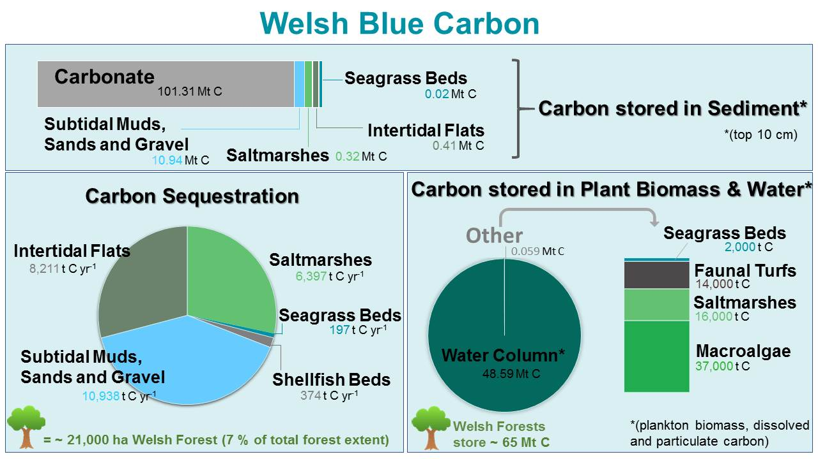

Image: Infographic on Welsh marine carbon storage and sequestration

Limitations to the data have been noted, for example in relation to carbon fluxes into and out of the Welsh marine area, uncertainties in habitat distribution and in relation to some sequestration rates. There is scope to improve the evidence base in many of these areas and thus better quantify carbon storage and sequestration in Welsh marine waters.

There is also the potential to improve the management of the Welsh marine area for blue carbon. In particular, the protection and restoration of habitats such as saltmarsh and seagrass which store and sequester carbon could contribute to significant increases in blue carbon. Greater protection of areas of seabed supporting (or with the potential to support) bivalve beds could also increase carbon sequestration.
- Introduction

The Environment (Wales) Act 2016 requires the Welsh Government to reduce emissions of greenhouse gases (GHGs) in Wales by at least 80% for the year 2050 with a system of interim emissions targets and carbon budgets. In March 2019, the Welsh Government published its first low carbon plan, ‘Prosperity for All: A Low Carbon Wales’; this outlines the Government’s approach to cut emissions and transition to a low carbon economy in a way which maximises wider benefits for Wales, ensuring a fairer, healthier and more equal society. Furthermore, the Welsh National Marine Plan (WNMP), which was published in November 2019, contains amongst its general cross-cutting policies a commitment to ‘improve the understanding and enable action supporting climate change adaptation and mitigation’.

There is, however, currently relatively limited understanding of the role Welsh marine waters and environments play in carbon storage and sequestration, which is a key tool in facilitating climate change mitigation. It is worth noting that, at around 32,000 km², the Welsh marine area is 35% larger than the Welsh land mass (which measures just under 21,000 km²). This study set out to improve the understanding of this key ecosystem service provided by the Welsh marine environment by mapping and quantifying Welsh marine carbon storage and sequestration.

A large proportion of the WNMP area is subject to one or more nature conservation designations, with many Marine Protected Areas (MPAs) containing marine carbon sequestering habitats including saltmarsh, seagrass and kelp. There are 139 MPAs in Welsh waters, that are made up of:

- 13 Special Protection Areas (SPAs);
- 15 Special Areas of Conservation (SACs);
- 1 Marine Conservation Zone (MCZs);
- 107 Sites of Special Scientific Interest (SSSIs); and
- 3 Ramsar sites.

Oceans and seas play an important role in climate regulation / mitigation as part of a coupled system encompassing atmosphere, ocean, cryosphere and land surface. In particular, oceans and seas have a critical role in the exchange of greenhouse gases between air and water (particularly carbon dioxide (CO₂), methane, nitrogen oxides (NOx) and water vapour) (Bigg et al., 2003). Coastal oceans are particularly important in processing inputs of terrestrial organic matter and exchanging of matter and energy with the open ocean (Gattuso et al., 1998). Both biological and physical processes can be important in cycling, storing and sequestering carbon, illustrated in Image 1.

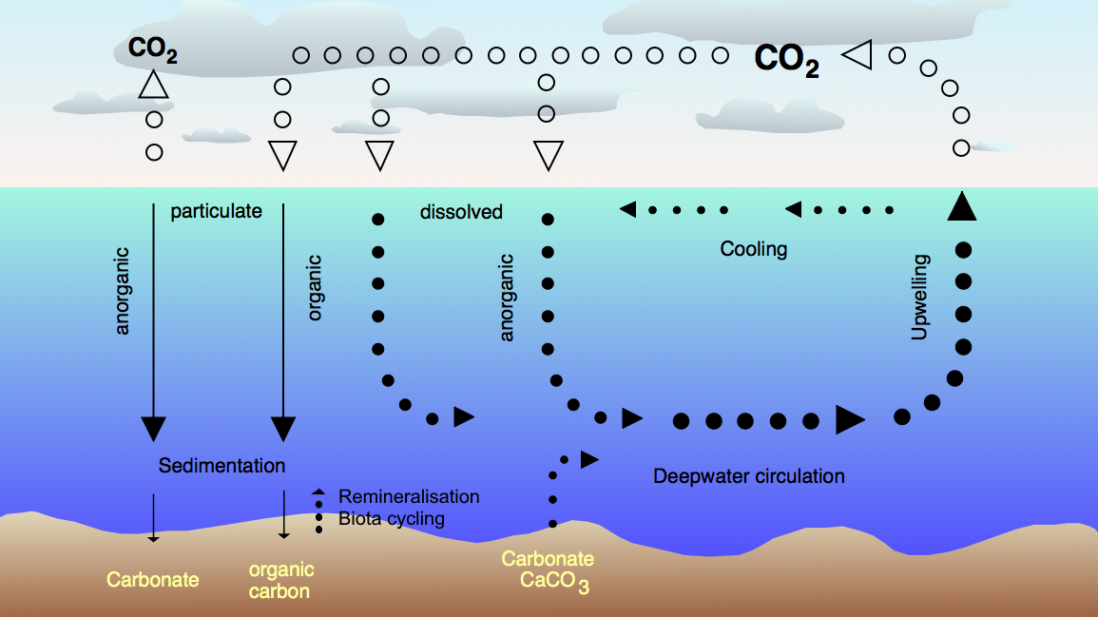
Adapter from: Wikipedia / Alfred Wegener Institute, 2006
(Remineralisation and biota cycling inserted by ABPmer)
Image 1 Marine biological and physical pumps of carbon (dioxide)

Recent research has highlighted the valuable role that coastal and marine ecosystems play in storing and sequestering CO₂ from the atmosphere. Several studies have focused on the contribution of seabed habitats to carbon storage and sequestration – so-called blue carbon (see, for example, McLeod et al., 2011; Burrows et al., 2014).

As noted above, there are no published papers documenting a carbon budget for Welsh seas. In order to fill this gap, this project has sought to map and quantify marine carbon storage and sequestration in Welsh waters to allow a greater understanding of how Welsh marine ecosystems contribute to offsetting the release of carbon through anthropogenic activities. The key objectives for the study have been:

- To review the literature around the carbon sink potential of different marine habitats present in Wales;
- To develop a methodology for calculating the carbon sequestration potential of the Welsh marine environment; and
- To create and apply the method to estimate carbon storage and sequestration potential of the Welsh marine environment.

The remainder of this report is structured as follows:

Section 4: Methodology – describes the methodology applied during the study;
Section 5: Literature Review – summarises the findings of the literature review;
Section 6: Carbon Storage and Sequestration in the Welsh Marine Environment – describes the outputs from the study and confidence in the estimates of carbon storage and sequestration potential; and
Section 7: Conclusions and Recommendations – provides overall conclusions from the work and makes recommendations in relation to the further development of the method and its application.

Please note that, for the purpose of this report, the following terminology is used:

- A carbon sink is a ‘natural or artificial reservoir that accumulates and stores carbon’ (Committee on Climate Change, 2018) (habitats, the ocean, etc.);
- A carbon store is understood to encompass the carbon stored in the water column, surface sediments and floral and faunal biomass. This storage may be short or long-term. Where carbon is stored in the long-term, it can be considered to be sequestered.

In adopting these definitions, it is acknowledged that different interpretations are sometimes used in the literature, and there is no agreed definition of how long carbon needs to be stored in order to be sequestered.

- Methodology

  - Introduction

In order to address the scope of requirements set out in the previous section, this study has sought to collate up-to-date information on the carbon storage and sequestration potential (and rates) of relevant / mappable potential sinks in Welsh waters through a literature and data review (Section 4.2). This information has then been used to parameterize a simple method which draws on datalayers to derive the spatial distribution of the relevant habitats. The information on storage and sequestration potential has been cross-checked against a basic carbon budget model for Welsh waters that draws on the outputs from a sophisticated numerical model and wider sources (Section 4.3). The derived carbon sequestration values have also been monetised and set into a Welsh context (Section 4.4).

  - Literature and data review

A literature and data review have been undertaken to inform the development of the methodology for estimating the blue carbon potential of the Welsh marine environment. The scope of the review focussed on the carbon storage and sequestration potential of the following key habitats / features known to be present in the Welsh marine environment:

- Water column (phytoplankton, zooplankton, etc.);
- Intertidal habitats:
  - Saltmarshes;
  - Mudflat and sandflats;
  - Intertidal macroalgae (vegetated rocky shores);
- Subtidal habitats which may have an intertidal element:
  - Seagrass beds;
- Subtidal habitats:
  - Shellfish beds (mainly horse mussel, blue mussel and oyster beds) (acknowledging that oyster and blue mussel beds can have intertidal elements);
  - Subtidal macroalgae (mainly kelp, but including maerl);
  - Brittlestar beds;
  - Faunal turf; and
- Subtidal muds, sands and gravel.

Some biogenic habitats that may be assumed to have a blue carbon function have been excluded. This is the case with habitats formed by reef-building polychaetes Sabellaria alveolata and S. spinulosa, as these consist of agglutinated sand grains and shell fragments (Naylor and Viles, 2000). These features therefore have very limited additional blue carbon potential and are not considered further in this report.

As a study undertaken for Scottish waters in 2014 (by Burrows et al., 2014) had recently summarised available literature in relation to carbon potential of most of the marine habitats / features listed above. The literature review for this report thus focussed on augmenting and updating this work and obtaining data on those features not covered by the earlier review.

Information on the spatial distribution of relevant habitat features in the Welsh marine environment has been collected by identifying the most applicable / usable data layers (see Section 4.3.2 for more detail).

  - Development of spatial model

    - Understanding / estimating carbon fluxes within WNMP area

A simple model for carbon in Welsh seas has been created that takes account of estimates of carbon fluxes into and out of the WNMP area including:

- Air-sea flux of CO₂;
- Terrestrial / riverine carbon inputs;
- Carbon flux across the offshore WNMP boundary; and
- Carbon flux to / from habitats.

A schematic of this model is presented in Image 2 below.

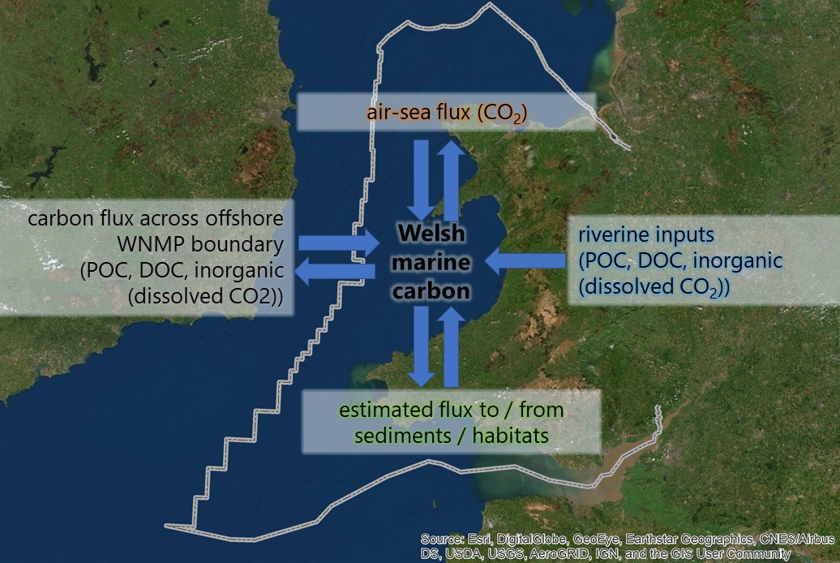
Image 2 Schematic of Carbon model applied for this study

Riverine inputs of particulate organic carbon (POC), dissolved organic carbon (DOC) and dissolved organic carbon (DIC) have been calculated based on values in the literature and an average annual average riverine discharge estimated for Wales by hydrologists from Natural Resources Wales (NRW) (see Section 6.2 for results / further detail).
Information on air-sea flux of CO₂ was obtained from Plymouth Marine Laboratory’s (PML’s) European Regional Seas Ecosystem Model (ERSEM) (Butenschön et al., 2016). This provided annual average net air-sea flux estimates of CO₂ based on the period 2008 -2015 at an 8 km grid resolution for Welsh seas. ERSEM is a well-established ecosystem model for the lower trophic levels of the marine food web, covering northwestern European shelf seas including the entirety of Welsh waters.

The current model release contains the essential elements for pelagic and benthic ecosystems, including the microbial food web, the carbonate system, and calcification (Butenschön et al., 2016); see Image 3.

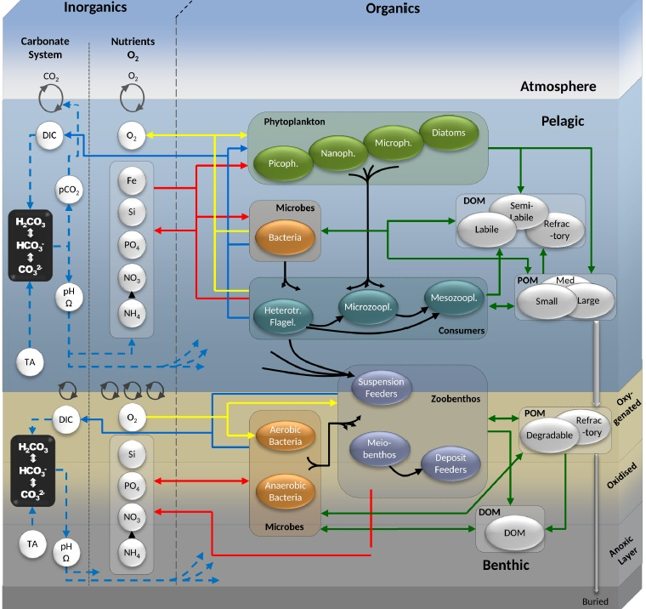
Source: Butenschön et al., 2016
Image 3 ERSEM schematic showing how model components interact / influence each other

The ERSEM model is not well resolved inshore and does not take account of terrestrial inputs of carbon. It is, therefore, not accurate in estuarine or near-shore coastal waters. To address this limitation, literature values for estuarine and near-shore coastal CO₂ fluxes have been obtained and applied to transitional and coastal waterbodies (as delineated for Water Framework Directive (WFD) purposes).

Information on annual average net fluxes across the offshore WNMP boundary have been derived from the ERSEM model for POC, DOC and DIC (dissolved CO₂).

The approach to estimating fluxes to / from habitats and sedimentary areas is described below.

    - Mapping of relevant habitats / features

Based on the data review undertaken, a combined / merged habitat and sediment map has been created for Welsh waters in order to facilitate the calculation of carbon storage and sequestration totals for the WNMP area. This is presented as Figure 2 in Section 6.4. The data layers used to create this merged map are listed in Table 1. The ‘combined’ habitat map administered by the Joint Nature Conservation Committee (JNCC) has been used as the key layer for biogenic habitats, as this covers most of the WNMP area and is regularly updated, including with data supplied by Welsh government bodies. For some habitats, where more recent and / or refined data was available, separate data layers have been used and given priority. The ’HabMap’ sediment data layer has been used as the key datalayer for sedimentary habitats, with offshore gaps filled using the JNCC layer.

The relevant created datalayer has been supplied with MEDIN compliant metadata, and a detailed processing log created, explaining clearly how the data have been processed to create the outputs. A summary of the datalayer processing process as is provided in Section 11 / Appendix B.

Table 1 Datalayers used to create combined carbon storage / sequestration maps

Habitats; in priority order | Datalayer Origin / Name | Processing detail
Base layers
- | JNCC - EUNIS Combined Map (available on JNCC website) | Key layer for biogenic habitats; also used to fill offshore gaps in HabMap layer; and re-classified according to Folk system
- | NRW - HabMap Sediment layer (not publicly available) | Key layer for sedimentary habitats. Where not already classed according to the Folk system, some polygons were re-classified (see Section 11 / Appendix B for further detail).
Habitat layers used to merge on top of base layers (as better information contained within)
Saltmarshes | Lle Geo-Portal - Saltmarsh Extents | -
Seagrass Beds | Lle Geo-Portal - Priority Marine Habitats of Wales: Seagrass Beds | -
Intertidal Macroalgae | Lle Geo-Portal - NRW Intertidal Phase 1 Habitat Survey | Only macroalgae polygons extracted
Intertidal mudflat and sandflats | Lle Geo-Portal - Marine Article 17 Reporting Habitat Features | Each polygon categorised according to Folk system
Maerl | Lle Geo-Portal - Environment (Wales) Act Section 7 and OSPAR: Marine Habitats | -
Shellfish Beds | Section 7 / OSPAR Oyster Bed layers (not publicly available) | Point file buffered and merged with polygon file
 | Lle Geo-Portal - Priority Marine Habitats of Wales: Blue Mussel Beds | -
 | Lle Geo-Portal - Priority Marine Habitats of Wales: Horse Mussel Beds | -
 | Lle Geo-Portal - Section 7 Musculus Discors Green crenella Beds | -
Subtidal Macroalgae | JNCC EUNIS Combined Map | Extracted higher EUNIS class information from ‘habitat type’ column, where available.
Subtidal Brittlestar beds
Surficial Sediments | NRW - HabMap Sediment layer

    - Quantifying stores and sequestration

In order to parameterise carbon stores and sequestration for the mapped habitats in Welsh waters, the extent of each feature was calculated and multiplied with the selected values as identified from the literature review (see Section 5; summarised in Table 5 / Section 5.6).

The confidence for each value used has also been assessed, using the criteria set out in Table 2.

Table 2 Confidence criteria applied to carbon values used for calculations in Section 6
Confidence Score | Definition
High (H) | There is a good understanding of the carbon storage or sequestration function of the feature and the assessment is well supported by consistent evidence which is highly relevant / transferable to Welsh waters / habitats. There is consensus amongst the experts.
Medium (M) | Whilst there is some understanding of the carbon storage or sequestration function of the feature, this may be based on limited evidence and / or proxy information, or is only moderately relevant / transferable to Welsh waters / habitats. The literature reports a wide range of variation in the function and conflicting evidence / opposing views exist.
Low (L) | There is limited or no understanding of the carbon storage or sequestration function of the feature and / or the assessment is not well supported by evidence, or is not immediately relevant / transferable to Welsh waters / habitats. There is no clear agreement amongst experts.
Note: Evidence is defined as expert opinion or advice, data, methodology, results from data analysis, interpretation of data analysis, and collations and interpretations of scientific information (meta-analysis), peer-reviewed papers, grey literature, industry knowledge and anecdotal evidence.

  - Monetising and contextualising carbon sequestration

Carbon sequestration estimates (tonnes CO₂ per year) have been converted into monetary values using the Department for Business, Energy and Industrial Strategy (DBEIS) non-traded carbon price for 2020. The values have also been set into the context of Welsh GHG emissions; see Section 6.5.

- Literature Review on Carbon in Marine Habitats

  - Introduction

There is very little direct work that has focused on mapping carbon cycling, storage and sequestration in Welsh waters. A recent review of blue carbon for the National Assembly for Wales provided context on the blue carbon credentials of saltmarshes, maerl and seagrass beds, and mapped these habitats (based on existing NRW data) (Stewart and Williams, 2019). However, the work did not seek to quantify the amounts of carbon stored or sequestered within these habitats.

Despite the limited direct evidence from Welsh waters on the storage and sequestration potential of relevant marine habitats, comparable information is available from other parts of the UK and northwest Europe. For example, Burrows et al. (2014) reviewed the carbon storage and sequestration potential of key marine habitats relevant to Scottish waters. The study used available evidence to determine whether features were likely to act simply as short-term carbon stores or whether they might be longer-term (decadal) stores of carbon, and thus would be considered to sequester carbon. The study collated rates of sequestration and storage, and also estimated the overall carbon storage and sequestration of Scottish marine habitats. Most of the features assessed within this Scottish study are relevant to Wales, with the exception of serpulid reefs or cold-water corals, which are absent from Welsh waters.

A small number of other studies have also sought to develop spatial maps to indicate the location and scale / value of carbon sequestration within the marine environment, usually in the context of seeking to map the climate regulation ecosystem service. For example, Hull et al. (2014) modelled carbon sequestration for UK seas taking account of broad-scale physical processes such as the North Sea Carbon pump (Thomas et al., 2005) and incorporating potential saltmarsh and sediment sequestration. The quantities of sequestered carbon were monetised using non-traded carbon prices. More recently, ABPmer et al. (2020) developed a simple spatial model representing the climate regulation ecosystem service in Irish waters. This was based on information on air-sea CO₂ flux across Irish waters, and the sequestration potential of two key coastal habitats - saltmarshes and sand dunes.

Most work hitherto has focused on carbon, particularly CO₂, with limited work done on other greenhouse gases such as methane and nitrous oxide. Methane has a global warming potential 28 to 36 times greater than CO₂ over 100 years and NOx 265-298 times greater. In order to fully understand the role of marine ecosystems in climate regulation it would be necessary to understand fluxes of methane and NOx as well as CO₂. This study focuses specifically on carbon storage and sequestration and, therefore, excludes NOx. While it also omits methane, the scale of methane exchanges to and from the marine environment are very small compared to other forms of carbon exchange (CO₂, organic) (Weber et al., 2019) and, therefore, not material when considering carbon storage, flux and sequestration.

As noted in Section 4.2, a literature review was undertaken to inform the development of the methodology for estimating the carbon sink potential of the Welsh marine environment. The scope of the review focussed on the habitats and features listed in Section 4.2; and this Section is structured according to the following habitat / feature categories:

- Water column (Section 5.2);
- Intertidal habitats (Section 5.3);
- Shallow subtidal habitats (with intertidal elements) (Section 0);
- Subtidal habitats (Section 5.5).

For each of the habitat / feature sections, brief general background information and some Welsh context are provided, and literature on carbon storage and sequestration summarised. A box at the end of each habitat / feature section highlights which value has been used in this study and briefly summarises the rationale for this. Please note that all values have been converted to kg m⁻² for this study.

A summary table is provided in Section 5.6; this details the carbon rates selected for use in this study, together with a confidence assessment and a brief justification of the selection.

  - Water

    - Water column

Background / carbon storage and sequestration

The biological carbon pump (coupled with the solubility pump) is an important process in the ocean-wide (water column) sequestration of carbon. It refers to the photosynthetic uptake of CO₂ by marine plankton in surface waters, which results in a fraction of produced biomass being transferred to the deep ocean and subsequently buried (Burrows et al., 2014). In this way, these photosynthetic micro-organisms convert dissolved inorganic carbon into organic forms of carbon, with the latter being mostly recycled in the upper waters of the sea (Smale et al., 2013). It is a proportion of POC that sinks into deeper waters and is accreted into the sediment as material is buried when fresh sediment accumulates. Some plankton also armour themselves with calcareous scales or shells, which subsequently sink; becoming particulate inorganic carbon (PIC).

The flux of carbon from surface waters into marine sediments can be ‘simulated’ using the calculation of a ‘Net Microplankton Production’ (NMP) rate. NMP is less than ‘net primary production', because it takes account of consumption within the euphotic zone by pelagic grazers (such as zooplankton) and is intended to measure the amount of organic matter available for export from this zone. Some of the exported POC is consumed by zooplankters, although a part of what is eaten is defaecated. Therefore, the NMP rate joins sinking, live and dead phytoplankton to calculate the total flux into the bottom boundary layer. Burrows et al. (2014) calculated that a value of 10% NMP represented the flux of carbon transported to deep-sea sediments.

Welsh context

As noted in the Section 3, Welsh marine waters cover an area of some 32,000 km²; the depth of these waters ranges from 0 m to around 180 m. The waters would thus all be classed as belonging to the continental shelf.

For the purpose of this study, PML’s ERSEM model was utilised to obtain values for biomass carbon contained in the water column within WNMP boundaries. Outputs provided by PML indicate that the water column in Welsh waters holds some 48.6 Mt C (mega / million tonnes of carbon) at any one time (on average), with zooplankton, phytoplankton and non-living POC making up just under 5 % of this (and the remainder being mostly DIC, with some DOC) – please see Table 8 and Section 6.3 for more detail.

  - Intertidal habitats

    - Saltmarsh

Background

Saltmarshes are generally established in areas sheltered from wave action, such as in estuaries, lagoons, beach plains, natural harbours and barrier islands, where fine silt and clay sediments settle. Saltmarshes cover approximately 55,000 km² of the world’s coastlines, with 26 species present within 470 km² of the UK’s marshes (Beaumont et al., 2014). Saltmarshes in Wales and on the west coast of the UK generally have a shallow organic-rich clay layer (<1 m) underlain by sandy substrate and are frequently grazed by livestock (May and Hansom 2003; cited in Beaumont et al., 2014), whereas the marshes of the south and east UK coasts are characterised by a deep (>10 m) organic-rich clay substrate and are most commonly ungrazed (Beaumont et al., 2014).

Welsh context

There are 76 km² of saltmarshes in Wales (as calculated from the ‘saltmarsh extent’ layer available on the Lle portal). Saltmarshes are widespread across the Welsh coast, where they are present in all major estuaries and inlets as well as in other more sheltered locations, including the lee of spits and in the shelter of islands (Welsh Government, 2018). The largest extents are found in the Severn Estuary and the estuaries of Carmarthen Bay. Whilst the Dee Estuary contains extensive stretches of saltmarsh, the majority of these are located on the English side of the estuary.

Saltmarshes are listed in Annex I of the Habitats Directive and are also a ‘habitat of principal importance’ under Section 7 of the Environment (Wales) Act 2016. Many Welsh saltmarshes are furthermore protected as features of SACs or SSSIs, and / or constitute supporting habitats for the bird interest features of many SPAs. SACs with saltmarsh features are listed in Table 3.

Table 3. Welsh designated sites where saltmarsh is a designated feature
European site | Annex 1 Feature
Dee Estuary SAC | Atlantic salt meadows; Salicornia and other annuals
Glannau Môn Cors Heli SAC | Atlantic salt meadows; Salicornia and other annuals
Pen Llŷn a'r Sarnau SAC | Atlantic salt meadows; Salicornia and other annuals, Mediterranean and thermo-Atlantic halophilous scrubs
Pembrokeshire Marine SAC | Atlantic salt meadows
Carmarthen Bay and Estuaries SAC | Atlantic salt meadows; Salicornia and other annuals
Kenfig SAC | Atlantic salt meadows
Severn Estuary SAC | Atlantic salt meadows
(Adapted from Welsh Government, 2018)

Carbon storage and sequestration

Saltmarsh carbon ‘sinks’ form when saltmarsh plants capture CO₂ from the surrounding air and water column and subsequently store this carbon in their roots and rhizomes. At the same time, saltmarsh roots physically bind together soil particles and encourage rhizomal microbes to do the same, trapping organic material (Ford et al., 2016). It is this exuding of captured carbon and organic material into the soil that creates an anaerobic, carbon-rich sediment (Reid and Goss, 1981; cited in Ford et al., 2016). This has the ability to accumulate carbon without reaching saturation (i.e. anaerobic conditions slow decomposition) and can potentially store carbon over millennial timescales (Stewart and Williams, 2019). As these habitats are dynamic however, and can be subject to die-back and physical remobilisation at intervals of decades or centuries (Burrows et al., 2014), they may not be capable of storing carbon over very long timescales.

Carbon sequestration rates vary between complexes, with variability related to numerous factors, including hydroperiod (time spent submerged), salinity, nutrient input (i.e. from pollution) and suspended sediment supply (Nelleman et al., 2009). Substrate type and thickness are also important factors in saltmarsh sequestration potential, with clay soils widely recognised as good stores of organic carbon due to the efficient adsorption of organics to clay particles (Ford et al., 2019). Plant community composition and plant diversity are also important, as they largely determine root properties such as biomass, sediment turnover and carbon exudate rate. Ford et al. (2016) suggest that species-rich saltmarshes undergo a reduced soil erosion rate and hence may sequester carbon for longer than less-diverse marshes. Similarly, the relationship between soil stabilisation and plant diversity was found to be stronger in erosion-prone sandy soils compared to resilient clay soils (Ford et al., 2016).

It is thought that saltmarshes have the highest carbon burial rate per unit area compared to other blue carbon habitats (Stewart and Williams, 2019), with total global sequestration rates of 5 and 87 Mt C yr⁻¹ (Chmura et al., 2003) and 10.2 Mt C yr⁻¹ (Ouyang and Lee, 2014) quoted in the literature. Large amounts of carbon have been calculated to have already been buried / sequestered in saltmarsh sediments globally, with levels as high as 430 Mt quoted by Chmura et al. (2003) for the upper 50 cm of tidal saltmarsh sediments.

Sequestration rates in UK saltmarsh range from 64 – 219 g C m⁻² yr⁻¹ (Adams et al., 2012), with typical figures around 120 – 150 g C m⁻² yr⁻¹ (Beaumont et al., 2014). Burrows et al. (2014) applied a value of 210 g C m⁻² yr⁻¹ for their Scottish study.

A 2015 Welsh study reported on by Ford et al. (2019) sampled a total of 23 saltmarsh sites to determine carbon stocks (see Image 4). Plant and soil characteristics were analysed for each site, and the carbon stock determined for each of the sampling locations (51 in total across the 23 sites). Stored carbon calculated for the top 10 cm of soil varied from 32 t C ha⁻¹ (or 3.2 kg C m⁻²) for the Atriplex portulacoides vegetation class to 50 t C ha⁻¹ for the Juncus gerardii vegetation class. Sandy soils were found to store less carbon (average 29 t C ha⁻¹) than non-sandy soils (43 t C ha⁻¹).

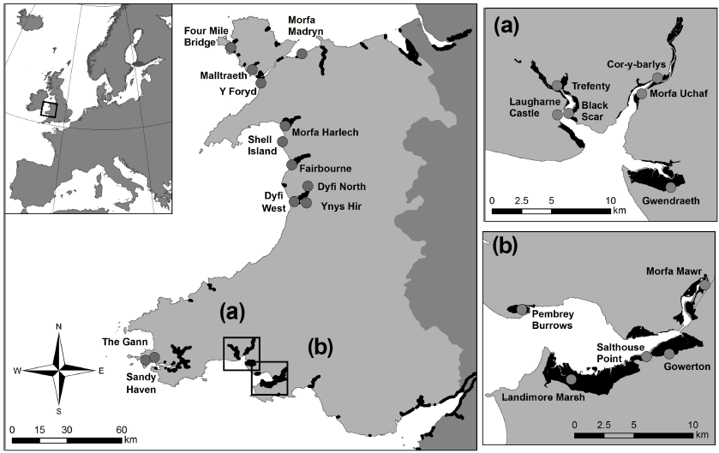
Source: Ford et al., 2019
Image 4 Location of Welsh saltmarsh study sites investigated by Ford et al. (2019)

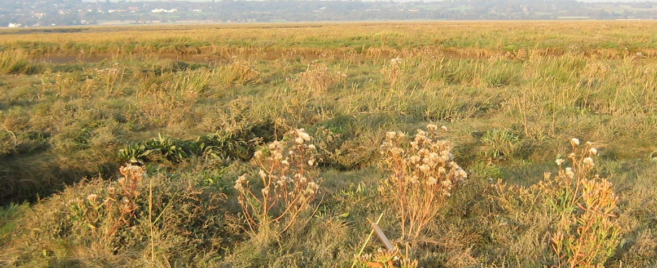
Source: ABPmer
Image 5 Saltmarsh (in the Dee Estuary)
For the purpose of this study, the following values have been applied for saltmarsh:

- Biomass standing stock: 0.21 kg m⁻². This has been taken from the report by Burrows et al. (2014), prepared for Scottish Natural Heritage (SNH) for Scotland.
- Soil standing stock: 4.2 kg m⁻² (top 10 cm). This is the average of values reported for 51 Welsh samples, as taken across 23 saltmarshes (see Ford et al. (2019) supplementary material).
- Sequestration: 0.084 kg m⁻² yr⁻¹. This has been calculated as a 2 mm proportion of the soil stock value. 2 mm accretion per annum was assumed for this (and all other intertidal habitats). It is noteworthy that higher values of 0.125 to 0.21 kg m⁻² yr⁻¹ have been quoted in the literature. However, applying a proportion of the standing stock is a) consistent with the methodology adopted for other habitats (e.g. see seagrass below), and b) likely to be more applicable to Welsh conditions, as the stock value was derived from a Welsh study.

    - Mudflat and sandflat

Background

Intertidal mudflats and sandflats are areas of unconsolidated sediment (Lopez-Calderon et al., 2015), characterised by marshy, muddy, sandy or mixed-sediments, that become exposed at low tide. Intertidal mudflats in the UK cover approximately 2,700 km².

Welsh context

There are around 433 km² of ‘bare’ intertidal flats in Wales (i.e. excluding those areas vegetated with seagrasses or populated by shellfish as mapped by this study), with the largest extents found in the Severn Estuary and Carmarthen Bay (and its estuaries). The area and quality of mudflats is thought to be declining in Wales, with increases in sea-level rise likely to have a significant impact on such habitats, particularly around estuaries and along sections of defended coast. It is possible that, depending on suspended sediment concentrations in the water column most UK mudflat environments could to keep pace with current rates of sea level rise due to accretion / sedimentation (and roll back) and thus potentially sequester carbon long-term (NRW, 2016). This is also dependent on management measures, such as those prescribed by Shoreline Management Plans (SMPs).

Intertidal mudflats and sandflats are listed in Annex I of the Habitats Directive and mudflats are also a habitat of principal importance under Section 7 of the Environment (Wales) Act 2016. Intertidal flats also frequently form a major component of two encompassing ‘habitat’ features, namely ‘estuaries’ and ‘large shallow inlets and bays’. Many Welsh intertidal flats are furthermore protected as features of SACs or SSSIs, and / or constitute supporting habitats for the bird interest features of many SPAs. For example, the following SACs contain ‘mudflats and sandflats not covered by seawater at low tide’ as a designated feature (Welsh Government, 2018):

- Y Fenai a Bae Conwy / Menai Strait and Conwy Bay SAC;
- Dee Estuary / Aber Dyfrdwy SAC;
- Carmarthen Bay and Estuaries / Bae Caerfyrddin ac Aberoedd SAC;
- Pen Llyn a'r Sarnau SAC;
- Pembrokeshire Marine / Sir Benfro Forol SAC;
- Severn Estuary / Môr Hafren SAC; and
- Glannau Môn: Cors heli / Anglesey Coast: Saltmarsh SAC.

Carbon storage and sequestration

Mudflats and sandflats can store and sequester carbon in both organic and inorganic (carbonate) forms. Sanders et al. (2010) found intertidal mudflats close to mangrove forests, in Tamandare (Eastern Brazil), to be sites of large organic carbon accumulation; storing almost four times the global average for sequestration in mangrove forests. The authors suggest that large fluxes of organic carbon produced and sequestered in mangrove forests are deposited and stored in mangrove margins and intertidal mudflats. In this way, intertidal mudflats may be sites of higher total organic carbon accumulation compared to sediments from mangrove forests and may be considered significant in the coastal ocean total organic carbon budgets (Sanders et al., 2010). Similarly, Cook (2002) found organic matter present in estuarine mudflats in Tasmania did not originate within the mudflats, instead having predominantly terrestrial sources, such as near shore estuarine transport (driven by riverine input) as well as direct terrestrial run-off and reworking of glacial and post-glacial sediments. Chaeho et al. (2019) studied organic carbon content in mudflat sediments (and other coastal wetlands) in South Korea and found that carbon storage in these tidal flats ranged from 18.2 to 28.6 kg C m⁻².

In England, Wood et al. (2015) collected surface sediment samples across English mud and sandflats in Essex and around Morecambe Bay. The available data shows that the percentage of carbon (dry weight) contained in intertidal flat sediments ranges from 0 to 7.5 %, with the average for Essex samples being 2.5 %, and the average for Morecambe Bay sites being 0.4 %; there being a clear correlation between mud and carbon content, as illustrated in Table 4. There was furthermore a relatively high CaCO₃ content in the samples, ranging from 1.3 % to 23 %, with averages listed in Table 4. Carbon can be assumed to make up 12 % of the mass of CaCO₃ (Van der Schatte et al., 2018). In simplistic percentage terms, the inorganic carbon content in intertidal flats could add an additional 1 to 1.6 % of carbon to the carbon budget of intertidal flats. When undertaking their study of Welsh saltmarshes, Ford et al. (2019) did not take mudflat samples (personal communication H. Ford / ABPmer, February 2020).

Table 4 Sediment composition for Essex and Morecambe Bay intertidal flats
Parameter | Average values across mudflat samples
 | Morecambe (n=396) | Essex (n=396)
% silt and clay | 13.37 | 78.80
% Water* | 23.90 | 48.36
% organic carbon* | 0.36 | 2.47
% CO₂* | 3.69 | 5.85
% CaCO₃* | 8.39 | 13.31
* As % composition (dry weight)
Calculated using data available at: https://catalogue.ceh.ac.uk/documents/d4e9f0f7-637a-4aa4-b9df-2a4ca5bfaded (last accessed February 2019)

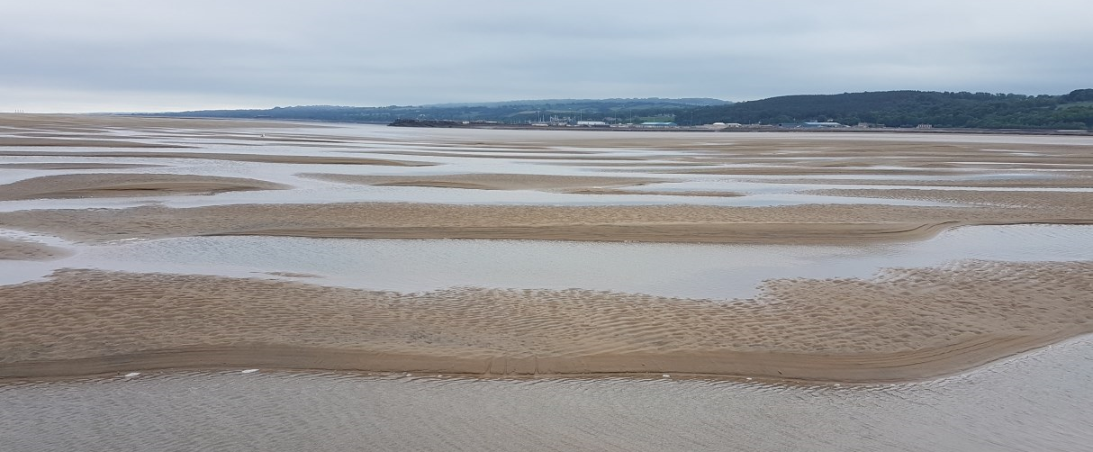Source: ABPmer
Image 6 Sandflat habitat (in the Dee Estuary)

For the purpose of this study, the following values have been applied for intertidal flats:

- Soil standing stock: 0.55 - 1.84 kg m⁻² (top 10 cm). These values have been derived by multiplying the individual sediment class values calculated by Diesing et al. (2017) for subtidal habitats (please see Section 5.5.5) by a factor of two. This is due to the latter authors highlighting that nearshore sediments hold more carbon. It is considered that this likely represents a conservative approach. Please refer to Section 10 / Appendix A for individual values applied for each sediment class.
- Sequestration: 0.011- 0.037 kg m⁻² yr⁻¹. This is a proportion of standing stock, assuming an accretion rate of 2 mm yr⁻¹ (this has been applied for all intertidal habitats - please see Footnote 3 for rationale).

    - Vegetated rocky shores

Background

Rocky shore habitats are relatively stable and provide secure surfaces for living things to attach to and hide within. The typical rock, which makes up a shore will vary, which in turn determines the type of animals, plants and algae that will colonise the area.

Welsh context

There are around 31 km² of mapped intertidal vegetated rocky shores in Wales, most commonly vegetated by algal communities dominated in biomass by large wracks / Fucus species (F. vesiculosus, F. serratus, F. spiralis), as well as brown seaweeds Pelvetia canaliculata, Ascophyllum nodosum and Laminaria digitata (kelp). These habitats are found along all Wales’ coastline, from estuaries to relatively exposed coasts. Notable areas include Pembrokeshire, the Lleyn Peninsula (Gwynedd) and Anglesey.

Many vegetated rocky shores types present in Wales form part of an Annex I (Habitats Directive) feature, namely ‘reefs’, which are defined as (mostly subtidal) ‘rocky marine habitats or biological concretions that rise from the seabed’. This habitat is the amongst the primary reasons for designation for the following Welsh SACs (Welsh Government, 2018):

- Cardigan Bay / Bae Ceredigion;
- Pembrokeshire Marine / Sir Benfro Forol;
- Pen Llŷn a'r Sarnau / Lleyn Peninsula and the Sarnau;
- Severn Estuary / Môr Hafren; and
- Y Fenai a Bae Conwy / Menai Strait and Conwy Bay.

Furthermore, several rare seaweeds present in these Welsh habitats are listed as species of principal importance in Wales (under Section 7 of the Environment (Wales) Act 2016).

Carbon storage and sequestration

As burial of carbon is precluded in rocky habitats, there is limited insight into the role of rocky shore vegetation on carbon accumulation and transport. Studies like Hanley and La Pierre (2015) suggest that carbon storage and sequestration are limited in these habitats as ‘detritus does not accumulate in rocky shore ecosystems and contribute to the formation of soil; instead, it is largely exported to adjacent beaches and other benthic marine ecosystems’ and, therefore, conclude there are limited opportunities for consumers to influence nutrient recycling within the ecosystem. It is then presumed that nutrients and energy stored within kelp are exchanged with adjacent ecosystems that are more influential to the carbon cycle. Similarly, macroalgal-derived matter is assumed to decompose too quickly to allow for long‐range export and burial (Howard et al., 2017; cited in Pessarrodona et al., 2018).

There is growing evidence, however, that suggests macroalgae-derived carbon may be transported to habitats hundreds of kilometres away from the source and / or being sequestered in deep-sea surficial sediments (Hobday, 2000). This transfer of carbon is an invaluable input for habitats with low autochthonous productivity, such as offshore sedimentary habitats (Krumhansl and Scheibling, 2012) and can contribute to carbon storage if they accumulate within habitats with long‐term carbon burial capacity, such as seagrass meadows or offshore depositional sediments (Hill et al., 2015). Similarly, studies such as Smale et al. (2013) suggest that production by intertidal kelp ecosystems is simply overlooked (and therefore underestimated); they argue that an estimation by Dayton (1985), that ‘kelp may account for 45% of primary production in UK coastal waters, and 12% of marine production in the entire UK’ did not include the extensive shallow subtidal rocky reef habitats found off England and Wales. Mann (2000; cited in Smale et al., 2013) also suggested when primary productivity rates of intertidal macroalgae are compared with subtidal macroalgae, intertidal production is typically 10%-20% of that from the subtidal, suggesting intertidal kelp habitats assimilate enough carbon to contribute substantially to primary production in coastal waters off the UK and Ireland (Smale et al., 2013).

Furthermore, Ning et al. (2019) suggest that a large fraction of carbon stored in consumer biomass in an intertidal rocky shore (Mirs Bay, China) originated from intertidal macroalgae and epiphytes within that habitat, and as such was acting as a blue carbon ‘sink’. It was noted, however, that suspended particulate organic matter (SPOM) collected from offshore areas was the most important production source supporting the biomass of the consumers. It was suggested that the selected carbon source depends on the composition of species within a rocky shore and, therefore, on feeding mode; with filter-feeding invertebrates principally feeding on suspended macroalgal detritus (Kang et al., 2008; cited in Ning et al., 2019) and phytoplankton and grazer limpets and chitons selecting epiphytes. These primary consumers are then predated upon by intertidal and offshore-based secondary grazers and facilitate the transfer of detrital carbon into offshore areas, fuelling the sequestration of carbon in living biomass as well as detritus that will eventually settle in offshore sediments (Pessarrodona et al., 2018).

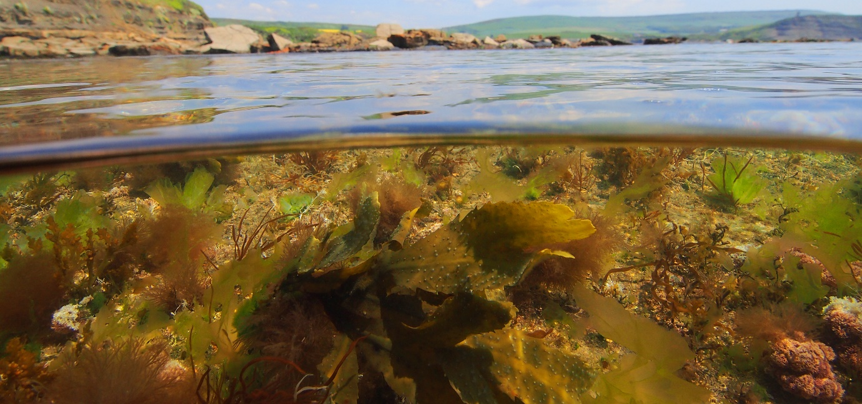
Source: Andy Pearson
Image 7 Intertidal macroalgae
For the purpose of this study, the following value has been applied for intertidal macroalgae biomass standing stock (noting that soil stock and sequestration are not applicable in this case, as discussed above): 0.047 kg m⁻². This represents 10% of the subtidal value (see Section 5.5.2) (applying a relationship quoted by Smale et al., 2016).

  - Shallow subtidal habitats (with intertidal elements)

    - Seagrass beds

Background

Seagrass beds develop in intertidal and shallow subtidal areas, typically up to 10 m depth, which are sheltered from significant wave action. Three species of Zostera occur in the UK; Dwarf eelgrass (Z. noltii), narrow-leaved eelgrass (Z. angustifolia) and eelgrass (Z. marina).

Welsh context

There are around 7.3 km² of mapped seagrass beds in Wales, with the largest extents found around Anglesey and in Milford Haven. Seagrasses are deemed as scarce in Wales (present only in 16–100 ten km squares) (Stewart and Williams 2019), although not necessarily declining. NRW (2016) note that ‘intertidal seagrass beds have increased in extent’ although the timescales over which this change has occurred are unclear.

Seagrass beds are a habitat of principal importance under Section 7 of the Environment (Wales) Act 2016. Many Welsh seagrass beds are furthermore located within designated sites, where they are protected as features of SACs or constitute a component of sheltered bays, although they are not an ‘Annex I’ habitat in their own right. Notable seagrass habitats are for example included in the Pembrokeshire Marine / Sir Benfro Forol SAC, which supports extensive beds of the narrow-leaved eelgrass Z. angustifolia. Also, seagrass is listed as a feature in the following SSSIs (Welsh Government, 2019):

- Beddmanarch – Cymyran;
- Burry Inlet and Loughor Estuary;
- Milford Haven Waterway;
- Porth Dinllaen i Borth Pistyll;
- Severn Estuary;
- Tiroedd a Glannau Rhwng Cricieth ac Afon Glaslyn;
- Traeth Lafan;
- Twyni Chwitffordd, Morfa Landimor a Bae Brychdwn / Whiteford Burrows etc; and
- Y Foryd.

Carbon storage and sequestration

Seagrass foliage slows water movement and sequesters CO₂ dissolved in seawater; storing organic carbon in the roots and rhizomes before exuding carbon into the soil, creating an anaerobic organic-carbon-rich sediment. It is estimated that between 5 and 18% of carbon is exuded into the soil (e.g. Holmer and Bondgaard, 2001), with 100% of this carbon being utilised by anaerobic bacteria in the seagrass sediments (Moriarty et al, 1986). The anoxic nature of marine seagrass sediments, paired with continual accumulation of sediment by seagrass foliage, low sediment hydraulic conductivity and slower microbial decomposition rates, facilitate carbon burial and the accumulation of carbon (Guy, 2010). The combination of these processes can preserve organic carbon in seagrass sediments over decadal to even millennial time scales (Kennedy et al., 2010; cited in Greiner et al., 2013). As such, it has been suggested that, although these plants only cover a relatively small area of the global ocean floor (0.1-0.2%), they are responsible for between 10 and 18% of the total carbon storage in the ocean (Laffoley and Grimsditch, 2009; Green et al., 2018).

The majority of blue carbon accumulated in seagrass habitats is stored in seagrass sediments; globally, an average of 2.51 ± 0.49 Mg C ha⁻¹ is thought to be stored in the living biomass (roots and rhizomes) of seagrass compared to 194.2 ± 20.2 Mg C ha⁻¹ in sediment (Green et al., 2018). It has been estimated that seagrass sediment carbon accumulation ranges from 27.4 to as much as 48-112 Mt C yr⁻¹ (Laffoley and Grimsditch, 2009; Green et al., 2018). This translates to a mean net sequestration rate of 83 g C m⁻² yr⁻¹ and a total global storage of 19.9 Pg C (billion tonnes carbon) within the top 100 cm of the world’s seagrass sediments (Green et al., 2018).

A recent UK study demonstrated that carbon storage ability can increase with sediment depth; Green et al. (2018) compared carbon content in sediment cores taken from the upper 30 cm and 100 cm in subtidal seagrass sediments of 13 seagrass meadows in south-west England, and found 100 cm samples contained a carbon store three times higher than samples taken solely from the top 30 cm; 41.54 ± 4.54 Mg C ha⁻¹ (30 cm depth), 140.98 ± 73.32 Mg C ha⁻¹ (100 cm depth). Sediment profiles showed no change at depth (see Image 8). When converted to carbon stored to a depth of 25 cm, Green et al. (2018) determined that the studied (English) seagrass meadows fell within the upper range of those recorded in the rest of Europe. The authors state that ‘across Europe, estimates of Z. marina carbon stock vary considerably, ranging from 500 ± 50.00 g C m² to 4,324.50 ± 1,188.00 g C m⁻² in the top 25 cm of sediment. With an average carbon stock of 3,372.47 ± 1,625.79 g C m⁻², the UK is second only to Denmark’.

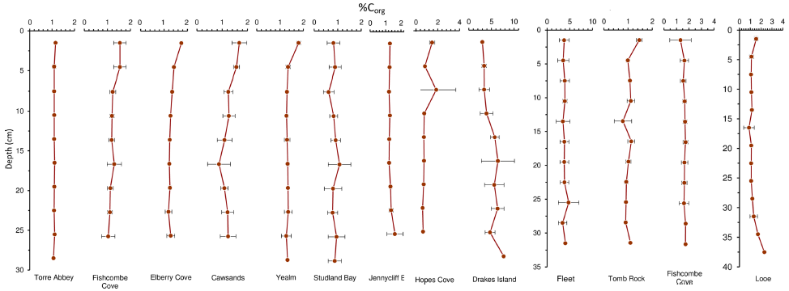
Source: Green et al., 2018
Image 8 Depth profiles of the seagrass sediment cores taken by Green et al. (2018); organic carbon (OC) expressed as a percentage of the dry weight

The anoxic nature of marine seagrass sediments, paired with continual accumulation of sediment by seagrass foliage, low sediment hydraulic conductivity and slower microbial decomposition rates, facilitate carbon burial and the accumulation of carbon stores.

The dense seagrass canopy above can reduce fine-grained sediment resuspension up to three times that of unvegetated sediments (Greiner et al., 2013), helping to trap sediments rich in organic matter. The combination of these processes can preserve organic carbon in seagrass sediments over decadal to even millennial time scales (Kennedy et al., 2010; cited in Greiner et al., 2013).

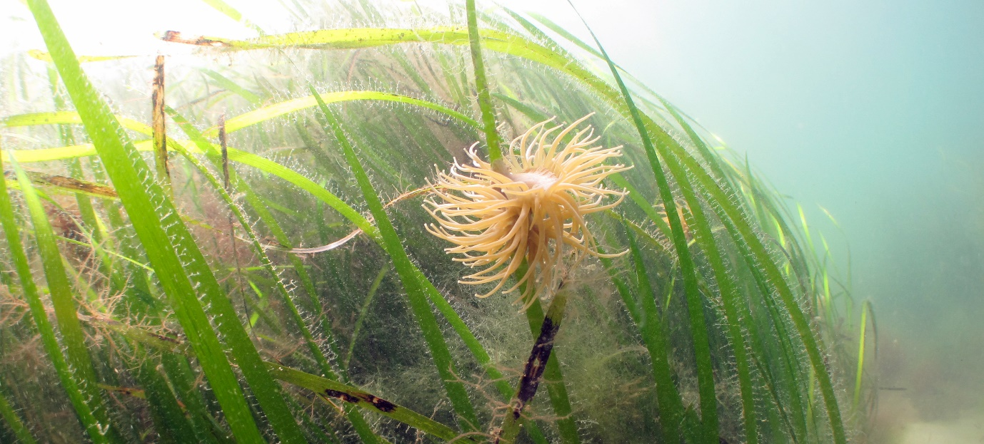
Source: Andy Pearson
Image 9 Seagrass

For the purpose of this study, the following values have been applied for seagrass:

- Biomass standing stock: 0.26 kg m⁻². This has been taken from the report by Burrows et al. (2014), prepared for SNH / Scotland.
- Soil standing stock: 1.35 kg m⁻² (top 10 cm). This was calculated by averaging values provided for 13 south-west English meadows by Green et al. (2018). As the latter authors only quoted values for the top 25 cm, a linear extrapolation was undertaken to arrive at a ‘top 10 cm’ value, after personal communication with the primary author of the study. This was to keep depth in line with that applied for all other habitats considered in this study (except for maerl (see Section 5.5.2)).
- Sequestration: 0.027 kg m⁻² yr⁻¹. Calculated as a 2 mm proportion of the soil stock value, assuming an accretion rate of 2 mm yr⁻¹ (as applied for all intertidal habitats, and also seagrasses, as they tend to be located in shallow subtidal to intertidal zones - please see Footnote 3 for rationale).

  - Subtidal habitats

    - Shellfish beds

Background

Four shellfish bed varieties have been considered for the purpose of this study, namely those formed by:

- The native oyster Ostrea. edulis; this is associated with highly productive estuarine and shallow coastal water habitats on firm bottoms of mud, rocks, muddy sand, muddy gravel with shells and hard silt.
- Musculus discors, a small bivalve; this is found in scattered, gregarious clumps growing epiphytically on the holdfasts of seaweeds and amongst faunal turfs from the lower intertidal to the circalittoral subtidal on most substrata.
- The common mussel Mytilus edulis; this from the high intertidal to the shallow subtidal attached by fibrous byssus threads to suitable substrata. Found on the rocky shores of open coasts attached to the rock surface and in crevices, and on rocks and piers in sheltered harbours and estuaries, often occurring as dense masses.
- The horse mussel Modiolus modiolus; this is part-buried in soft sediments or coarse grounds or attached to hard substrata, forming clumps or extensive beds or reefs. May be found on the lower shore in rock pools or in laminarian holdfasts, but more common subtidally to ca 280 m.

Welsh context

15.7 km² of shellfish beds have been mapped for the purpose of this study; 8.7 km² of this is horse mussel beds and 6.9 km² blue mussel beds. 0.01 km² of oyster beds have also been mapped; the locations of which are considered sensitive, and hence are not discussed here (but they have been included in the calculations). 0.16 km² of M. discors beds have been mapped; these are all located off the Lleyn Peninsula (Gwynedd). Significant horse mussel beds can be found to the north of the Lleyn Peninsula and Anglesey, whereas blue mussel beds have been mapped along the majority of the Welsh coastline. Native oyster and horse mussel beds around Wales have been suffering significant habitat loss since 2008 (NRW, 2016).

Please note that, for most shellfish beds, particularly horse mussels which, of all the species studied here, are found at the greatest depths, there is a large amount of uncertainty regarding the locations of such habitats. This is due to the mapping of these (and other subtidal) habitats relying heavily on observational surveying methods (including underwater video), and as such exact maps are difficult and time-consuming to obtain. Thus, it is considered highly likely that the areas quoted above represent an underestimate of these habitats in Welsh waters.
With regard to conservation importance, M. discors, horse mussel and blue mussel beds are habitats of principal importance, and native oyster are designated as a species of principal importance, under Section 7 of the Environment (Wales) Act 2016.

Carbon storage and sequestration

Shellfish assimilate carbon in the form of calcium carbonate, via shell production (Hickey 2008; cited in Van der Schatte et al., 2018), with carbon comprising (on average) 11.7% of shell material (Van der Schatte et al., 2018). During the calcification process, CO₂ is formed; potentially leading to an increase in the partial pressure of CO₂ in surface waters and the release of CO₂ to the atmosphere, especially in shallow well-mixed coastal waters where shellfish are typically farmed. As such, the calcification process, and therefore shellfish bed habitats, are often considered to be a source of atmospheric CO₂ (Fodrie et al., 2017).

Most of the studies on carbon sequestration / storage potential of oysters have focussed on American species. Fodrie et al. (2017) sampled 22 eastern oyster reefs (Crassostrea virginica) in Northern Carolina, United States, and found that only a subset of restored reefs had functioned as net CO₂ sinks, namely those fringing saltmarshes and those located in the shallow subtidal. Conversely, their data highlight that ‘CO₂-related climate mitigation is not a service that should be expected / promoted for intertidal reefs constructed over unstructured sandflats’. They concluded that ‘the role of shellfish reefs as CO₂ sources or sinks ultimately depends on the relative balance between organic and inorganic carbon burial’, with the filtration and subsequent deposition of particulate organic matter (as faeces) being the route to organic carbon burial.

Hickey (2008) calculated the amount of carbon sequestered per year in oyster farms, using shell carbon content, spat weight, grow‐out time and stocking density, to be between 3.81 and 17.94 t C ha⁻¹ yr⁻¹. Similarly, Higgins et al. (2011) estimated that one (American / Chesapeake Bay) oyster bed could remove a total of 13.47 ± 1.00 t C ha¹ yr¹ in a single growing season at a density of 286 oysters m².

These values are, therefore, highly dependent on oyster densities, even if American oysters were to have similar carbon producing characteristics to European oysters. Whilst Fodrie et al. (2017) did not specify density in writing, a figure contained within the paper indicates that live density would tend to be high (with a minimum around 100 individuals m⁻²). Welsh oyster beds are likely to be much more impoverished; for example, for two Welsh beds, Seasearch (2017) reported very low densities of 0.17 to 0.05 individuals m⁻².

Many authors however argue that carbon stored in shell represents a long‐term store; Collins (1986) studied a horse mussel bed at 160-190 m depth in the Firth of Lorn, Scotland and estimated a standing stock value of 8,543 t of CaCO₃ in the top 5 cm of superficial sediments, representing 1,025 t of stored carbon.

Horse mussels are large bivalves with robust shells that occur in dense beds, and as such, the accumulation of empty shells may be important sources of biogenic carbonate. M. modiolus beds are identified as habitats of principle importance (HPI) within the UK and Wales, and as such may store carbon for as long as they remain undisturbed. In the Firth of Lorn, M. modiolus accounted for 94% of carbonate standing stock in the mussel bed community, but only 38% of the estimated carbonate production (Collins, 1986). Instead, brachiopods, brittlestars, barnacles and ‘mussel mud’; an anoxic layer comprising of faeces, pseudo-faeces and sediment, accounted for the remaining community production. The very low production / biomass (P/B) ratio of M. modiolus (0.05) was attributed to a long lifespan (circa 40 years) and slow growth rate (Burrows 2014), and in consequence has a low area-specific carbonate production rate, estimated as 330 g CaCO3 m² yr⁻¹ in the Firth of Lorn (Collins, 1986; cited in Burrows et al., 2014) equivalent to 40 g C m² yr⁻¹. Most carbonate degradation is believed to take place at the sediment-water interface, with bioerosion on temperate shelves thought to require a timescale of centuries to several millennia for total shell destruction (Smith and Nelson, 2003), especially for large, robust shells such as those of M. modiolus. Furthermore, thick deposits of horse mussel shells have the potential to store carbon over a timescale of 1,000 years (Burrows et al., 2014), with ‘mussel mud’ potentially storing carbon for longer (Mainwaring et al., 2014).

No relevant literature on carbon sequestration rates in relation to blue mussel or M. discors beds could be located; instead, assumptions have been made based on the horse mussel and oyster literature presented above (see Table 5 for details).

For the purpose of this study, the following values have been applied for shellfish:

- Biomass standing stock: not available / applicable; shell ‘calcimass’ would essentially be incorporated into soil standing stock (see Burrows et al., 2014).
- Soil standing stock: 0.13 to 4 kg m⁻² (top 10 cm) (lowest values for oysters, highest for horse mussel, see Appendix A for all values). Taken from Burrows et al., 2014 for horse mussels; for all other shellfish categories: derived by applying same relationship as used by latter authors for horse mussels.
- Sequestration: 0.001 to 0.04 kg m⁻² yr⁻¹ (lowest values for oysters, highest for horse mussel, see Appendix A for all values). Oyster value is 1 % of US value quoted by Fodrie et al. (2017), on the basis that Welsh oyster beds tend to have very low densities when compared with US beds, as noted above. Horse mussel values taken from Burrows et al., 2014. For blue mussels and all other mussels, 10 % of the horse mussel value was applied as an estimate on the basis that horse mussels are significantly larger than these other mussels.

    - Macroalgae

Background

Subtidal macroalgae have a global distribution, being present along around 25% of the world’s coastlines in temperate and polar regions. They are generally found living attached to rock or other hard substrates in the shallow region of coastal areas and can range in size from microscopic phytoplankton and small coralline algae which form spikey underwater maerl ‘beds’, to large kelps that form vast underwater ‘forests’.
UK coastlines are home to more than 650 species of macroalgae, representing approximately 14% of the world’s known marine seaweeds, and host seven out of 14 European kelp species (Stewart and Williams, 2019).

Two key types of subtidal macroalgae have been considered for this report; kelp and maerl. Kelps are defined as large brown seaweeds that make up the order Laminariales. Key species present within the WNMP include Laminaria digitata and L. hyperborea; which are found attached to bedrock or other suitable hard substrata in the lower intertidal and sublittoral fringe, down to a maximum depth of 20 m to 30 m in clear waters (MarLIN, 2020).

Unlike fleshy macroalgae, maerl has a calcium carbonate skeleton and does not break down quickly, thus forming long-lasting maerl beds that are populated by invertebrate and vertebrate biota (Burrows et al., 2014). Two key maerl species are observed in British waters, Phymatolithon calcareum (common maerl) and Lithothamnion corallinoides (coral maerl). Both are typically found together, in less than 20 m depth on sand, mud or gravel substrata in areas that are protected from strong wave action but have moderate to high water flow (MarLIN, 2020).

Welsh context

This study estimates that there are at least 80.4 km² of subtidal macroalgae in Wales, most commonly vegetated by kelp, although 0.2 km² of ‘live’ maerl can be found. The latter is exclusively located in Milford Haven, whereas the mapped kelp beds are located along much of the Welsh shoreline with lower suspended sediment loads, with notable concentrations around the Lleyn Peninsula (Gwynedd), Anglesey, and in Milford Haven.

With regard to kelp, it should be noted that there is a large amount of uncertainty regarding the locations of subtidal kelp beds around Wales; the mapping of these habitats relies heavily on observational surveying, and as such exact maps are difficult and time-consuming to obtain. For this study, the data has been taken from the JNCC EUNIS Combined Map (see Section 4.3.2), where specified, and the area quoted above is considered to be an underestimate.

With regard to conservation importance, no macroalgae beds are listed in Annex I of the Habitats Directive. Kelp beds are not considered to be of principal importance in Wales (under Section 7 of the Environment (Wales) Act 2016), but maerl beds are (as both habitats and plant species). Many kelp beds, however, fall within designated sites; for example, kelp is mentioned as an important component of the ‘reef’ feature in the Pen Llyn a'r Sarnau / Lleyn Peninsula and the Sarnau SAC.

Carbon storage and sequestration

Kelp

Like intertidal macroalgae, it is thought that carbon from subtidal kelp is not stored long-term within kelp beds and instead algal detritus is exported to other habitats via dislodgement and transport or through consumption and egestion / defecation by consumers. Thus, kelp supports numerous coastal food webs, particularly benthic suspension-feeding organisms in rocky areas (such as mussels and barnacles), grazers such as limpets, and organisms in soft sediment areas. It has been theorised however that the majority (>80%) of kelp production enters the carbon cycle as detritus / DOC (Smale et al., 2013); also, the readiness with which kelp detrital material is consumed by detritivores and broken down by microbial activity suggests a minimal amount of production is incorporated into long-term stores.

Kain’s (1979) study determined that standing stock of kelp diminishes rapidly with depth, with only 10% of surface value density present at 12-25 m depth when compared to shallower kelp stocks (0-9 m range). Burrows et al. (2014) applied a value of 187.7 g organic carbon m⁻² for their Scottish study, for areas where kelp was identified as being ‘abundant’ (>20% cover).

Smale et al. (2016) surveyed 12 UK kelp forests dominated by L. hyperborea, three of which were in Wales (all near St. Brides, Pembrokeshire), three in Devon (south-east of Plymouth) and the rest in Scotland. The depth at these sites ranged between 4 m and 7 m. It was found that regional averages for total standing stock of carbon differed markedly between the two northernmost regions and the two southernmost regions; with values in the two Scottish regions being highest (Region A: 1,146 ± 380 g C m⁻²; Region B: 808 ± 324 g C m⁻²), followed by the Devon sites (575 ± 96 g C m⁻²), with the carbon stock at the Welsh sites being lowest (355 ± 38 g C m⁻²). The authors did not elaborate on reasons for different values for their ‘southern’ sites (i.e. Wales and Devon), but suggested that Scottish values are higher due to a combination of cooler water temperatures, higher light levels, longer summer days and often increased wave exposure, all of which promote greater kelp biomass. The Smale et al. (2016) study-wide average for carbon contained within kelp forests was 721 ± 140 g C m⁻², with the vast majority (~86%) stored in canopy-forming, rather than sub-canopy, plants.

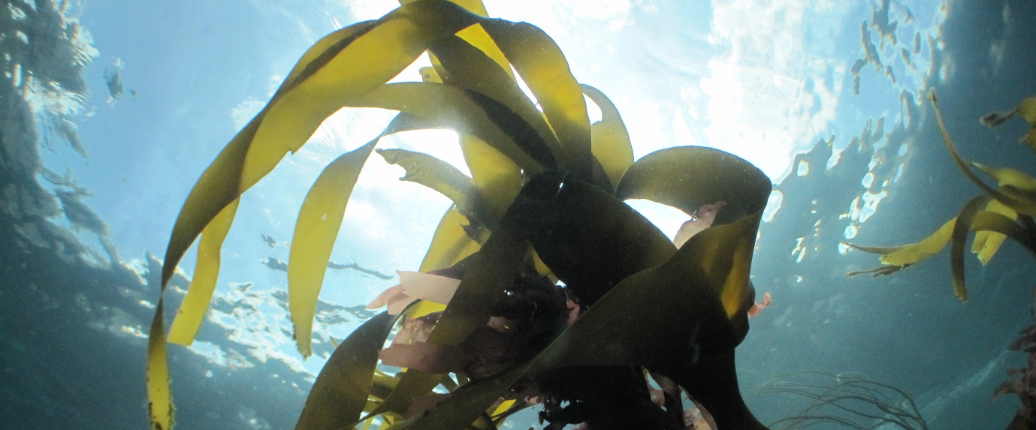
Source: Andy Pearson
Image 10 Kelp

Maerl

Maerl deposits act as a longer-term store for organic and inorganic carbon and lock-in calcifying biota. The rate of maerl deposit accretion is generally slow (0.25 mm yr⁻¹); however, beds can be extensive. Scottish species-specific accretion rates varied from 420 to 1,432 g CaCO₃ m⁻² yr⁻¹ in a study by Freiwald and Henrich. (1994) (cited in Burrows et al., 2014). Live maerl deposits on the west coast of Scotland can reach at least 60 cm depth with some dead deposits residing significantly deeper (Kamenos, 2010). Burrows et al. (2014) applied an annual (inorganic) carbon sequestration rate of 0.074 kg m⁻² for the purpose of their Scottish study.

As noted above, Welsh maerl covers a very small area, limited to Milford Haven, and is currently classed as ‘degraded’. As such, it is unlikely that Welsh maerl contributes substantially to carbon sequestration in Welsh waters, and a smaller rate has thus been applied for the purpose of this study (see Table 5 for more detail).

For the purpose of this study, the following values have been applied for subtidal macroalgae:

- Kelp: 0.47 kg m⁻² for biomass standing stock (noting that soil stock and sequestration are not applicable in this case, as discussed above). This value was calculated by averaging numbers derived by Smale et al. (2016) for three Welsh and three Devon sites. As the three Welsh study sites were all immediately adjacent to each other, they were considered not fully representative, and Devon being relatively close to Wales, Devenish kelp was considered as being in the same bioregion. It is worth noting that the Scottish sites studied by Smale et al. (2016) averaged 0.97 kg m⁻², whereas Burrows et al. (2014) applied a value of 0.19 kg m⁻² for Scottish beds
- Maerl:
  - Biomass standing stock: 0.09 kg m⁻² (for live maerl). This represents one fifth of the value applied by Burrows et al., 2014 (as Welsh beds are dominated by P. calcareum species, which sequesters approximately one fifth less than Lithothamnion glaciale, and also as Welsh beds are considered degraded (see above));
  - Soil standing stock: 12.4 kg m⁻² (top 60 cm) (for live and dead maerl beds). Again, this is one fifth of the value applied by Burrows et al. 2014, for same reasons as quoted in previous bullet.
  - Sequestration: 0.0095 kg m⁻² yr⁻¹. Represents minimum sequestration rate quoted for P. calcareum by Burrows et al. 2014.

    - Brittlestar beds

Background

The main bed-forming brittlestar species, the common brittlestar (Ophiothrix fragilis), has five fragile arms that are long and spiny. It is found from the lower shore to circalittoral offshore habitats on hard substrata including bedrock, boulders and on coarse sediment, and most abundant on tide-swept rock and on mixed coarse sediments. In the intertidal, the species is found in crevices and under boulders (MarLIN, 2020).

Welsh context

This study mapped only 0.07 km² of brittlestar beds, mostly off the Pembrokeshire coast. This is likely to be a large underestimate, as individual records of brittlestars indicate very widespread presence in Wales (see, for example, the NBN Atlas, 2020). Similarly, drop-down video surveys of the Wylfa Newydd Development Area in the North of Anglesey, as well as NRW surveys in this area, have found extensive brittlestar beds (NRW, personal communication). Thus, more beds are likely to exist.

Brittlestars or their beds are not listed in Annex I of the Habitats Directive, nor are they considered to be of principal importance in Wales (under Section 7 of the Environment (Wales) Act 2016), as either a species or habitat.

Carbon storage and sequestration

As echinoderms, brittlestars have an endoskeleton of calcareous plates, and due to their abundance in virtually all benthic environments, they may play an important role in the marine carbon cycle (Lebrato et al., 2010; cited in Burrows et al., 2014). For example, a one-year study of an O. fragilis bed located in the Dover Strait, England found that this averaged 1,229 individuals m⁻², representing 555 g CaCO₃ m⁻², equivalent to 66.2 g C m⁻². A sequestration rate was also calculated for the same bed, at a rate of 82 g C m⁻² yr¹ (Migné et al., 1998; cited in Burrows et al., 2014).

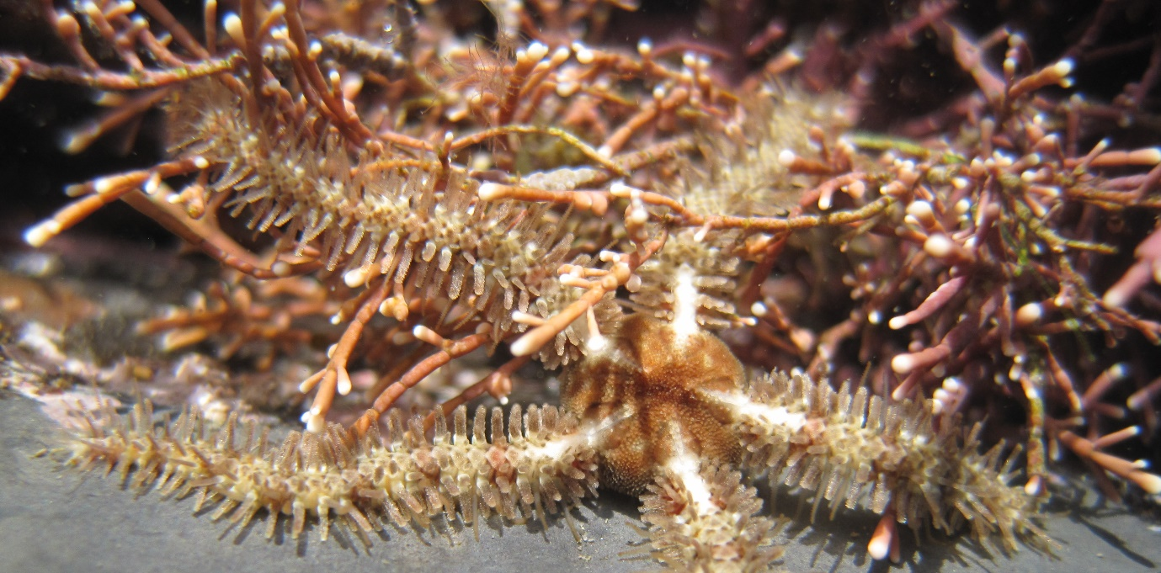
Source: Andy Pearson
Image 11 Brittlestars

After death, brittlestar skeletons will disaggregate and individual calcareous plates will become incorporated into the bottom sediments (Lebrato et al., 2010; cited in Burrows et al., 2014), forming ‘Echinoderm sands’ containing a high proportion of echinoderm skeletal particles, along with fragments of other shell-forming organisms that have been described within the coastal zone of Australia (Brunskill et al., 2002; cited in Burrows et al., 2014). Brittlestar skeletal fragments will be subject to the same processes of bioerosion and chemical dissolution as carbonates produced by corals, serpulids or bivalves, and their longevity in sediments will, therefore, depend on the local environment (Walker and Goldstein, 1999; cited in Burrows et al., 2014).

For the purpose of this study, the following values have been applied for brittlestar beds:

- Biomass standing stock: None, as no value could be found in the literature, and as the brittlestar contribution to biomass stock in Wales would be negligible due to the limited area mapped (see above).
- Soil standing stock: 0.0116 kg m⁻² (top 10 cm). No specific value could be found in the literature for brittlestar beds, but this study applied the same value as derived for subtidal sandy gravel (see Appendix A), as brittlestars are normally found on coarse sediment.
- Sequestration: 0.082 kg m⁻² yr⁻¹. Taken from Burrows et al., 2014.

    - Faunal turf

Background

'Faunal turfs' are assemblages of attached animals growing on hard substrata. These organisms can vary substantially in growth form, 'turf' being used in a highly generic sense. They will range from low encrusting forms less than a centimetre high, such as many ectoprocts (sea mats) and sponges, to tall erect forms such as alcyonarians (soft corals) and gorgonians (sea fans) which may exceed 25 cm in height (Hartnoll, 1998).

Welsh context

2.1 km² of Welsh subtidal faunal turf was mapped for the purpose of this study. The presence of larger extents of such turfs is expected, as individual records for the species typically present in such turfs abound in Wales (e.g. NBN Atlas (2020) records for the bryozoan Alcyonidium diaphanum, the hydroid Halecium halecinum and the sponge Scypha ciliate, to name but a few of the fauna typically present amongst such turfs).

Faunal turfs are not listed in Annex I of the Habitats Directive, nor are they considered to be of principal importance in Wales (under Section 7 of the Environment (Wales) Act 2016).

Carbon storage and sequestration

Literature on carbon content or storage associated with faunal turfs is sparse. Two papers were used to estimate a carbon storage rate for these habitats (see Table 5). Firstly, a paper from New Zealand (Taylor, 1998) which gives examples of ash free dry weight of similar faunal turf habitats (urchin barrens and turf flats) as 26 to 42 g m⁻². No literature on carbon content of faunal turf could be located, but a paper on such content of Euphausiacea determined a range of 36-46% carbon (as a proportion of total dry weight) (Lindley et al., 1999).

For the purpose of this study, the following biomass value has been applied for faunal turf (noting that soil standing stock and sequestration are considered not applicable for this study, as this habitat is mostly found on rock): 0.014 kg m⁻². This value was calculated for this study using the weight values quoted by Taylor (1998), and assuming 40% carbon (as per Lindley et al., 1999).

    - Sedimentary habitats (surficial sediment)

Background

Connor et al. (2004) define subtidal sediments as: ‘Sediment habitats in the sublittoral near shore zone, typically extending from the extreme lower shore down to the edge of the bathyal zone (200 m)’. For the purpose of this study, any sedimentary habitat which is not rock has been classed according to the Folk system and mapped.

Welsh context

There are 29,514 km² of subtidal muds, sands and gravels in Welsh waters; 7% of this is predominantly muds, 52% sands and 41% gravels.

‘Sandbanks which are slightly covered by sea water all the time’, ‘estuaries’ and ‘large shallow inlets and bays’ are all ‘habitats’ listed in Annex I of the Habitats Directive which contain subtidal sedimentary habitats. Several Welsh marine SACs contain such habitats, and they often constitute supporting habitats for the bird interest features of Welsh SPAs. For example, one of the primary reasons for the selection of the Severn Estuary / Môr Hafren SAC as such a site is its ‘estuaries’ feature; with ‘sandbanks which are slightly covered by sea water all the time’ being listed as a qualifying feature. The following sublittoral sediment categories are considered habitats of principal importance in Wales (under Section 7 of the Environment (Wales) Act 2016):

- Tidal swept channels;
- Subtidal mixed muddy sediments;
- Mud habitats in deep water; and
- Subtidal sands and gravels.

Carbon storage and sequestration

Surficial sediments, and particularly deep-sea sediments, are the primary marine store of biologically-derived carbon (Burrows et al., 2014). Carbon may be sequestrated as precipitated carbonates or as POC, with the latter being a small proportion of the POC present in the water column (either produced there or derived from terrestrial sources) which has sunk to the seabed and has then been incorporated into surface sediments. Sedimented carbon can potentially remain sequestered in the seabed for decades to centuries, depending on physical processes (such as particle movement, bedform migration due to storms and tides, water column temperature) and biological processes (including infaunal activity and mode of feeding). Additionally, POC supply, incorporation and storage may be disturbed by human activities such as bottom trawling (Jenness and Duineveld, 1985; Diesing et al., 2017; Luisetti et al., 2019).

Sediment characteristics are also thought to influence carbon sequestration capacity; Diesing et al. (2017) analysed 849 sediment samples taken from the north-west European continental shelf adjacent to the North–East Atlantic Ocean, and calculated POC concentration and dry-bulk density for each sample according to sediment class, based on Folk (1954). The authors’ results supported ”the concept that the highest concentrations of POC are associated with muddy sediments”. However, the study determined that these did not always translate into the highest values in terms of mass per unit area, as dry bulk densities of muddy sediments were usually low. Rather counterintuitively, Diesing et al. (2017) found that muddy sediments (mud, slightly gravelly mud, slightly gravelly sandy mud, sandy mud, gravelly mud) contributed little to the total POC stock ‘due to their spatially restricted areas and low dry bulk densities’. Conversely, sand, slightly gravelly sand and gravelly sand contributed 71 % of the POC stock ‘due to high dry bulk densities and widespread occurrence in the study area’. An average of 390.4 t POC km⁻² for the standing stock of POC in the top 10 cm of shelf sediments was concluded, and a total POC stock value of 476 Mt C calculated for the top 10 cm of sediments on the NW European Continental Shelf (1,111,812 km²).

Similarly, Burrows et al. (2014) calculated a total standing stock of organic carbon in Scotland’s marine sediments to be 18.1 Mt C (covering an area of approximately 470,000 km²), and that of inorganic carbon to be 1,738 Mt C. The authors assumed that Burrows et al. (2014) estimated carbonate storage for Scottish marine sediments using British Geological Survey (BGS) data on carbonate content from sediment cores and estimate carbonate storage in surficial sediments based on sediment type. Carbonate content varied from less than 10% in some offshore muddy sediments to up to 30-90% in carbonate rich gravels. The amount of carbon associated with carbonates was then calculated on the assumption of the density of calcite being around 2,800 kg m⁻³, and 12 % of that being carbon. Further multiplying the total volume of carbonate by density and percentage carbon in calcite provided the estimate of carbon mass as standing stock. It is noteworthy that the authors remarked that Scottish sediment generally held more carbonate than other UK regions, but did not provide values for other areas.

For the purpose of this study, the following values have been applied for subtidal sediments

- Biomass standing stock: not applicable.
- Soil standing stock:
  - 0.28- 0.92 kg m⁻² (top 10 cm, per sediment type) for POC. These values were derived from Diesing et al., 2017 (noting that the lead author was contacted to ensure the correct formula was applied, as no direct unit values were supplied in this paper); 3.36 kg m⁻² (top 10 cm) for carbonate. This value has been calculated based on relationships quoted in Burrows et al., 2014, and a conservative assumption of 10% carbonate across all sediments. Please note that this carbonate value was also applied to intertidal sedimentary habitats, as well as non-rocky biogenic habitats.
- Sequestration: 0.0003 - 0.0009 kg m⁻² yr⁻¹. This has been calculated as a 0.1 mm proportion of the soil stock value per sediment type. 0.1 mm accretion per annum was assumed for all subtidal sedimentary habitats (as sedimentation over subtidal habitats is typically negligible, but some would occur, particularly in the shallower nearshore areas, and in areas such as the Bristol Channel where suspended sediment loads are relatively high (e.g. Collins, 1983)). This compares with annual sequestration values applied by Burrows et al., 2014 of 0.041 kg m⁻² yr⁻¹ for fine sediments and 0.0002 kg m⁻² yr⁻¹ for coarse sediments. Further, Nelleman et al. 2009 estimated shelf sequestration at 0.02 m⁻² yr⁻¹, whilst Thomas et al. 2005 stated that shelf sequestration was negligible.

  - Summary

Table 5 below summarises the carbon storage and sequestration values adopted for this study, based on the above literature review, for those habitats relevant to Welsh waters. For ease of comparison, all values are reported in kg per square metre. A brief justification is again included in the table, and confidence in the presented / derived rates assessed. For an extensive table providing a more comprehensive breakdown of values, as well as justification and comparison with other values in the literature, please refer to Appendix A (presented as Section 10). Where no value is given, then a given carbon function is not applicable to the habitat in question (e.g. no sequestration on rocky habitats such as kelp).

Table 5 Summary of carbon sequestration and storage values per studied habitat
Sedimentary area / habitat | Carbon Rate | Parameter (unit) | Source / Justification | Confidence
Intertidal (organic carbon)
Saltmarsh | 0.21 | Biomass standing stock (kg m⁻²) | Taken from Burrows et al., 2014 | M
 | 4.20 | Soil standing stock (kg m⁻²*) | Average of 51 Welsh samples (Ford et al., 2019). | H
 | 0.084 | Sequestration (kg m⁻² yr⁻¹) | Proportion of stock value (2 mm yr⁻¹ accretion) | M-H
Intertidal macroalgae | 0.0465 | Biomass standing stock (kg m⁻²) | 10% of subtidal value (as per Smale et al., 2013) | M
Intertidal Muds, gravels and sand (POC) | 0.55 - 1.84 | Soil standing stock (kg m⁻²* ) | Subtidal values from Diesing et al., 2017, times 2 | M
 | 0.011- 0.037 | Sequestration (kg m⁻² yr⁻¹) | Proportion of stock value (2 mm yr⁻¹ accretion) | M
Shellfish beds (incl. intertidal) (organic and inorganic carbon)
Oysters (Ostrea) (may have intertidal element) | 0.13 | Soil standing stock (kg m⁻²*) | Proportion of sequestration (relationship as per Burrows et al., 2014) | L
 | 0.001 | Sequestration (kg m⁻² yr⁻¹) | 1% of US value in Fodrie et al. (2017). | L
Horse mussel (Modiolus) | 4.00 | Soil standing stock (kg m⁻²*) | All: Burrows et al. 2014 values (10 cm depth inferred) | L-M
 | 0.040 | Sequestration (kg m⁻² yr⁻¹)
Other mussels (Mytilus, discord, etc.) | 0.40 | Soil standing stock (kg m⁻²*) | All: 10% of horse mussel values, as lower biomass assumed | L
 | 0.004 | Sequestration (kg m⁻² yr⁻¹)
Subtidal (organic and inorganic carbon)
Seagrass (may have intertidal element) | 0.26 | Biomass standing stock (kg m⁻²) | Taken from Burrows et al., 2014 | M
 | 1.35 | Soil standing stock (kg m⁻²*) | Average of 13 SW England meadows quoted in Green et al. 2018, adjusted to top 10 cm | H
 | 0.027 | Sequestration (kg m⁻² yr⁻¹) | Proportion of stock value (2 mm yr⁻¹ accretion) | M-H
Macroalgae - kelp | 0.47 | Biomass standing stock (kg m⁻²) | Average of six sites (Smale et al., 2016) | H
Macroalgae - maerl | 0.10 | Biomass standing stock (kg m⁻²) | 10 times sequestration (same relationship as applied by Burrows et al., 2014) | L-M
 | 12.41 | Soil standing stock (kg m^{-2∆}) | 20 % of value applied by Burrows et al., 2014 for kelp (as Welsh beds contain much less carbon) | L-M
 | 0.010 | Sequestration | From Table 3 of Burrows et al., 2014 | L-M
Brittlestar Beds | unknown | Biomass standing stock | No values found in literature | -
 | 0.29 | Soil standing stock | Applied same value as subtidal sandy gravel, as brittlestars normally found on coarse sediment. | M
 | 0.082 | Sequestration (kg m⁻² yr⁻¹) | Taken from Burrows et al., 2014 | M
Faunal Turf | 0.014 | Biomass standing stock (kg m⁻²) | Calculated for this study using weight values quoted by Taylor (1998) for New Zealand, and assuming 40% carbon. | L
Subtidal Muds, gravels and sand (POC) | 0.28- 0.92 | Soil standing stock (kg m⁻²*) | Derived from Diesing et al., 2017 | M-H
 | 0.0003 - 0.0009 | Sequestration (kg m⁻² yr⁻¹) | Proportion of stock value (0.1 mm yr⁻¹ accretion) | M
Sediments (carbonate) | 3.36 | Soil standing stock (kg m⁻²*) | Calculated based on relationships in Burrows et al., 2014, and conservative assumption of 10% carbonate across all sediments. | L
 | 0 | Sequestration | n/a (or see shellfish beds) | -
*top 10 cm
∆top 60 cm

- Carbon Storage and Sequestration in the Welsh Marine Environment

  - Introduction

This section provides the results of this study in five sections. First, the carbon flux into / out of the Welsh marine environment is estimated in Section 6.2. Then, in Section 6.3, the total amount of carbon stored in the Welsh marine environment is estimated. As noted in Section 3, storage may be temporary, for example, in the water column and floral and faunal biomass or potentially longer-term when stored in sediments. In Section 6.4, annual sequestration of carbon (addition to long-term stores) has been estimated. Lastly, the carbon stored and sequestered is valued and contextualised in Section 6.5.

  - Carbon flux into / out of WNMP boundary

In order to estimate the total amount of carbon potentially available for sequestration in Welsh marine waters, parts of the box model outlined in Section 4.3.1 (Image 2) have been estimated as follows:

- Air-sea flux values have been:
  - Obtained from PML’s ERSEM model for offshore waters;
  - Calculated for transitional and coastal waters based on literature values (with total Welsh area derived from WFD waterbody datalayers);
- River inputs have been calculated based on literature values (with annual average riverine input provided by NRW’s hydrology team).

It had initially been intended to calculate a net flux value of carbon across the WNMP boundary from the ERSEM mode (i.e. approximately how much carbon in the form of POC, DOC or DIC leaves Welsh waters and gets transported to adjacent shelf and deeper waters). While the analysis provided plausible estimates for the net flux of POC and DOC, the, estimates for DIC suggested a very large negative flux (of -10.74 to -42.56 Mt C yr⁻¹) across the offshore boundary. The confidence in this value is very low as the indicative values are an order of magnitude greater than any carbon inputs to the WNMP. It is concluded that it not possible to derive an accurate estimate of the net flux of DIC across the WNMP boundary using this model due to the relative coarseness of the model and issues with calculating DIC fluxes across adjoining deep cells. Thus, it has been decided to disregard the DIC offshore boundary flux values for this study. The offshore boundary flux values for POC and DOC estimated from the ERSEM model appear more in keeping with other flux data, although uncertainty remains concerning the absolute values. Such uncertainties around DIC values are a function of the model used, and such modelling being relatively novel; to better estimate boundary fluxes, significant additional modelling and assessment effort would be required, which has been outside of the scope of this study.

Table 6 summarises the outcome of the carbon flux calculation exercise. In total, this exercise estimates a net input of 0.07 to 1.16 Mt of carbon to Welsh marine waters from the air, offshore boundary and the rivers, with the majority being derived from the air. It is likely that the influx constitutes an under-estimate, and that a flux of 1.16 Mt C would be an upper bound chiefly due to a likely offshore DIC flux. This agrees with the general scientific understanding, which indicates that shallow shelf seas (such as Welsh waters) are net-exporters of carbon (e.g. Chen and Borges, 2009).

Table 6 Carbon flux into / out of Welsh marine waters
Parameter | Area / volume | Rate applied | Total Value (Mt C yr⁻¹)
Air-sea flux – offshore  – inshore* | 24,253 km² | n/a | 0.76*
 | Transitional: 434 km²;  Coastal: 4,264 km²;  Other: 1,828 km² (counted as coastal) | Transitional: -575.4 t C km-² yr⁻¹;  Coastal: +10.91 t C km⁻² yr⁻¹ | -0.25**  0.07**
River inputs | ~ 700 m³ s⁻¹, or 22,000,000 Ml (Megalitres) yr⁻¹ *** | POC & DOC: n/a | 0.08#
 |  | DIC: 10 mg l^{-1 ##} | 0.22
WNMP offshore boundary flux for POC and DOC | n/a | n/a | DOC: -0.83 to 0.175###
 |  |  | POC: 0.023 to 0.107###
Net flux (sum) | n/a | n/a | 0.07 to 1.16
* Offshore value derived from PML’s ERSEM model. For inshore, 6 % (or 1,828 km²) of the WNMP area was not covered by either the ERSEM model nor WFD transitional or coastal waterbodies; these areas have been counted as coastal in the above calculations, as most are relatively close to the shore (see ‘other’ inshore).
** Based on values provided by Chen and Borges (2009) (for transitional) and Borges et al (2006) (average of seven non-upwelling marginal seas for coastal); with CO₂ converted to carbon. Negative values denote export of carbon.
*** Annual average; valued provided by NRW hydrologists. Includes the River Severn.
# 9% of British total quoted in Hope et al., 1997 (as per Welsh percentage quoted by same author).
## Derived from Jarvie et al., 2017 (supplementary tables).
### Provided by PML. Positive values represent fluxes into the WNMP area; negative values denote export of carbon. Excludes DIC due to very low confidence in value derived, see text above table.

  - Carbon storage

Carbon sinks in Welsh marine waters have been mapped and rates obtained from the literature (see Table 5) applied in order to estimate how much carbon is stored in the water column and / or biomass of flora, fauna and sediments every year, either temporarily or longer term in the WNMP area.

Results are summarised in Table 7. With regard to the extents quoted for the habitats, please note that these have been derived from a dedicated datalayer created for carbon calculation purposes, with the caveat that that there are known uncertainties and mapping gaps for some habitats, notably subtidal biogenic habitats such as kelp. Table 7 shows that at least 113 Mt of carbon are already stored in the top 10 cm of the Welsh marine environment, excluding rocky habitats. The table also shows that, in any given year, the Welsh water column holds at least another 48.7 Mt of carbon, mostly in the form of DIC (see Table 8). When compared to this value, the cumulative carbon biomass held in vegetated habitats is relatively modest in comparison, at 69,000 tonnes of carbon (or 0.07 Mt C), with kelp and saltmarshes being the most productive habitats.

Table 7 Carbon stored in Welsh marine sediments and habitats
Habitat | Mapped area (km²)* | Carbon stored in sediments (Mt C) | Carbon stored in biomass and / or water column (annual storage) (Mt C)
Saltmarsh | 76.1 | 0.32 | 0.016
Intertidal flats | 432.8 | 0.41 | n/a
Intertidal macroalgae (vegetated rocky shores) | 30.9 | n/a | 0.000
Seagrass beds | 7.3 | 0.02 | 0.002
Shellfish beds | 15.7 | 0.04 | 0.000
Subtidal macroalgae | 80.4 | n/a | 0.037
Brittlestar beds | 0.07 | 0.000005 | n/a
Faunal turfs | 2.12 | n/a | 0.014
Subtidal muds, sands and gravel – organic carbon | 29,514.1 | 10.94 | n/a
All (bar carbonate habitats) – carbonate | 30,140.5** | 101.27 | n/a
Water column (average) | n/a | n/a | 48.59
Total |  | 113.00 | 48.66
* Habitat areas mapped and calculated using available evidence sources outlined in Table 1 and therefore may not represent the total extent of these habitats.
** excludes carbonate producing habitats, i.e. shellfish, brittlestar and maerl beds.

Table 8 Water column carbon store as derived from ERSEM model
Variable | Peak month | Lowest month | Peak C | Lowest C | Average C
 |  |  | Value (Mt C)*
DIC | February | August | 47.06 | 45.75 | 46.41
DOC | September | March | 2.44 | 1.47 | 1.95
Non-living POC | July | February | 0.17 | 0.02 | 0.09
Zooplankton Biomass | June | February | 0.10 | 0.01 | 0.05
Phytoplankton Biomass | April | January | 0.17 | 0.03 | 0.09
Total |  |  | 49.95 | 47.28 | 48.59
* Values derived from 10-year (2011-2021) average of monthly means, based on Representative Concentration Pathway (RCP) 4.5. Please note that the model does not cover Welsh inshore waters, see, for example, Figure 1.

Figure 1 indicates peak average months for the different water column variables across the 10-year modelling period.

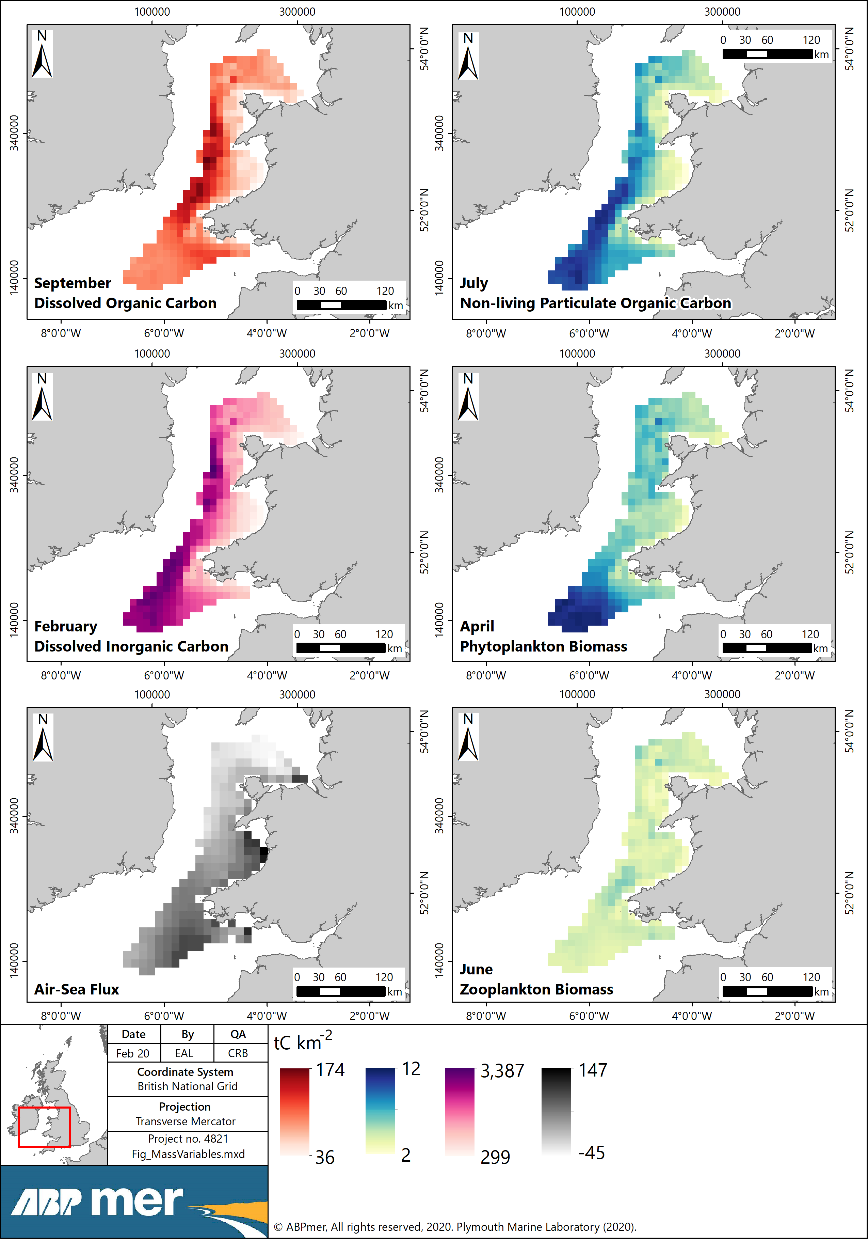

Figure 1 Peak months for mass variables and air-sea flux total

The amount of carbon stored in Welsh marine sediments is likely to be an underestimate. This is firstly due to only the top 10 cm having been considered. Also, relatively conservative values were generally applied, including for carbonate content of Welsh sediments. Analysis of BGS sampling data could for example be undertaken to derive specific carbonate values for Welsh sediments.

With regard to biomass, as noted in Section 5.5.2, kelp is garnering a lot of attention in the media as a carbon ‘donor’ habitat. It is thought that more than the 80.4 km² of subtidal kelp habitat is likely to exist in Welsh waters; however, due to the mapping of such subtidal habitats largely relying on observational surveying, more exact maps may be difficult to obtain. Thus, modelling as undertaken by Burrows et al. (2014) for Scotland may be warranted. This was, however, outside the scope of this study.

  - Carbon sequestration potential

With regard to carbon sequestration, as summarised in Section 5, not all habitats will sequester carbon. Notably, any habitats on rock are considered not to fulfil this function. Sequestering habitats have been mapped to facilitate the carbon calculations for this study, using the best available datalayers, whilst noting uncertainties and mapping gaps as outlined in Section 6.3. Figure 2 depicts this datalayer; please note that a processing summary is provided in Appendix B / Section 11, to show how this datalayer has been assembled. Carbon storage and sequestration rates have been obtained from the literature (see Table 5) and applied to the calculated areas in order to estimate how much carbon is sequestered in the Welsh marine environment every year.

Results are summarised in Table 9. It is estimated that at least 26,100 tonnes of carbon (or 0.03 Mt C) are potentially sequestered in the Welsh marine environment every year, with saltmarshes and seagrasses accounting for the bulk of this value on a per unit area basis. When expressed in CO₂ equivalent units, which is the unit most commonly applied in sequestration reporting, this equates to 95,900 t CO₂e (or 0.096 Mt CO₂e).

Table 9 Annual carbon sequestration in Welsh marine habitats
Habitat | Mapped area (km²) | Sequestration (tonnes C yr⁻¹)
Saltmarsh | 76.1 | 6,397
Intertidal flats | 432.8 | 8,211
Intertidal macroalgae (vegetated rocky shores) | 30.9 | n/a
Seagrass beds | 7.3 | 197
Shellfish beds | 15.7 | 374
Subtidal macroalgae | 80.4 | n/a
Brittlestar beds | 0.07 | 5
Faunal turfs | 2.12 | n/a
Subtidal muds, sands and gravel | 29,514.1 | 10,938
Total |  | 26,122

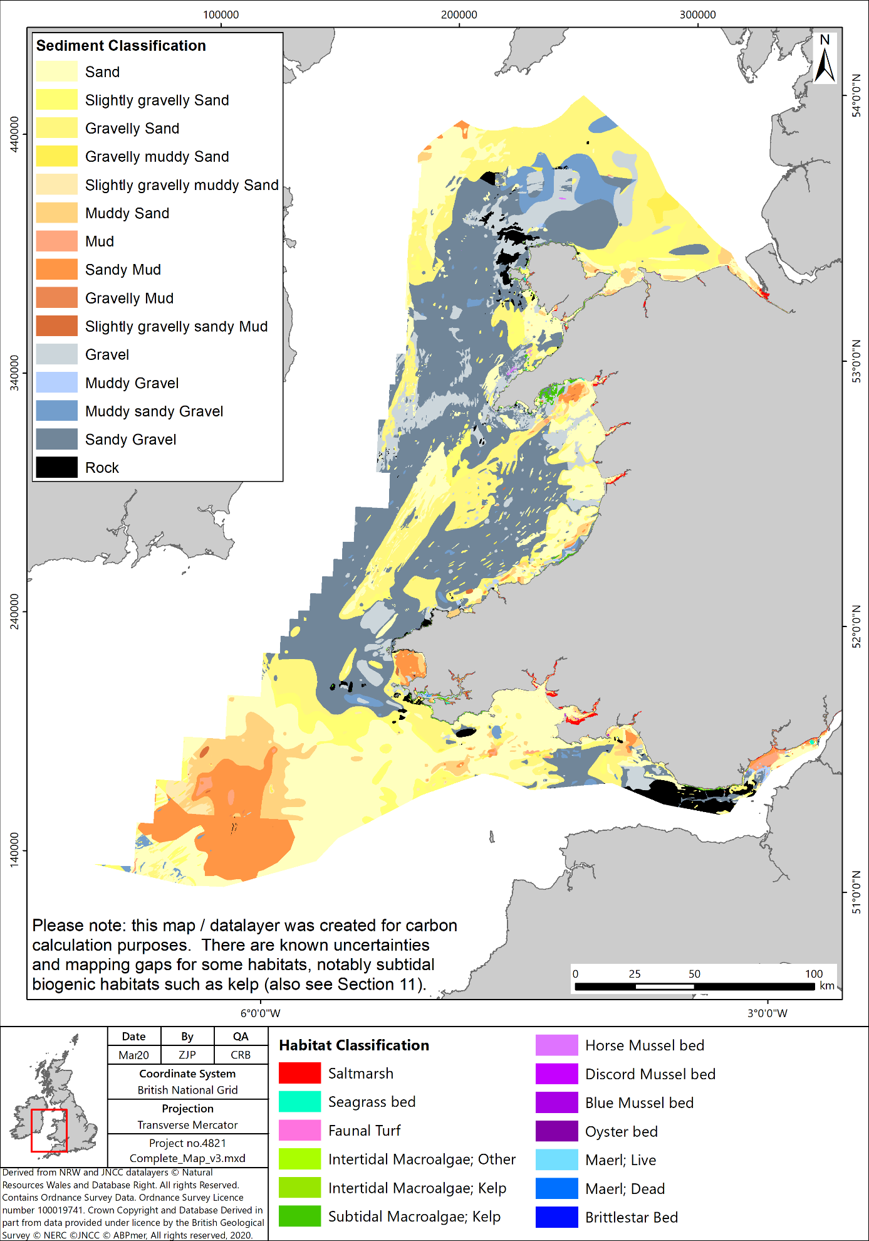

Figure 2 Sedimentary and habitat areas as mapped for the WNMP area for blue carbon calculation purposes.
It is considered likely that the sequestration value discussed above constitutes a slight under-estimate of the Welsh marine environment’s potential for sequestration. For example, relatively conservative accretion rates have been applied across intertidal areas (2 mm⁻¹ yr⁻¹) and subtidal habitats (0.1 mm yr⁻¹); such rates are known to be higher after storm events (e.g. Kirby, 1986) and also vary across Wales. Also, some sequestering habitats may not have been sufficiently mapped, for example, brittlestar beds are thought to be much more widespread in Wales than the currently available mapping indicates (see Section 5.5.3). It is also noteworthy that uncertainty remains on the extent of rocky habitats, with these areas likely to have been slightly underestimated in this study due to mapping limitations and the occurrence of rock within mosaic habitats (see Appendix B / Section 11, specifically HabMap processing). Thus, carbon values may have been overestimated in those areas. However, it is considered that these uncertainties would not, on balance, have led to an over-estimation of sequestration potential.

  - Welsh blue carbon – monetary value and context

This study has estimated that around 0.03 Mt of ‘blue’ carbon are sequestered annually in the Welsh marine environment (see Table 9 above). This equals 0.096 Mt CO₂e (or 95,900 t CO₂e), and equates to 0.2 % of Welsh carbon emissions (in 2017).

At least 113 Mt C are already stored in Welsh marine habitats; this equates to almost 10 years’ worth of Welsh carbon emissions. It furthermore represents over 170 % of the carbon held in Welsh forests.

Just under 49 Mt C are held in the Welsh marine environment in any given year, with the vast majority of this being in the water column (POC, DOC, DIC, plankton), and a comparatively small amount of less than 0.07 Mt C (or 69,000 tonnes C) contained in the plants of biogenic habitats such as kelp, saltmarshes and seagrasses. This overall blue carbon store is around 75 % of that held within Welsh forests (which has been estimated as 64.7 Mt C, see Footnote 6 for explanation).

Carbon sequestration is classed as a ‘climate regulation’ ecosystem service provided by marine areas and habitats. Ecosystem services are defined as services provided by the natural environment that benefit people. The blue carbon sequestered by Welsh marine habitats has been converted to monetary values using the 2020 non-traded (central) price for CO₂e (£69 per tonne) (DBEIS, 2011). On this basis, the sequestration benefits of marine habitats in 2020 are worth approximately £6.6 million yr⁻¹ across the WNMP area. Based on projected increases in the non-traded price of carbon, this value would more than treble by 2050 (2050 non-traded carbon price of £221).
This monetary value is an estimate of the benefit relating to current carbon sequestration. In the future, there will be variations in annual sequestration due to a wide range of factors, including climate change, sea level rise, erosion / drowning of sequestering habitats, etc.

The estimated carbon sequestration in the Welsh marine environment every year is equivalent to the average annual fuel consumption of 64,800 cars, or 115,400 return flights from Cardiff to the Canary Islands. When comparing ‘blue carbon’ habitats with ‘green carbon’ (terrestrial) habitats, Welsh marine habitats sequester around 7 % as much as Welsh woodlands, and their carbon sequestration strength equates to that of 210 km² of woodland.

Table 10 below ranks Welsh marine habitats in order of their carbon sequestration potential (using the rates applied by this study), and compares them with Welsh woodlands. As can be seen, 1 ha of woodland sequesters more than any one of the marine habitats, with saltmarshes sequestering the most out of all Welsh marine habitats, at 66 % of woodlands’ rates. As noted in Section 5 however, marine habitat sequestration rates are very much dependent on rates of accretion, and could thus be significantly higher in areas where sedimentation rates are typically higher than the rates which have been assumed for this study. It is considered that saltmarshes in estuaries with high suspended sediment loads in the water column, such as the Severn Estuary, would sequester more than woodlands, likely more than 1.5 times as much. Further research is recommended on this aspect, see Section 7.2.1.

Table 10 Marine habitat carbon sequestration per unit area, compared with woodlands
Parameter | Rate applied (kg m⁻² yr⁻¹) | Rate applied (t ha⁻¹ yr⁻¹) | % when compared with sequestration of 1 ha of Welsh woodland*
Saltmarsh | 0.084 | 0.84 | 66
Horse mussel (Modiolus) | 0.04 | 0.4 | 32
Seagrass | 0.027 | 0.27 | 21
Intertidal Muds, gravels and sand (POC) (upper and lower bounds) | 0.011 | 0.11 | 9
 | 0.037 | 0.37 | 29
Other mussels (Mytilus, discord, etc.) | 0.004 | 0.04 | 3
Oysters (Ostrea) | 0.001 | 0.01 | 0.8
Subtidal Muds, gravels and sand (POC) (upper and lower bounds) | 0.0009 | 0.009 | 0.7
 | 0.0003 | 0.003 | 0.2
* which is assumed to be 1.3 t ha⁻¹ yr⁻¹, see Footnote 8 for explanation.

- Discussion, Conclusions and Recommendations

  - Discussion

This study has sought to compile information on carbon storage and sequestration within the Welsh marine environment. Limitations in the data mean that is not possible to present a complete carbon budget for Welsh waters. A key information gap relates to the lack of available evidence on carbon flux across the WNMP offshore boundary, particularly for DIC. There are also significant uncertainties relating to air-sea flux estimates, particularly in inshore coastal and estuarine waters, which are not covered by PML’s ERSEM model. There are furthermore substantial uncertainties concerning riverine inputs, due to limited information on river discharge volumes and on the concentrations of DIC, DOC and POC in Welsh rivers. Some of the biogenic habitats are furthermore considered to be under-represented in the maps, notably subtidal habitats such as kelp.

Evidence on carbon stores indicates that the great majority (>95%) of the estimated average of 48.7 Mt of carbon stored in the water column in Welsh waters is dissolved CO_{2,} with most of the remainder present as dissolved organic carbon. This study’s figures suggest that less than 0.3% of marine carbon is stored in living biomass in Welsh waters (either within the water column or on / within the seabed).

It is estimated that around 113 Mt of carbon has already been sequestered in sediments within the Welsh marine environment; this equates to almost 10 years’ worth of Welsh carbon emissions and furthermore represents over 170 % of the carbon held in Welsh forests. The 113 Mt C value is likely to be an underestimate, as the figure only includes the top 10 cm of sediments. 10% of this total is associated with organic carbon contained in muds, sands and gravels, the predominant habitat types in Welsh waters, and 89 % with carbonate (inorganic carbon) stored in sediments or below existing vegetated habitats. While biogenic habitats such as saltmarshes, seagrass beds, brittlestar beds and shellfish beds have high sequestration potential, their very small spatial extent in Welsh waters means that they contribute relatively little to the amounts of carbon already stored longer term in the Welsh marine environment (just under 0.4 Mt C out of 113 Mt C), compared with sedimentary habitats. The 113 Mt C value compares with Scottish estimates of 174 Mt of inorganic and 28 Mt of organic carbon estimated as being stored in Scottish sediments (Burrows et al., 2014). Separately, Diesing et al. (2017) calculated that at least 476 Mt of organic carbon is stored in the top 10 cm of sediments of the north-western European Continental Shelf.

This study has calculated an initial estimate of annual carbon sequestration in Welsh waters as 26,100 tonnes of carbon (or 0.03 Mt), with subtidal sediments accounting for the largest percentage of this, followed by intertidal flats, saltmarshes and seagrass beds. This sequestration figure is uncertain. The estimated net flux of carbon into the WNMP area (which could provide an upper bound for carbon sequestration) is 0.07 to 1.16 Mt C, although this does not include potential negative flux of DIC from WNMP area. 43 %of the estimated 0.02 Mt is estimated to be sequestered within intertidal sediments and saltmarshes. The remainder is largely sequestered in subtidal muds, sands and gravels. This 0.03 Mt C yr⁻¹ value compares with Scottish estimates derived by Burrows et al. (2014) of 7.2 Mt of organic and 0.44 Mt of inorganic carbon being sequestered in Scottish waters every year. These large values for Scottish waters are a function of the size of the area, which is almost 15 times that of the WNMP area, and the high rates applied to, and large spatial area of, fine shelf sediments (which has a reported sequestration potential of 7 Mt C yr⁻¹).

  - Recommendations

Recommendations are presented in two sections, firstly recommendations relating to improving the evidence, and secondly recommendations for policy and management

    - Evidence

This study set out to fill an important evidence gap related to blue carbon and has in itself revealed some additional gaps which could usefully be investigated further.

First, there is uncertainty concerning carbon fluxes into and out of Welsh waters. Collecting robust data on carbon fluxes into / out of the Welsh marine environment is, however, likely to prove challenging, particularly across the offshore boundary. To obtain better estimates of offshore boundary fluxes, particularly for DIC, significant additional effort would be required and confidence in any estimates would likely remain low. To better estimate fluxes in near shore coastal waters and estuaries, downscaled models would be required which simulate relevant processes at smaller spatial scales. Modelling of all Welsh estuaries is not realistic, but it may be possible to gather information for a small number of Welsh estuaries to better inform overall flux estimates for Wales. Better information on riverine inputs would also be helpful, particularly in terms of average concentrations of DIC, DOC and POC at the downstream limits of main rivers.

Better information is also required on carbon sequestration rates for some of the habitats studied here, although relevant rates have been obtained for key habitats such as saltmarshes, seagrass beds and subtidal sediments. However, for habitats such as shellfish and brittlestar beds, no Welsh (or southern UK) values could be determined, and proxy values from elsewhere have thus been employed which may over or underestimate rates due to differences in environmental conditions. Also, there is considerable uncertainty related to the amounts of carbonate stored in Welsh sediments, with a lower bound estimate applied for this study. Dedicated (and likely higher) Welsh values might be obtained from the interrogation of BGS sediment records and mapping values against sediment type extent.

There is further uncertainty concerning the rates of sequestration both in intertidal and subtidal sediments – this is mostly a function of long-term sedimentation rates, for which monitoring data is scarce. Estimates of annual carbon sequestration could thus be improved through a better understanding of sedimentation rates in the marine environment, particularly the subtidal zone. This could potentially be achieved through the analysis of core samples using radiocarbon dating.

Lastly, this work has focused on carbon, particularly CO₂, due to the limited work done on other greenhouse gases such as methane and nitrous oxide. In order to fully understand the role of marine ecosystems in climate regulation, it would however be necessary to understand fluxes of methane and nitrous oxide as well as CO₂, particularly as these gases have a greater global warming potential than CO₂ (e.g. the global warming potential of methane is 28 to 36 times greater than CO₂).

    - Policy and management

The evidence provided in this report indicates that potentially a wide range of marine habitats contribute to carbon sequestration. Subtidal muds, sands and gravel were found to sequester the greatest amount of carbon, followed by intertidal flats and saltmarshes.

Protecting these areas from damaging activities is therefore likely to be important. There is limited evidence on how human activities may disrupt carbon sequestration by marine habitats, in particular how sequestration rates may vary with habitat condition. Further work to understand how the ecosystem service varies with habitat condition would be helpful in refining carbon sequestration estimates. Studies such as Luisetti et al. (2019), however, have proposed that the cessation of bottom trawling would promote improved carbon storage in subtidal sedimentary habitats. Further evidence of the impacts of activities on subtidal sedimentary habitat carbon storage, and building subsequent knowledge into management of the marine environment, may thus have increased benefits over and above those associated with biodiversity improvements.

Restoring intertidal and shallow subtidal habitats would yield the greatest per unit area benefit in terms of increased carbon sequestration; there are various techniques which have been used to achieve this, with managed realignment being the most commonly applied (and proven) method for creating intertidal habitats. This has, for example been undertaken an Morfa Friog in Gwynedd (NRW, 2015). For some shallow subtidal biogenic habitats such as seagrasses and oyster beds, creation should be feasible based on foreign examples, but UK restoration success has often not been proven to a sufficient extent, or at all. For example, seagrass restoration has been conducted for over 50 years globally, but successful UK examples have been scarce (e.g. MMO, 2018). A noteworthy pilot project has recently been initiated near Dale in West Wales, led by Swansea University (Project Seagrass, 2020). Further such pilot projects should be promoted / encouraged in order to increase the evidence base around blue carbon habitat restoration techniques and ultimately facilitate the increased application of such methods.

Given the amount of evidence available on the importance of marine habitats in relation to carbon storage and sequestration, which has been supported by this study, it is perhaps surprising that marine habitat creation projects are not currently able to access most carbon offsetting funds. This is related to difficulties with accurately calculating all the bio-geochemical processes, but also with issues around the source of the carbon. Thus, government funding to fill this gap could facilitate the meeting of Verified Carbon Standards by key habitats such as saltmarshes and seagrasses and could in turn greatly bolster restoration efforts.

- References

ABPmer, 2020. Spatial Data and Evidence Projects, Project 3 - Natural Capital and Ecosystem Services Mapping. ABPmer Report No. R.3161. A report produced by ABPmer for the Marine Institute, January 2020.
Adams, C.A., Andrews, J.E. and Jickells, T., 2012. Nitrous oxide and methane fluxes vs. carbon, nitrogen and phosphorous burial in new intertidal and saltmarsh sediments. Science of the Total Environment, 434, pp. 240-251.
Beaumont, N.J., Jones, L., Garbutt, A., Hansom, J.D. and Toberman, M., 2014. The value of carbon sequestration and storage in coastal habitats. Estuarine, Coastal and Shelf Science, 137, pp. 32-40.
Bigg, G.R., Jickells, T.D., Liss, P.S. and Osborn, T.J., 2003. The Role of the Oceans in Climate. International Journal of Climatology, 23, pp.1127–1159.
Borges, A.V., Schiettecatte, L.-S., Abril, G., Delille, B. and, Gazeau, F., 2006. Carbon dioxide in European coastal waters. Estuarine, Coastal and Shelf Science, 70(3), pp. 375-387.
Bruggeman, J., Cazenave, P., Ciavatta, S., Kay, S., Lessin, G., van Leeuwen, S., van der Molen, J., de Mora, L., Polimene, L., Sailley, S., Stephens, N., and Torres, R., 2016. ERSEM 15.06: a generic model for marine biogeochemistry and the ecosystem dynamics of the lower trophic levels, Geoscientific Model Development, 9, pp. 1293–1339.
Brunskill, G. J., Zagorskis, I. and Pfitzner, J., 2002. Carbon burial rates in sediments and a carbon mass balance for the Herbert River region of the Great Barrier Reef continental shelf, North Queensland, Australia. Estuarine, Coastal and Shelf Science, 54, pp. 677-700.
Burrows M.T., Kamenos N.A., Hughes D.J., Stahl H., Howe J.A. and Tett P., 2014. Assessment of carbon budgets and potential blue carbon stores in Scotland’s coastal and marine environment. Scottish Natural Heritage Commissioned Report No. 761.
Butenschön, M., Clark, J., Aldridge, J. N., Allen, J. I., Artioli, Y., Blackford, J., Bruggeman, J., Cazenave, P., Ciavatta, S., Kay, S., Lessin, G., van Leeuwen, S., van der Molen, J., de Mora, L., Polimene, L., Sailley, S., Stephens, N., and Torres, R., 2016. ERSEM 15.06: a generic model for marine biogeochemistry and the ecosystem dynamics of the lower trophic levels, Geosci. Model Dev., 9, pp. 1293–1339.
Cazenave, A. and Nerem, R. S., 2004. Present-day sea level change, Observations and causes, Reviews of Geophysics, 42, RG3001.
Chaeho, B., Lee, S.H. and Kang, H., 2019. Estimation of carbon storage in coastal wetlands and comparison of different management schemes in South Korea. Journal of Ecology and Environment (2019) 43: 8p.
Chen, C.T.A. and Borges A.V., 2009. Reconciling opposing views on carbon cycling in the coastal ocean: continental shelves as sinks and near-shore ecosystems as sources of atmospheric CO2. Deep Sea Research, Part II 56(8–10): pp. 578–590.
Chmura, G.L., Anisfeld, S.C., Cahoon, D.R. and Lynch, J.C., 2003. Global carbon sequestration in tidal, saline wetland soils. Global biogeochemical cycles, 17(4). 22p.
Church, J.A. and White, N.J., 2006. A 20th century acceleration in global sea-level rise. Geophysical Research Letters, 33, L01602, doi:10.1029/2005GL024826.
Collins, M J., 1986. Taphonomic processes in a deep water Modiolus-brachiopod assemblage from the west coast of Scotland. University of Glasgow.
Collins, M.B., 1983. Supply, Distribution and Transport of Suspended Sediment in a Macrotidal Environment: Bristol Channel, U.K. Canadian Journal of Fisheries and Aquatic Sciences, 40 (supl. 1), pp. 44-59.
Committee on Climate Change, 2018. Land use: Reducing emissions and preparing for climate change. Committee on Climate Change, London, 101p.
Connor, D.W., Allen, J.H., Golding, N., Howell, K.L., Lieberknecht, L.M., Northen, K.O. and Reker, J.B., 2004. The marine habitat classification for Britain and Ireland Version 04.05. JNCC, Peterborough.
Cook, P.L.M., 2002. Carbon and nitrogen cycling on intertidal mudflats in a temperate Australian estuary (Doctoral dissertation, University of Tasmania).
Dayton, P.K., 1985. Ecology of Kelp Communities. Annual Review of Ecology and Systematics, 16, pp. 215-245
Department for Business, Energy and Industrial Strategy (DBEIS), 2011. A brief guide to the carbon valuation methodology for UK policy appraisal, October, 2011. Accessed at https://assets.publishing.service.gov.uk/government/uploads/system/uploads/attachment_data/file/48184/3136-guide-carbon-valuation-methodology.pdf [last accessed March 2020]
Diesing, M., Kröger, S., Parker, R., Jenkins, C., Mason, C. and Weston, K., 2017. Predicting the standing stock of organic carbon in surface sediments of the North–West European continental shelf. Biogeochemistry, 135(1-2), pp. 183-200.
Duarte, C.M. and Cebrián, J., 1996. The fate of marine autotrophic production. Limnology and Oceanography, 41, pp. 1758-1766.
Fodrie F.J., Rodriguez A.B., Gittman R.K., Grabowski J.H., Lindquist N.L., Peterson C.H et al., 2017. Oyster reefs as carbon sources and sinks. Proceedings of Royal Society 284: 20170891.
Ford, H., Garbutt, A., Duggan-Edwards, M., Harvey, R., Ladd, C. and Skov, M.W., 2019. Large-scale predictions of salt-marsh carbon stock based on simple observations of plant community and soil type. Biogeosciences, 16(2), pp. 425-436.
Ford, H., Garbutt, A., Ladd, C., Malarkey, J. and Skov, M.W., 2016. Soil stabilization linked to plant diversity and environmental context in coastal wetlands. Journal of vegetation science, 27(2), pp. 259-268.
Freiwald, A. and Henrich, R., 1994. Reefal coralline algal build‐ups within the Arctic Circle: morphology and sedimentary dynamics under extreme environmental seasonality. Sedimentology, 41(5), pp.963-984.
Gattuso, J.-P. , Frankignoulle, M. and Wollast, R., 1998. Carbon and carbonate metabolism in coastal aquatic systems. Annual Review of Ecology and Systematics, pp. 405-34
Green, A., Chadwick, M.A. and Jones, P.J.S., 2018. Variability of UK seagrass sediment carbon: Implications for blue carbon estimates and marine conservation management. PLoS ONE 13(9): e0204431.
Greiner, J.T., McGlathery, K.J., Gunnell, J. and McKee, B.A., 2013. Seagrass restoration enhances "blue carbon" sequestration in coastal waters. PloS one, 8(8), e72469.
Guy, H., 2010. The microbial role in carbon cycling within seagrass sediments. PhD thesis, Plymouth University.
Hanley, T.C. and La Pierre, K.J. eds., 2015. Trophic Ecology. Cambridge University Press, Cambridge, 420p.
Hartnoll, R.G., 1998. Volume VIII. Circalittoral faunal turf biotopes: An overview of dynamics and sensitivity characteristics for conservation management of marine SACs. Scottish Association of Marine Sciences, Oban, Scotland. UK Marine SAC Project. Natura 2000 report
Hickey, J.P., 2008. Carbon sequestration potential of shellfish. In Seminars in Sustainability –School of Natural and Built Environs, University of South Australia.
Higgins C.B., Stephenson K. and Brown B.L. 2011. Nutrient bioassimilation capacity of aquacultured oysters: quantification of an ecosystem service. Journal of Environmental Quality 40, pp. 271-277.
Hill, R., Bellgrove, A., Macreadie, P.I., Petrou, K., Beardall, J., Steven, A. and Ralph, P.J., 2015. Can macroalgae contribute to blue carbon? An A ustralian perspective. Limnology and Oceanography, 60(5), pp. 1689-1706.
Hobday, A.J., 2000. Abundance and dispersal of drifting kelp Macrocystis pyrifera rafts in the Southern California Bight. Marine Ecology Progress Series, 195, pp. 101-116.
Holmer, M. and Bondgaard, E.J., 2001. Photosynthetic and growth response of eelgrass to low oxygen and high sulfide concentrations during hypoxic events. Aquatic Botany, 70(1), pp.29-38.
Hope, D., Billett, M.F., Milne, R. and Brown, T.A.W., 1997. Exports of Organic Carbon in British Rivers. Hydrological Processes, 11 (3), pp. 325-344
Howard, J., Sutton-Grier, A., Herr, D., Kleypas, J., Landis, E., Mcleod, E., Pidgeon, E. and Simpson, S., 2017. Clarifying the role of coastal and marine systems in climate mitigation. Frontiers in Ecology and the Environment, 15(1), pp. 42-50.
Hull, S., Dickie, I., Tinch, R. and Saunders, J., 2014. Issues and challenges in spatio-temporal application of an ecosystem services framework to UK seas. Marine Policy 45, pp. 359-367
Intergovernmental Panel on Climate Change (IPCC), 2013: Climate Change 2013: The Physical Science Basis. Contribution of Working Group I to the Fifth Assessment Report of the Intergovernmental Panel on Climate Change [Stocker, T.F., D. Qin, G.-K. Plattner, M. Tignor, S.K. Allen, J. Boschung, A. Nauels, Y. Xia, V. Bex and P.M. Midgley (eds.)]. Cambridge University Press, Cambridge, United Kingdom and New York, NY, USA, 1,535p.
Intergovernmental Panel on Climate Change (IPCC), 2001. Climate Change 2001: The Scientific Basis. Contribution of Working Group I to the Third Assessment Report of the Intergovernmental Panel on Climate Change [Houghton, J.T.,Y. Ding, D.J. Griggs, M. Noguer, P.J. van der Linden, X. Dai, K. Maskell, and C.A. Johnson (eds.)]. Cambridge University Press, Cambridge, United Kingdom and New York, NY, USA, 881p.
Jarvie, H.P., King, S. and Neal, C., 2017. Inorganic carbon dominates total dissolved carbon concentrations and fluxes in British rivers: Application of the THINCARB model – Thermodynamic modelling of inorganic carbon in freshwaters. Science of The Total Environment. 575, pp. 496-512.
Jenness, M.I. and Duineveld, G.C.A., 1985. Effects of tidal currents on chlorophyll a content of sandy sediments in the southern North Sea. Marine Ecology Progress Series 21, pp. 283–287
Joint Nature Conservation Committee (JNCC), 2004. Common Standards Monitoring Guidance for Saltmarsh Habitats. August 2004. published online.
Jones, L., Thistlethwaite, G., Passant, N., Wakeling, D., Walker, C., Karagianni, E., Turtle, L., Kilroy, E., Hampshire, K., May,K. and Webb, N., 2019. Greenhouse Gas Inventories for England, Scotland, Wales & Northern Ireland: 1990-2017. Spreadsheet available at: https://naei.beis.gov.uk/reports/reports?section_id=4 [last accessed March 2019]
Kain, J. M., 1979. A view of the genus Laminaria. Oceanography and Marine Biology an Annual Review, 17, pp. 101-161.
Kamenos, N.A., 2010. North Atlantic summers have warmed more than winters since 1353, and the response of marine zooplankton. Proceedings of the National Academy of Sciences, 107(52), pp. 22442-22447.
Kang, C.K., Choy, E.J., Son, Y., Lee, J.Y., Kim, J.K., Kim, Y. and Lee, K.S., 2008. Food web structure of a restored macroalgal bed in the eastern Korean peninsula determined by C and N stable isotope analyses. Marine Biology, 153(6), pp. 1181-1198.
Kennedy, H., Beggins, J., Duarte, C.M., Fourqurean, J.W., Holmer, M., Marbà, N. and Middelburg, J.J., 2010. Seagrass sediments as a global carbon sink: Isotopic constraints. Global Biogeochemical Cycles, 24(4).
Kirby, R., 1986. Suspended Fine Cohesive Sediment in the Severn Estuary and Inner Bristol Channel, U.K. Report to United Kingdom Atomic Energy Authority. Ravensrodd Consultants Ltd., Taunton.
Krumhansl, K.A. and Scheibling, R.E., 2012. Production and fate of kelp detritus. Marine Ecology Progress Series, 467, pp.281-302.
Laffoley, D. and Grimsditch, G.D. (eds.), 2009. The management of natural coastal carbon sinks. IUCN, Gland, Switzerland, 53p.
Lebrato, M., Iglesias-Rodríguez, D. , Feely, R. A., Greeley, D. , Jones, D. O. B., Suarez-Bosche, N., Lampitt, R. S. , Cartes, J. E., Green, D. R. H. and Alker, B., 2010. Global contribution of echinoderms to the marine carbon cycle: CaCO3 budget and benthic compartments. Ecological Monographs, 80, pp. 441-467.
Lindley, J.A., Robins, D.B. and Williams, R., 1999. Dry weight carbon and nitrogen content of some euphausiids from the north Atlantic Ocean and the Celtic Sea. Journal of Plankton Research, 21(11). pp. 2053–2066.
López-Calderón,, J.M., Meling A. and Riosmena-Rodríguez, R. (2016) Sandflat. In: Kennish M.J. (eds) Encyclopedia of Estuaries. Encyclopedia of Earth Sciences Series. Springer, Dordrecht .
Luisetti,T., Turner, R.K., Andrews, J.E., Jickells, T.D., Kröger, S. and Diesing, M., 2019.Quantifying and valuing carbon flows and stores in coastal and shelf ecosystems in the UK. Ecosystem services, 35, pp. 67-76.
Mainwaring, K., Tillin, H and Tyler-Walters, H., 2014. Assessing the sensitivity of blue mussel beds to pressures associated with human activities. Peterborough, Joint Nature Conservation Committee, JNCC Report No. 506.
Mann, K.H., 2000. Ecology of Coastal Waters, with Implication for Management. Blackwell Sciences. Inc. Massachusetts. 432pp.
Mcleod, E., Chmura, G.L., Bouillon, S., Salm, R., Björk, M., Duarte, C.M., Lovelock, C.E., Schlesinger, W.H. and Silliman, B.R., 2011. A blueprint for blue carbon: toward an improved understanding of the role of vegetated coastal habitats in sequestering CO₂. Front Ecol Environ 2011; 9(10), pp. 0552–560
Menéndez, M. and Woodworth, P.L., 2010. Changes in extreme high water levels based on a quasi‐global tide‐gauge dataset, J. Geophys. Res., 115, C10011.
Migné, A., Davoult, D. and Gattuso, J.P., 1998. Calcium carbonate production of a dense population of the brittle star Ophiothrix fragilis (Echinodermata: Ophiuroidea): role in the carbon cycle of a temperate coastal ecosystem. Marine Ecology Progress Series, 173, pp. 305-308.
Marine Management Organisation (MMO), 2018. Identifying sites suitable for marine habitat restoration or creation (MMO1135). Produced by ABPmer for MMO. MMO, Newcastle, 96p.
Moriarty, D.J.W., Iverson, R.L. and Pollard, P.C., 1986. Exudation of organic carbon by the seagrass Halodule wrightii Aschers. And its effect on bacterial growth in the sediment. J. Exp. Mar. Biol. Ecol. 96, pp. 115–126.
MyClimate, 2020. Calculate and offset your CO₂ emissions! Online content available at: https://co2.myclimate.org/en/offset_further_emissions [last accessed March 2020]
National Assembly for Wales, 2017. Research Briefing: Woodlands in Wales: a quick guide. National Assembly for Wales, Cardiff, 12p.
Natural Resources Wales (NRW), 2015. New saltmarsh habitat completes Fairbourne flood defence scheme. Available at: https://naturalresources.wales/about-us/news-and-events/news/new-saltmarsh-habitat-completes-fairbourne-flood-defence-scheme/?lang=en. [last accessed March 2020].
Natural Resources Wales (NRW), 2016. State of Natural Resources Report (SoNaRR): Assessment of the Sustainable Management of Natural Resources. Technical Report. Natural Resources Wales.
Natural Resources Wales (NRW), 2018. Carbon Positive Project - Summary Report. NRW, Cardiff, 20p.
Naylor, L.A. and Viles, H.A., 2000. A temperate reef builder: an evaluation of the growth, morphology and composition of Sabellaria alveolata (L.) colonies on carbonate platforms in South Wales. In: Insalaco, E., Skelton, P.W. and Palmer, T.J. (eds.) Carbonate Platform Systems: Components and Interactions, Geological Society, London, Special Publications 178, pp. 9-19.
NBN Atlas, 2020. Species. Website content available at: https://species.nbnatlas.org/ [last accessed February 2020]
Nellemann, C. and Corcoran, E. eds., 2009. Blue carbon: the role of healthy oceans in binding carbon: a rapid response assessment. UNEP/Earthprint.
NimbleFins, 2019. Average Car Mileage UK. Website content available at: https://www.nimblefins.co.uk/average-car-mileage-uk [last accessed March 2019]
Ning, J., Du, F., Wang, X., Wang, L. and Li, Y., 2019. Trophic connectivity between intertidal and offshore food webs in Mirs Bay, China. Oceanologia, 61(2), pp. 208-217.
Ouyang, X. and Lee, S.Y., 2014, Updated estimates of carbon accumulation rates in coastal marsh sediments. Biogeosciences, 11,pp. 5057–5071.
Pessarrodona, A., Moore, P.J., Sayer, M.D. and Smale, D.A., 2018. Carbon assimilation and transfer through kelp forests in the NE Atlantic is diminished under a warmer ocean climate. Global change biology, 24(9), pp .4386-4398.
Project Seagrass. (2020). Project Seagrass | Advancing the conservation of seagrass [online]. Available at: https://www.projectseagrass.org. [last accessed March 2020].
Pye, K. and French, P., 1993. Erosion & Accretion Processes on British Salt Marshes. Volume One : Introduction: Saltmarsh process & morphology. Cambridge : Cambridge Environmental Research Consultants.
Reid, J.B. and Goss, M.J., 1981. Effect of living roots of different plant species on the aggregate stability of two arable soils. Journal of Soil Science, 32(4), pp. 521-541.
Robinson, K.A., Ramsay, K., Lindenbaum, C., Frost, N., Moore, J., Petrey, D. and Darbyshire, T., 2009. Habitat Mapping for Conservation and Management of the Southern Irish Sea (HabMap). II: Modelling & Mapping. Studies in Marine Biodiversity and Systematics from the National Museum of Wales. BIOMÔR Reports 5(2): 210pp & DVD.
Sanders, C.J., Smoak, J.M., Naidu, A.S., Sanders, L.M. and Patchineelam, S.R., 2010. Organic carbon burial in a mangrove forest, margin and intertidal mud flat. Estuarine, Coastal and Shelf Science, 90(3), pp. 168-172.
Seasearch, 2017. Native Oyster, Ostrea edulis Milford Haven Waterway. Survey report March 2017. 24 p report available at: http://www.seasearch.org.uk/downloads/Milford-Haven-oyster-report.pdf [last accessed March 2020]
Smale, D.A., Burrows, M.T., Evans, A.J., King, N., Sayer, M.D., Yunnie, A.L. and Moore, P.J., 2016. Linking environmental variables with regional-scale variability in ecological structure and standing stock of carbon within UK kelp forests. Marine Ecology Progress Series, 542, pp.79-95.
Smale, D.A., Burrows, M.T., Moore, P., O'Connor, N. and Hawkins, S.J., 2013. Threats and knowledge gaps for ecosystem services provided by kelp forests: a northeast Atlantic perspective. Ecology and evolution, 3(11), pp. 4016-4038.
Smith, A.M. and Nelson, C.S. 2003. Effects of early sea-floor processes on the taphonomy of temperate shelf skeletal carbonate deposits. Earth-Science Reviews, 63, 1-31.
Stewart, C. and Williams, E., 2019. Blue Carbon Research Briefing. National Assembly for Wales, Senedd Research, December 2019.
Taylor, R., 1998. Density, biomass and productivity of animals in four subtidal rocky reef habitats: the importance of small mobile invertebrates. Marine Ecology Progress Series, 172, pp. 37-51.
The Guardian, 2019. CO₂ emissions from average UK new car rise for first time since 2000. Online content available at: https://www.theguardian.com/business/2018/feb/27/co2-emissions-from-average-uk-new-car-rise-for-first-time-since-2000 [last accessed March 202]
The Marine Life Information Network (MarLIN), 2020. Species. Online content available at: https://www.marlin.ac.uk/species [last accessed February 2020]
Thomas, H., Bozec, Y., de, Baar, H.J.W., Elkalay, K., Frankignoulle, M. and Schiettecatte, L,S, 2005. The carbon budget of the North Sea. Biogeosciences 2005; 2: 87–96.
van der Schatte, O.A., Jones., L., Vay., L.L., Christie, M., Wilson, J. and Malham, S.K., 2018. A global review of the ecosystem services provided by bivalve aquaculture. Reviews in Aquaculture.
Walker, S.E. and Goldstein, S.T., 1999. Taphonomic tiering: experimental field taphonomy of molluscs and foraminifera above and below the sediment–water interface. Palaeogeography, Palaeoclimatology, Palaeoecology, 149, pp. 227-244.
Weber, T., Wiseman, N.A. and Kock, A., 2019. Global ocean methane emissions dominated by shallow coastal waters. Nat Commun. 2019;10(1), p.4584.
Welsh Government, 2018. Marine Protected Area Network: Management Framework for Wales 2018–2023. Welsh Government, Cardiff, 61p.
Welsh Government, 2019. Welsh National Marine Plan. Welsh Government, Cardiff, 180p.
Wikipedia/Alfred Wegener Institute, 2006. Air-sea exchange of CO₂. Image available at: https://en.wikipedia.org/wiki/Biological_pump#/media/File:CO2_pump_hg.svg [last accessed February 2020]
Wood, C.L., Hawkins, S.J., Godbold, J.A. and Solan, M., 2015. Coastal Biodiversity and Ecosystem Service Sustainability (CBESS) total organic carbon in mudflat and saltmarsh habitats. NERC Environmental Information Data Centre https://doi.org/10.5285/d4e9f0f7-637a-4aa4-b9df-2a4ca5bfaded [last accessed February 2020]
- Acronyms

BGS British Geological Survey
C Carbon
CaCO₃ Calcium Carbonate
CO₂ Carbon Dioxide
CO₂e Carbon Dioxide equivalent
DBEIS Department for Business, Energy and Industrial Strategy
DIC Dissolved Inorganic Carbon
DOC Dissolved Organic Carbon
ERSEM European Regional Seas Ecosystem Model
EUNIS European Nature Information System
GHGs Greenhouse Gases
ha Hectare
HabMap Habitat Mapping for Conservation and Management of the Southern Irish Sea
HPIs Habitats of Principle Importance
IC Inorganic Carbon
IPCC Intergovernmental Panel on Climate Change
JNCC Joint Nature Conservation Committee
kg Kilogram
m Metre
MarLIN Marine Life Information Network
MCCIP Marine Climate Change Impacts Partnership
MCZ Marine Conservation Zone
MEDIN Marine Environmental Data and Information Network
Ml Megalitres
MPA Marine Protected Area
Mt CO2e Million tonnes of Carbon Dioxide equivalent
NBN Atlas NBN Atlas Partnership
NEMO Nucleus for a European Model of the Ocean
NMP Net Microplankton Production
NOx Nitrogen Oxides
NRW Natural Resources Wales
O₂ Oxygen
OC Organic Carbon
OSPAR Convention for the Protection of the Marine Environment of the North-East Atlantic
Pg C billion tonnes of carbon
PIC Particulate Inorganic Carbon
PML Plymouth Marine Laboratory
POC Particulate Organic Carbon
POLCOMS Proudman Oceanographic Laboratory Coastal Ocean Modelling System
Ramsar Wetlands of international importance, designated under The Convention on Wetlands (Ramsar, Iran, 1971)
RCP Representative Concentration Pathway
SAC Special Area of Conservation
SMP Shoreline Management Plan
SNH Scottish Natural Heritage
SPA Special Protection Area
SPOM Suspended Particulate Organic Matter
SSSI Site of Special Scientific Interest
t Tonnes
tC Tonnes of Carbon
UK United Kingdom
US United States (America)
WFD Welsh Water Framework Directive
WNMP Welsh National Marine Plan

- Appendix A – Full Carbon Rates Table

The table below constitutes are more comprehensive version of that presented in Section 5.6.
Table 11 Applied carbon sequestration and storage values per studied habitat
Sedimentary area / habitat | Parameter (unit) | Value | Source / Justification
Sedimentary areas
Subtidal Mud | Soil standing stock (kg m⁻² (top 10 cm)) | 0.51040 | Stock: derived from Diesing et al., 2017 (contacted author to ensure calculations are correct, as no per area stock values supplied per se);  Sequestration: assumed at 0.1 mm yr⁻¹ as proportion of soil standing stock value; compares with fine sediment annual sequestration value by Burrows et al., 2014 of 0.041 kg m⁻² yr⁻¹, and coarse of 0.0002 kg m⁻² yr⁻¹. Note that Thomas et al. 2005 state that shelf sequestration is negligible, and Nelleman et al. 2009 estimated shelf sequestration at 0.2 tC ha⁻¹, or 0.02 kg m⁻².
 | Sequestration (kg m⁻² yr⁻¹) | 0.00051
Subtidal Sandy mud | Soil standing stock (kg m⁻² (top 10 cm)) | 0.64584
 | Sequestration (kg m⁻² yr⁻¹) | 0.00065
Subtidal Muddy sand | Soil standing stock (kg m⁻² (top 10 cm)) | 0.71442
 | Sequestration (kg m⁻² yr⁻¹) | 0.00071
Subtidal Sand | Soil standing stock (kg m⁻² (top 10 cm)) | 0.36264
 | Sequestration (kg m⁻² yr⁻¹) | 0.00036
Subtidal Slightly gravelly sandy mud | Soil standing stock (kg m⁻² (top 10 cm)) | 0.63315
 | Sequestration (kg m⁻² yr⁻¹) | 0.00063
Subtidal Slightly gravelly muddy sand | Soil standing stock (kg m⁻² (top 10 cm)) | 0.73278
 | Sequestration (kg m⁻² yr⁻¹) | 0.00073
Subtidal Slightly gravelly sandy mud | Soil standing stock (kg m⁻² (top 10 cm)) | 0.33264
 | Sequestration (kg m⁻² yr⁻¹) | 0.00033
Subtidal Gravelly mud | Soil standing stock (kg m⁻² (top 10 cm)) | 0.92001
 | Sequestration (kg m⁻² yr⁻¹) | 0.00092
Subtidal Gravelly muddy sand | Soil standing stock (kg m⁻² (top 10 cm)) | 0.68453
 | Sequestration (kg m⁻² yr⁻¹) | 0.00068
Subtidal Gravelly sand | Soil standing stock (kg m⁻² (top 10 cm)) | 0.34845
 | Sequestration (kg m⁻² yr⁻¹) | 0.00035
Subtidal Muddy gravel | Soil standing stock (kg m⁻² (top 10 cm)) | 0.81468
 | Sequestration (kg m⁻² yr⁻¹) | 0.00081
Subtidal Muddy sandy gravel | Soil standing stock (kg m⁻² (top 10 cm)) | 0.42978
 | Sequestration (kg m⁻² yr⁻¹) | 0.00043
Subtidal Sandy gravel | Soil standing stock (kg m⁻² (top 10 cm)) | 0.28899
 | Sequestration (kg m⁻² yr⁻¹) | 0.00029
Subtidal Gravel | Soil standing stock (kg m⁻² (top 10 cm)) | 0.27522
 | Sequestration (kg m⁻² yr⁻¹) | 0.00028
Intertidal Mud | Soil standing stock (kg m⁻² (top 10 cm)) | 1.02080 | Stock: subtidal values from Diesing et al., 2017 multiplied by 2 - on the assumption that nearshore sediments hold more carbon (likely underestimates stock);  Sequestration: assumed at 2 mm yr⁻¹ as proportion of soil standing stock value (2 mm accretion per annum assumed for all intertidal areas). Compares to ABPmer carbon calculator value of 22 g C m⁻²(so 0.0222 kg m⁻²) for 2 mm of accretion, based on 5% carbon (at 2% carbon it would be 4 g C m⁻², so 0.004 kg m⁻²).
 | Sequestration (kg m⁻² yr⁻¹) | 0.02042
Intertidal Sandy mud | Soil standing stock (kg m⁻² (top 10 cm)) | 1.29168
 | Sequestration (kg m⁻² yr⁻¹) | 0.02583
Intertidal Muddy sand | Soil standing stock (kg m⁻² (top 10 cm)) | 1.42884
 | Soil standing stock (kg m⁻² (top 10 cm) | 1.42884
 | Sequestration (kg m⁻² yr⁻¹) | 0.02858
Intertidal Sand | Soil standing stock (kg m⁻² (top 10 cm)) | 0.72528
 | Sequestration (kg m⁻² yr⁻¹) | 0.01451
Intertidal Slightly gravelly sandy mud | Soil standing stock (kg m⁻² (top 10 cm)) | 1.26630
 | Sequestration (kg m⁻² yr⁻¹) | 0.02533
Intertidal Slightly gravelly muddy sand | Soil standing stock (kg m⁻² (top 10 cm)) | 1.46556
 | Sequestration (kg m⁻² yr⁻¹) | 0.02931
Intertidal Slightly gravelly sandy mud | Soil standing stock (kg m⁻² (top 10 cm)) | 0.66528
 | Sequestration (kg m⁻² yr⁻¹) | 0.01331
Intertidal Gravelly mud | Soil standing stock (kg m⁻² (top 10 cm)) | 1.84002
 | Sequestration (kg m⁻² yr⁻¹) | 0.03680
Intertidal Gravelly muddy sand | Soil standing stock (kg m⁻² (top 10 cm)) | 1.36906
 | Sequestration (kg m⁻² yr⁻¹) | 0.02738
Intertidal Gravelly sand | Soil standing stock (kg m⁻² (top 10 cm)) | 0.69690
 | Sequestration (kg m⁻² yr⁻¹) | 0.01394
Intertidal Muddy gravel | Soil standing stock (kg m⁻² (top 10 cm)) | 1.62936
 | Sequestration (kg m⁻² yr⁻¹) | 0.03259
Intertidal Muddy sandy gravel | Soil standing stock (kg m⁻² (top 10 cm)) | 0.85956
 | Sequestration (kg m⁻² yr⁻¹) | 0.01719
Intertidal Sandy gravel | Soil standing stock (kg m⁻² (top 10 cm)) | 0.57798
 | Sequestration (kg m⁻² yr⁻¹) | 0.01156
Intertidal Gravel | Soil standing stock (kg m⁻² (top 10 cm)) | 0.55044
 | Sequestration (kg m⁻² yr⁻¹) | 0.01101
Rock | Soil standing stock | 0 / n/a
 | Sequestration | 0 / n/a
Biogenic habitats
Saltmarsh | Biomass standing stock (kg m⁻²) | 0.21000 | Biomass: taken from Burrows et al. 2014 (compares Beaumont et al. 2014 values of 0.28 kg m⁻² (± 0.23 kg m⁻²);  Stock: based on average of 51 Welsh samples - see Ford et al. (2019) supplementary material (NB: lead author contacted to enquire whether mudflat cores were also taken, confirmed that this was not the case);  Sequestration: proportion of stock value, assuming 2 mm accretion yr⁻¹ (noting that Adams et al., quoted 0.125 to 0.15 kg m⁻² yr⁻¹, and Burrows et al. (2014) 0.21 kg m⁻² yr⁻¹).
 | Soil standing stock (kg m⁻² (top 10 cm assumed)) | 4.20000
 | Sequestration (kg m⁻² yr⁻¹) | 0.08400
Seagrass | Biomass standing stock (kg m⁻²) | 0.26100 | Biomass: taken from Burrows et al. 2014;  Stock: average value based on 13 SW England meadows quoted in Green et al. 2018; Sequestration: assumed at 2 mm yr⁻¹ as proportion of Soil standing stock value (noting that Burrows et al. applied value of 0.083 kg m⁻² yr⁻¹).
 | Soil standing stock (kg m⁻² (top 25 cm)) | 3.37200
 | Sequestration (kg m⁻² yr⁻¹) | 0.02698
Intertidal macroalgae | Biomass standing stock (kg m⁻²) | 0.04650 | Biomass: 10% of subtidal value (relationship quoted by Smale et al., 2016 / Mann, 2000)  Soil standing stock: n/a (on rock)  Sequestration: n/a (on rock)
 | Soil standing stock | 0 / n/a
 | Sequestration | 0 / n/a
Faunal turf | Biomass standing stock (kg m⁻²) | 0.01400 | Biomass: Calculated from various sources; see Section 5.5.4.  Soil standing stock: n/a (on rock)  Sequestration: n/a (on rock)
 | Soil standing stock | 0 / n/a
 | Sequestration | 0 / n/a
Shellfish beds (incl. intertidal)
Oysters (Ostrea) | Soil standing stock (kg m⁻² (top 10 cm assumed)) | 0.13000 | Stock & biomass: Applied same relationships to soil stock for these as Burrows et al. 2014 did for horse mussel.  Sequestration: Fodrie et al. (2017) noted 0.13 kg m⁻² net annual sequestration for some (American) oyster reefs, whereas subtidal on sand ones tended to be net producers (emitting up to 0.71 kg per m⁻² yr⁻¹). Assumed 1% of that for Welsh beds due to very low densities in Welsh beds.
 | Sequestration (kg m⁻² yr⁻¹) | 0.00130
Horse mussel  (Modiolus) | Soil standing stock (kg m⁻² (top 10 cm assumed)) | 4.00000 | All: Burrows et al. 2014 values (10 cm depth inferred)
 | Sequestration (kg m⁻² yr⁻¹) | 0.04000
Blue mussel (Mytilus) | Soil standing stock (kg m⁻² (top 10 cm assumed)) | 0.40000 | All: Using 10% of horse mussel values, as lower biomass assumed
 | Sequestration (kg m⁻² yr⁻¹) | 0.00400
Other (incl. discord  mussel (Musculus),  etc.) | Soil standing stock (kg m⁻² (top 10 cm assumed)) | 0.04000 | All: using 10% of horse mussel values, as lower biomass assumed
 | Sequestration (kg m⁻² yr⁻¹) | 0.00040
Subtidal Macroalgae
Kelp | Biomass standing stock (kg m⁻²) | 0.46500 | Biomass: applied Smale et al. (2016) average of Welsh and SW English sites (as the 3 Welsh study sites were all adjacent to each other, so probably not fully representative). NB: for Scotland, the average for the Smale et al. sites was 0.97 kg m⁻². Burrows et al., 2014 applied 0.187 kg m⁻², based on relatively old data.  Soil standing stock: n/a (on rock)  Sequestration: n/a (on rock)
 | Soil standing stock | 0 / n/a
 | Sequestration | 0 / n/a
Maerl - dead | Soil standing stock (kg m⁻² (top 60 cm) | 12.41127 | Stock: one fifth of value applied by Burrows et al., 2014 - as Welsh bed's species sequesters less, and likely less healthy
Maerl - live | Biomass standing stock (kg m⁻²) | 0.09500 | Stock: one fifth of value applied by Burrows et al., 2014 (as Welsh bed's species sequesters approx. that proportion less (as per Table 3 of Burrows et al. 2014), and likely less healthy (NRW pers comm);  Sequestration: applied min sequestration for Phymatolithon calcareum quoted by Burrows et al. 2014 in their Table 3 (min used as Welsh bed less healthy (NRW pers comm)). NB: Burrows et al., 2014 applied 0.074 kg m⁻² value;  Biomass: 10 times sequestration (same relationship as applied by Burrows et al., 2014)
 | Soil standing stock (kg m⁻² (top 60 cm) | 12.41127
 | Sequestration (kg m⁻² yr-1) | 0.00950
Brittlestar Beds | Biomass standing stock | unknown / negligible | Biomass standing stock: no values found in literature;  Sequestration: Burrows et al. 2014 value;  Soil standing stock: applied same value as subtidal sandy gravel, as brittlestars normally found on coarse sediment.
 | Soil standing stock | 0.01156
 | Sequestration (kg m⁻² yr⁻¹) | 0.08200

- Appendix B – Datalayer Processing Summary

  - Introduction

This Appendix provides of a brief summary of the processing undertaken in order to create a combined / merged habitat and sediment map for Welsh waters so as to facilitate the calculation of carbon storage and sequestration totals for the WNMP area. It should be noted that a detailed (separate) processing log has been produced and provided to NRW, together with the final datalayer and a metadata sheet.

A map of this datalayer has been presented in Figure 2 (Section 6.4) above. The 11 datalayers used to create this merged map have furthermore been listed in Table 1 in Section 4.3.2, together with high level processing comments.

The two key habitat layers were the following:

- The ‘combined’ EUNIS habitat map administered by JNCC; and
- The ’HabMap’ sediment datalayer, held and supplied by NRW.

In addition to these two key layers, several habitat-specific datalayers have been utilised, notably for saltmarshes, intertidal flats, seagrass beds and shellfish beds.

The following high-level processing steps are now discussed in the sub-sections below:

- Habitat-specific datalayer processing;
- HabMap processing;
- JNCC combined map processing; and
- Datalayer merge and clipping.

  - Species habitat-datalayers processing

Most of these habitat-specific datalayers were downloaded from the Lle Geoportal, and not processed prior to being merged with the other layers. Notable exceptions were:

- The intertidal flats datalayer, whereby each polygon was categorised according to the Folk system (see HabMap processing Section 11.3 for more detail);
- Macroalgal polygons only were extracted from the ‘NRW Intertidal Phase 1 Habitat Survey’ datalayer (as all other intertidal blue carbon habitats had other, more up to date, datalayers associated with them);
- The oyster bed point files, whereby points were buffered (by 25 m) and merged with the polygon file.

  - HabMap processing

The HabMap sediment map was used to obtain information about the sedimentary habitats in subtidal areas within the Welsh WNMP area. In the HabMap, sedimentary areas are classified using four schemes (Robinson et al., 2009);

1) Folk (1954);
2) A new classification scheme focussing on cobbles, pebbles and granules;
3) A new classification scheme focussing on mixed sediments; and
4) Classifying areas of ‘Mosaics with Rock’.

This 2020 carbon sequestration study required the sedimentary habitats to be classified as in Folk (1954) only, to be in-keeping with Diesing et al. (2017) and hence required areas classified using the last three schemes to be re-classified.

This was done as follows:

- All HabMap areas designated using Scheme 2 were reclassified as ‘Gravel’ in the new combined map. This is because Diesing et al. (2017) classified areas of ‘Rock’ as areas of Bedrock only, not cobbles/granules/pebbles, and ‘gravel’ is the closest designation to these habitats that Folk (1954) offers.
- All areas designated using Scheme 3 were reclassified using the latter letters. In this way, areas of ‘Mimsg’ were reclassified as areas of ‘Muddy sandy Gravel’, in-keeping with Folk (1954) designations. ‘Mi’ – ‘Mixture (unknown)’ areas were reclassified as ‘Gravel’.
- HabMap areas designated using Scheme 4; ‘Mosaics with Rock’ (MoR_) were also reclassified using the latter letters of the classification (where provided); e.g. MoRS - mosaic of rock and sand would have been reclassified as sand for the purposes of the calculation process.
- The Article 17 Subtidal reefs GIS layer, and the JNNC combined map, were brought into the GIS environment to compare classifications for added reassurance. This step may have led to an underestimation of rock habitats.

  - JNCC combined map processing

The JNCC combined map was utilised for the following purposes:

- To fill gaps left by HabMap in order to completely fill the offshore WNMP area (HabMap does not include the Northern-most and Southern-most corner areas of the WNMP areas). These areas were re-classified in a similar fashion to that outlined above for HabMap.
- To extract subtidal macroalgae and brittlestar bed polygons, where these were identified in the higher EUNIS class information in the ‘habitat type’ column.

  - Datalayer merge and clipping

The last processing steps involved the merging of the various original and derived datalayers, and clipping the final datalayer to the outer WNMP boundary. Inner / near shore extents were determined by the upper boundaries of the individual layers, notably for saltmarshes and intertidal flats, which, it was found, can extend beyond the terrestrial WNMP boundary line. The merging process included an overlap removal process.

- Data Archive Appendix

Data outputs associated with this project are archived on server–based storage at Natural Resources Wales.
The data archive contains:

[A] The final report in Microsoft Word and Adobe PDF formats.

[B] A series of GIS layers on which the maps in the report are based and data processing log providing details of the data

[C] Microsoft Excel spreadsheets of the processing log and carbon values used in the report.

[D] Infographics in English and Welsh in Microsoft PowerPoint.

Metadata for this project is publicly accessible through Natural Resources Wales’ Library Catalogue https://libcat.naturalresources.wales (English Version) and https://catllyfr.cyfoethnaturiol.cymru (Welsh Version) by searching ‘Dataset Titles’. The metadata is held as record no 124741.

It should be noted that the number of sites within the MPA network is reported differently (140) by Welsh Government, 2018. This is assumed to be a function of the SSSI features that are considered to be coastal/marine within the respective counts. The latest details with respect to designations should be obtained from Lle – A Geo-Portal for Wales (inshore and coastal), or JNCC’s Protected Area Datasets (offshore).
Version 15.06, coupled to POLCOMS for the water column data and NEMO for the air-water flux.
On the assumption that these habitats would be able to keep pace with some of the sea level rise taking place at present, although this would to some extent depend on local conditions, notably water column suspended sediment concentrations. Sea level has risen globally by around 0.2 m from 1901 to 2010, at an average rate of 1.7 mm yr⁻¹ (Intergovernmental Panel on Climate Change (IPCC), 2013). An apparent change in rate to ~3 mm yr⁻¹ has been observed during the past 30 years, as determined from a number of studies looking at satellite records of global mean sea level (e.g. Cazenave and Nerem, 2004; Church and White, 2006), as well as tide gauges worldwide (e.g. Menendez and Woodworth, 2010). The 2 mm assumption likely represents a conservative approach for Welsh saltmarshes. For example, Pye and French (1993) quote accretion rates of 3 to 6 mm yr⁻¹ for saltmarshes at Angle Bay in Milford Haven, and 3 to 4 mm yr⁻¹ for Severn Estuary saltmarshes between the 1940s and 1980s.
Habitat information obtain from The Marine Life Information Network (MarLIN), 2020.
Horse mussel beds can however be surveyed for extent-mapping purposes using side-scan sonar and / or multibeam bathymetry surveying techniques, due to the distinct acoustic signature they often provide, signalling wave-like bedform properties. This is especially true of the horse mussel beds lying off the North of the Llyn peninsula (NRW, personal communication).
2017 emissions were 41.75 Mt CO₂e (Jones et al., 2019), which equals approximately 11.38 Mt C (applying assumption that 3.67 t of CO₂ contain 1 t of carbon).
As calculated by extrapolating the stock value quoted in NRW, 2018 (for the NRW estate only), using total woodland values reported in National Assembly for Wales, 2017 (306,000 ha in total). A Welsh woodland stock value of 64.7 Mt C was thus estimated.
Based on 2018 average car emissions of 121.0 g of CO₂ km⁻¹ (as reported by The Guardian, 2019), and a 2018 UK average mileage of 7,600 miles (or 12,231 km) (as reported by NimbleFins, 2019).
Noting that other carbon calculators return different values, e.g. MyClimate (2020) suggests 0.97 t CO2 for the same round trip.
Calculated based on woodland sequestration value of 1.42 Mt of CO₂e quoted by National Assembly for Wales, 2017 and area extent noted in Footnote 6.
Using 4 mm accretion rate quoted for the Severn by Pye and French, 1993.

