

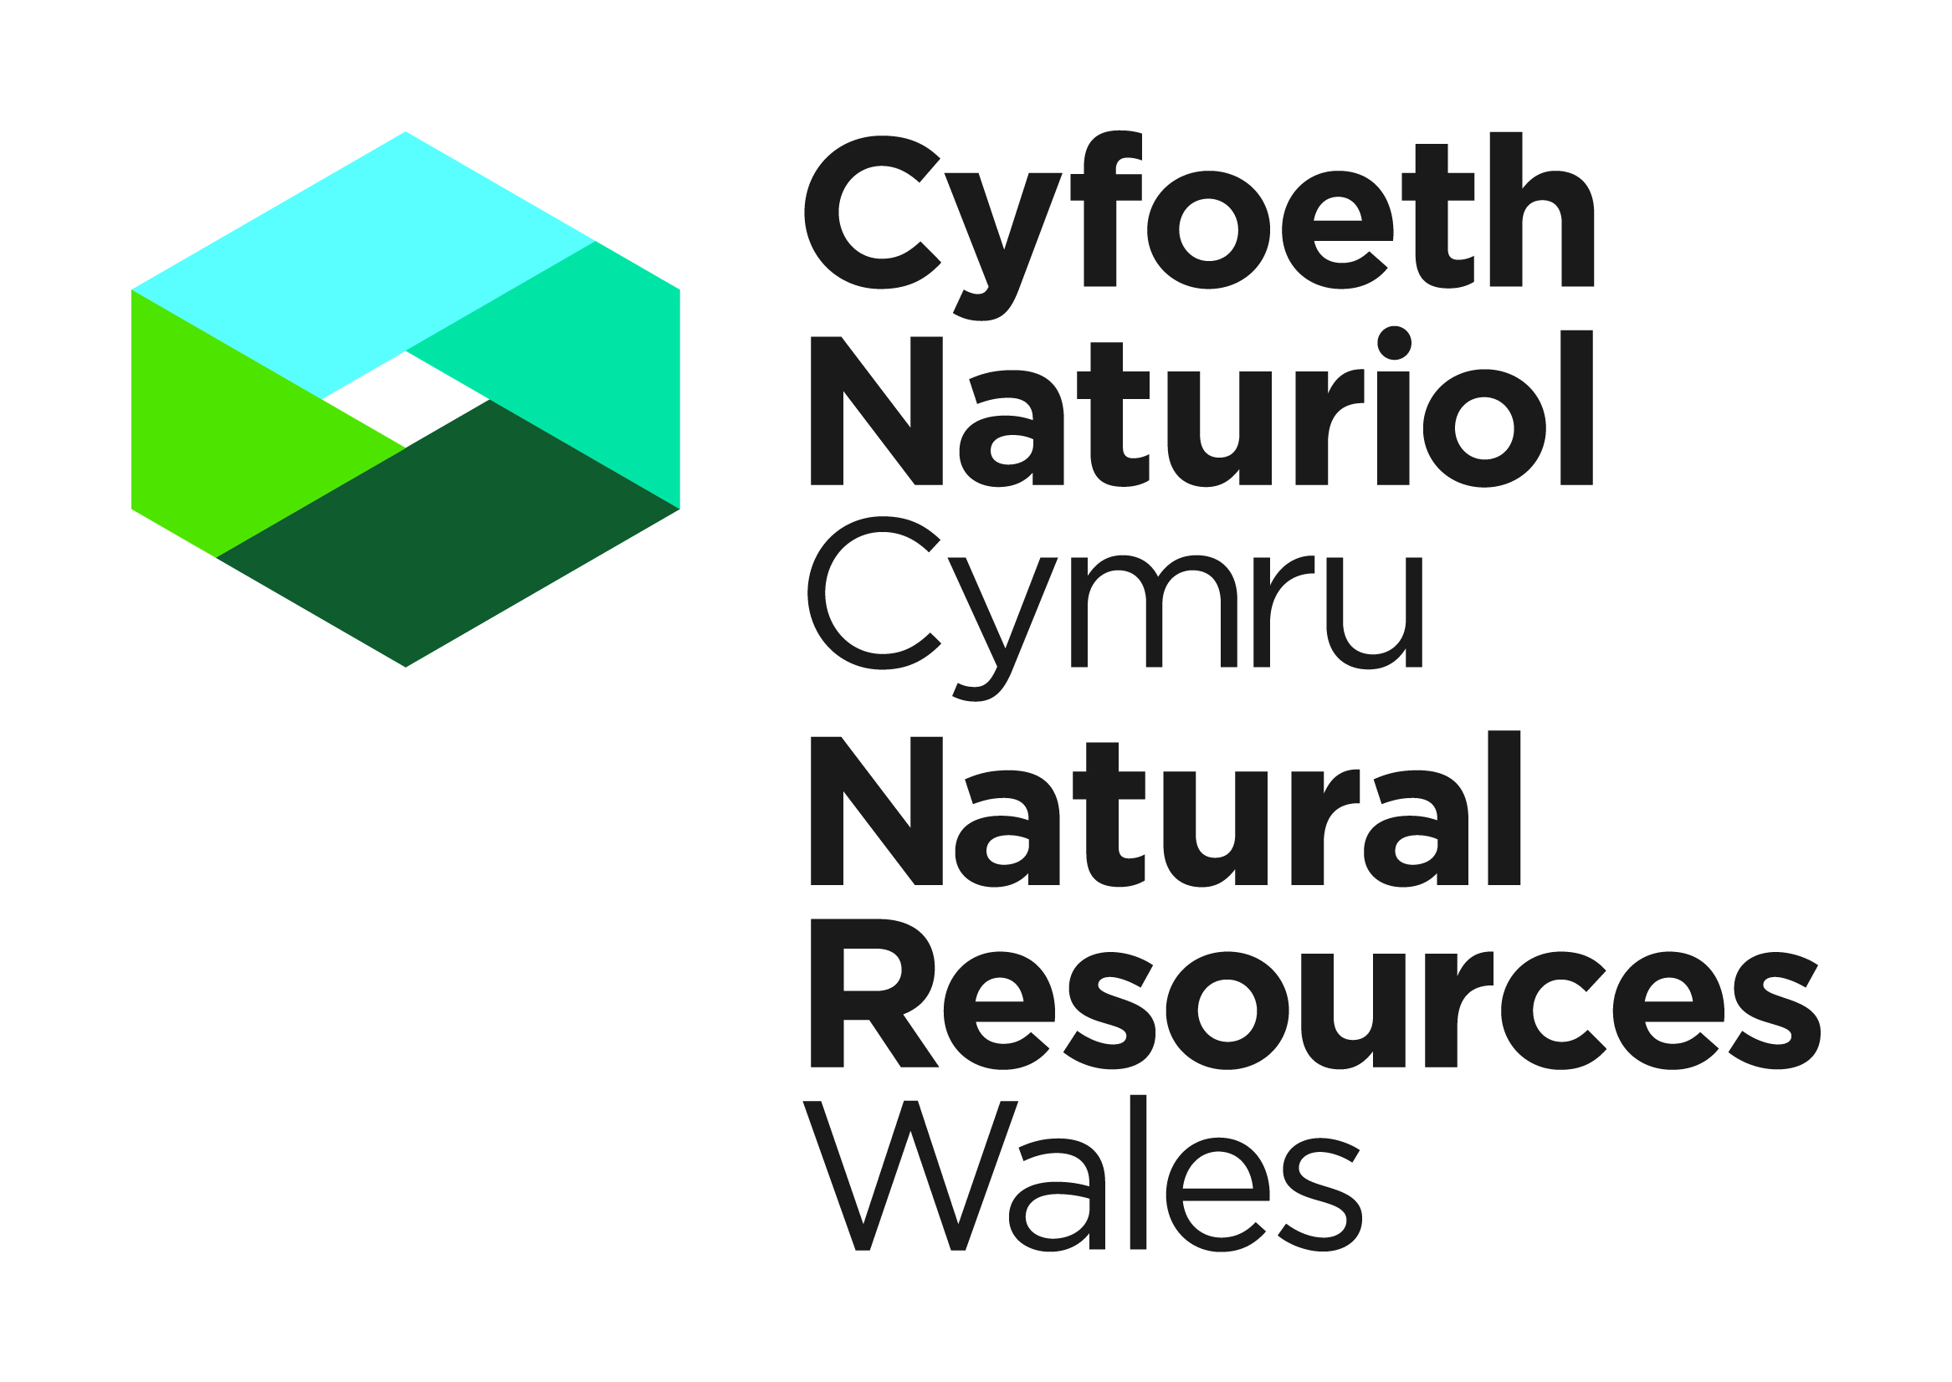

|  |
| --- |
| **APPLICATION FOR A LICENCE TO KILL, TAKE, DISTURB OR POSSESS ANY WILD ANIMAL (OR DERIVATIVE).** THE WILDLIFE AND COUNTRYSIDE ACT 1981 (AS AMENDED) (WCA) OR THE CONSERVATION OF HABITATS AND SPECIES REGULATIONS 2010. |

**This application form is for:**

Licences to kill, take, disturb, or temporarily possess wild animals (or derivatives) for science or education, conservation, ringing or marking, protection of a zoological collection, or photography:

* species listed under annex IV of the Council Directive 92/43/EEC on the Conservation of natural habitats and of wild fauna and flora,
* species listed under schedule 5 and 6 of the Wildlife and Countryside Act 1981 (as amended).

Depending on the species involved, licences may be granted under:

* Section 16 (3) of the WCA, and
* Regulation 53 of the Conservation of Habitats and Species Regulations 2010.

This application form **does not** cover:

* Bat species.
* Permanent possession.

If you want to apply for a bat licence, or to permanently possess wild animals (or derivatives), please use the appropriate application form available on our website.

We aim to process applications within 30 working days of receipt of all necessary information. We cannot guarantee an earlier response.

***A licence from NRW does not grant access or power of entry onto any land***

**Before you complete this application form, please read these guidance notes:**

**Completing and submitting this form**

* **Part A** must becompleted by all applicants; they must also be able to demonstrate that they have the necessary and suitable amount of expertise to achieve the objectives of the proposed work.
* **Part B** should be completed if you are working on species listed under annex IV of the Council Directive 92/43/EEC on the Conservation of natural habitats of wild fauna and flora.
* **Part C** should be completed if you are working on species listed under schedule 5 and 6 of the Wildlife and Countryside Act 1981 (as amended).
* **Part D** should only be completed if you are intending to temporarily possess specimens or derivatives.
* **Part E and F** must be completed by all applicants.

Complete questions in full: failure to provide adequate information will delay the processing of your application. Any further information you wish to provide should be appended on additional sheets.

* If you are applying for a conservation licence, your application must be supported by a method statement, which should include contingency plans for any species found on site whilst work is underway.
* This form can be returned to Species Permitting Team:
* By email: [specieslicence@naturalresourceswales.gov.uk](mailto:specieslicence@naturalresourceswales.gov.uk)
* By post: Natural Resources Wales, Maes y Ffynnon, Penrhosgarnedd, Bangor, LL57 2DW

**Length of licences and reporting**

* Licences issued for scientific or educational purposes (survey licences) are normally issued for a one year period in the first instance.
* Renewed licences are normally issued for a two-year period, providing previous licence reports have been submitted on time.
* Licences issued for specific projects, such as research projects or conservation management will be issued for the life of the project (normally to a maximum of 3 years).
* It is a condition of any licence issued that a full report of the work carried out under licence is submitted within four weeks of the expiry of the licence. Failure to do so may result in future applications being refused.
* Renewal of a licence, including any alterations to species, locations or activities may be requested by completing a renewal application form.

**How we handle your information**

All of the information held by NRW, relating to your application for a licence will be processed and managed by us in accordance with our obligations and duties under the:

* Data Protection Act 1998;
* Freedom of Information Act 2000;
* The Environmental Information Regulations 2004; and
* All other laws relating to access to information.

With this in mind, your information, including your personal information, may be the subject of a request by another member of the public. When responding to such requests we may be required to release information, including your personal information. Our response to such requests will be in accordance with the guidelines provided by the Welsh Government Code of Practice on Access to Information which can be found at [www.information.wales.gov.uk](http://www.information.wales.gov.uk)

For further information about the personal data collected and its use, if you have any concerns about the accuracy of personal data, or wish to exercise any of your rights under the above legislation you should contact:

* Access to Information Officers, Natural Resources Wales, Tŷ Cambria, 29 Newport Road Cardiff CF24 0TP, or email [atiteam@naturalresourceswales.gov.uk](mailto:atiteam@naturalresourceswales.gov.uk) or telephone 0300 065 3000.
* The Information Commissioners Office help line can be contacted on 029 2067 8400 or at [www.ico.gov.uk](http://www.ico.gov.uk)

**Any information included in this application which the applicant considers to be in confidence for commercial or industrial reasons or to be the applicant’s intellectual property must be clearly marked as such.**

In this document “Natural Resources Wales” means the Natural Resources Body for Wales established by article 3 of the Natural Resources Body for Wales (Establishment) Order 2012. The Natural Resources Body for Wales (Functions) Order 2013 transferred the relevant functions of the Countryside Council for Wales, and functions of the Environment Agency and the Forestry Commission in Wales to the Natural Resources Body for Wales.

.

###### PART A: Personal Details and Experience

All questions relate to the person who will be the named licensee if a licence is granted under the WCA or the Conservation of Habitats and Species Regulations 2010. That person should complete and sign this form. Please complete in **BLOCK CAPITALS** (* delete as applicable)

|  |
| --- |
| 1. **APPLICANT DETAILS** |

|  |  |  |  |
| --- | --- | --- | --- |
| **Title** (Mr/Mrs/Miss/Ms/Dr) | **Forenames** | | **Surname** |
|  |  | |  |
| **Home Address** *(including post code)* | |  | |
| **Telephone Number** | |  | |
| **Mobile Number** | |  | |
| **Personal E mail address** | |  | |
| **Business Name** | |  | |
| **Business Address ( including postcode)** | |  | |
| **Business E mail Address** | |  | |
| **Business mobile or telephone number** | |  | |

|  |  |  |  |  |  |  |
| --- | --- | --- | --- | --- | --- | --- |
| This licence required for: | Business (Work) |  | Personal (Hobby) |  | Both |  |

|  |  |  |  |  |
| --- | --- | --- | --- | --- |
| To which email addressed should we issue your licence | Business |  | Personal |  |

**2. Who will provide the expertise during the licenced work?** (please tick the relevant box)

|  |  |  |  |
| --- | --- | --- | --- |
|  | Applicant |  | Other (please provide details ) |

**3. YOUR EXPERIENCE AND QUALIFICATIONS IN RELATION TO REQUESTED SPECIES**

1. Please give details of **your** qualifications and/or experience in relation to working with the requested species. Please include details of any courses you have attended and submit copies of any relevant training certificates and completed log books to support your application.

|  |
| --- |
|  |

1. Please provide two references from individuals who are familiar with your work. They should be able to comment on your experience of working with the relevant species and your ability to use the methods and equipment you have proposed. Ideally your referees should have held a similar licence within the last two years and should have experience of your work for at least one survey season. The completed references should state the following information:
2. their knowledge of the extent of the applicant’s experience in this type of work, including the use of any equipment
3. any personal knowledge they may have of the care taken by the applicant while engaged in this type of work, to avoid undue harm or disturbance to wildlife
4. their own experience in this field.
5. Do you hold a similar level of licence from Natural England or Scottish Natural Heritage for this species? If yes, please submit a copy of this/these licences with your completed application form.

**4. ACCREDITED AGENT / ASSISTANT REQUESTS**

An **accredited agent** is a suitably qualified experienced person who is able to carry out work under a licence without the personal supervision of the licensee. To carry out work they must be in possession of a letter signed by the licensee appointing him or her as an accredited agent of the licensee for the purpose of the licence. At all times the licensee is fully responsible for all the work carried out under licence.

An **assistant** is employed by a licensee or his/her agent to work under their direct personal supervision at all times. A breach of the licence conditions by an accredited agent, assistant or helper may result in the revocation of your licence. If you propose to employ accredited agents please state what work they will be carrying out and their relevant experience. Please give their full names and addresses.

A. If you propose to employ ACCREDITED AGENTS please give their full names and addresses.

|  |  |  |
| --- | --- | --- |
| Name | Postal Address | E mail Address |
|  |  |  |
|  |  |  |
|  |  |  |

B. If you propose to employ ASSISTANTS please give their full names and addresses.

|  |  |  |
| --- | --- | --- |
| Name | Postal Address | E mail Address |
|  |  |  |
|  |  |  |
|  |  |  |

5. **WILDLIFE OFFENCE?**

Have you or your accredited agents or assistants ever been convicted of a wildlife offence?





|  |
| --- |
| If YES, please give details including the name of the person |
|

#### PART B: Application Details for European Protected Species

#### Only complete this part if you are applying for a licence dealing with species listed on Annexe IV of the Council Directive 92/43/EEC on the Conservation of natural habitats and of wild fauna and flora.

1. Please complete the table below to show all licensable actions that the project will involve. Please read the notes at the bottom of this page. Use photocopies of this page if there is insufficient space on one sheet

|  |  |  |  |  |  |  |  |
| --- | --- | --- | --- | --- | --- | --- | --- |
| **Species** | **Activity** | **Method or field technique** | **Number** | **Sex** | **Age or life stage** | **Time period in which the activity will be carried out.** | **Location** |
|  |  |  |  |  |  |  |  |
|  |  |  |  |  |  |  |  |
|  |  |  |  |  |  |  |  |
|  |  |  |  |  |  |  |  |

|  |  |
| --- | --- |
| **NOTES** | |
| **Activity**. | List all the activities you wish to carry out. Start a new line if it helps to distinguish between different activities at different places. Choose from:  Kill  Injure  Take - *including handling for a limited period before release (e.g. marking, measurements etc).*  Take or destroy eggs – *to take or destroy the eggs of such an animal.*  Possess - *if the animal is to be temporarily retained in captivity away from the site of capture.*  Possess derivatives - *to temporarily* *retain any part of that animal including blood samples*.  Damage, destroy – *a breeding site or resting place.*  Obstruct access - *to impact on any structure or place which the animal uses for breeding, shelter or protection.*  Disturb – *to disturb an animal* |
| **Method or field technique** | Please state all the methods that you propose to use for each licensable activity. State whether your methods involve ringing or marking and if so by what means. |
| **Number, sex and age** | This only needs to be completed where applicable. In many cases this will not be known. Where appropriate give an estimate of the number of animals or derivatives involved. |
| **Time period** | If this is your first survey licence application then NRW will normally issue the licence for 1 year. Standard renewal licences are normally then issued for 2 years unless there have been problems in receiving licence reports. Time periods for conservation licences will depend on the project. |
| **Location** | Please state specific **sites** and **counties** where the work will occur including 6 figure **grid references** if possible. You may specify that you wish your licence to cover all of Wales. Please also state whether the site is a Site of Special Scientific Interest (SSSI). Consent may be required to work within an SSSI. If any of the work you propose will take place on a National Nature Reserve please provide the name of that reserve. |

7. If your application concerns a European Protected Species, please confirm how your proposed actions will not be detrimental to the maintenance of the population of the species concerned at a favourable conservation status within their natural range. Please also provide a statement as to why there is no satisfactory alternative to the issue of this licence to permit the proposed activities.

**PART C: Application Details for species protected under the Wildlife & Countryside Act 1981 (as amended)**

Only complete this part if you are applying for a licence dealing with species listed on Schedule 5 & 6 of the Wildlife & Countryside Act 1981

1. Please complete the table below to show all licensable actions that the project will involve. Please read the note at the bottom of this page. Use photocopies of this page if there is insufficient space on one sheet

|  |  |  |  |  |  |  |  |
| --- | --- | --- | --- | --- | --- | --- | --- |
| **Species** | **Activity** | **Method or field technique** | **Number** | **Sex** | **Age or life stage** | **Time period in which the activity will be carried out.** | **Location** |
|  |  |  |  |  |  |  |  |
|  |  |  |  |  |  |  |  |
|  |  |  |  |  |  |  |  |
|  |  |  |  |  |  |  |  |
|  |  |  |  |  |  |  |  |

|  |  |
| --- | --- |
| **NOTES** | |
| **Activity** | List all the activities you wish to carry out. Start a new line if it helps to distinguish between different activities at different places. Choose from:  Kill  Take - *including handling for a limited period before release (e.g. marking, measurements etc).*  Possess - *if the animal is to be retained in captivity away from the site of capture.*  Possess derivatives - *to retain any part of that animal including blood samples.*  Damage, destroy or obstruct access - *to impact on any structure or place which the animal uses for breeding, shelter or protection.*  Disturb – *to disturb an animal while it is in a structure or place used for shelter or protection.* |
| **Method or field technique** | Please state all the methods that you propose to use for each licensable activity. State whether your methods involve ringing or marking and if so by what means. |
| **Number, sex and age** | This only needs to be completed where applicable. In many cases this will not be known. Where appropriate give an estimate of the number of animals or derivatives involved. |
| **Time Period** | If this is your first survey licence application then NRW will normally issue the licence for 1 year. Standard renewal licences are normally then issued for 2 years unless there have been problems in receiving licence reports. Time periods for conservation licences will depend on the project. |
| **Location** | Please state specific **sites** and **counties** where the work will occur including 6 figure **grid references** if possible. You may specify that you wish your licence to cover all of Wales. Please also state whether the site is a Site of Special Scientific Interest (SSSI). Consent may be required to work within an SSSI. If any of the work you propose will take place on a National Nature Reserve please provide the name of that reserve. |

#### PART D: Possession of protected material

#### 

9. Complete only if animals are to be kept **temporarily** in captivity or under your control or you wish to take **temporarily** or possess derivatives. Please provide details on the following:

1. how and when the animal or its derivatives came into your possession,
2. under what conditions and for how long animals (or their derivatives) will be kept,
3. specify the nature of the part or derivative,
4. state the number of specimens.

And:

1. If the animals will be returned to the wild give the proposed date and place of release and any steps which would be taken to re-accustom them to the wild.
2. If the animals will not be returned to the wild how they will be disposed of or if any derivatives are not retained what method of disposal will be adopted. If any animal, or any part of, will be passed on to a third party give the reason why and their name and address.
3. Indicate if, and under what appendix, any of the species you wish to sell are listed under CITES.

|  |
| --- |
|  |

#### PART E: Details of work for all parts B & C above

1. Will you/do you have the owner or occupiers’ permission to carry out this work?





11. NRW may wish to monitor the work you carry out. Is the owner or occupier willing to allow NRW staff access to the site of your work for this purpose?





12. Please tick the main purposes behind the licensable elements of your work.

|  |  |
| --- | --- |
|  | Science or education |
|  | Ringing and marking, or examining any ring or mark |
|  | Conserving wild animals or introducing them to particular areas |
|  | Photography |

13. Please state whether the work is likely to extend into future years so that NRW is aware of the scale of the proposed work.

|  |
| --- |
|  |

14. Please explain the need to carry out the proposed work and the objective of your activities. State if the work involves translocations (introductions, re-introductions or moving species in anyway).

|  |
| --- |
|  |

15. Where licences are issued for scientific purposes it is important that the data collected is used to increase scientific knowledge. Please state how the data you collect will be used and where it will be lodged.

|  |
| --- |
|  |

1. Please confirm which of the following supporting information is submitted with your application.

|  |  |
| --- | --- |
|  | Method Statement |
|  | Survey/Monitoring Report |
|  | Specification for Research Project |
|  | Other: Please specify |

Any **further information** you wish to provide in support of your application should be appended on additional sheets. For example, if the work forms part of a scientific project, it will help your application if you provide a description of the methods with a detailed timescale. However, all questions on the application form must be completed in full

##### PART F: Declaration

WARNING: NRW can modify or revoke any licence that may be issued but this will not be done without good reason. Any licence that is issued is likely to be revoked immediately if it is discovered that false or incorrect information had been provided on this form or any enclosures that resulted in the issue of a licence.

Applicants should note that it is an offence under Section 17 of the WCA and under regulation 57 of the Conservation of Habitats and Species Regulations 2010 to knowingly or recklessly provide false information in order to obtain a licence.

|  |  |
| --- | --- |
|  | I understand that failure to comply with any conditions included on any licence granted in respect of this application may constitute an offence |
|  | I have read the notes for guidance at the front of this form |
|  | I declare that the particulars given in this application and accompanying documents are correct to the best of my knowledge and belief, and I apply for a licence in accordance with these particulars |
|  | If a licence is granted I agree to send to NRW a written report of the licensed activities within four weeks of the expiry of the licence |

|  |  |  |  |
| --- | --- | --- | --- |
| Signature | | Date | |
| ***For electronic applications please insert an electronic signature above or place an x in the box opposite to confirm agreement with the declarations above.*** | | |  |
| NAME IN BLOCK LETTERS |  | | |