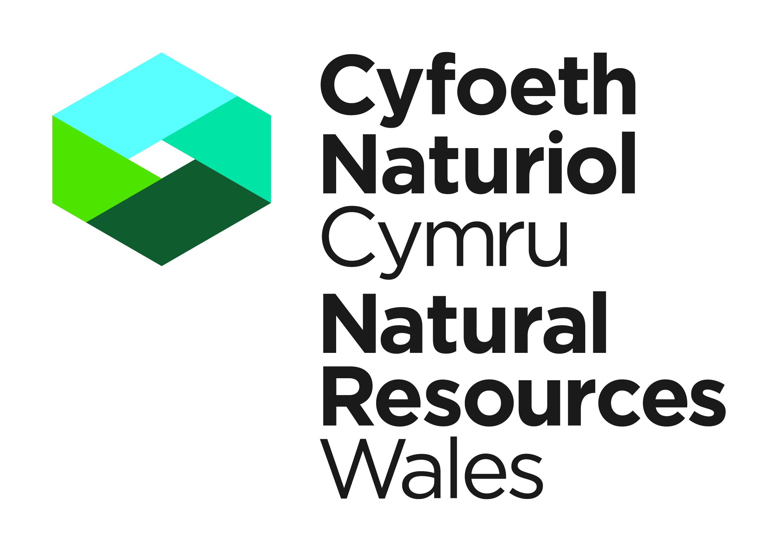 | REPORT BY THE LICENCE HOLDER OF ACTION TAKEN UNDER LICENCE European Protected Species |  | Species Protection Team,  National Permitting Service,  Natural Resources Wales,  Maes-y-Ffynnon,  Penrhosgarnedd,  Bangor,  Gwynedd,  LL57 2DW  specieslicence@naturalresourceswales.gov.uk  Tel. 03000 653000 | 
 | Name of licensee:
 | Address of site:
 | Email Address:

GUIDANCE NOTES Please read the following notes carefully before completing the table overleaf in BLOCK CAPITALS or type. This form may be downloaded from our website and emailed to us.
- It is a condition of your licence that you provide Natural Resources Wales with a report detailing action taken under the licence. This report must be completed, even if no action is taken, and must be returned to Natural Resources Wales (details above) within 4 weeks of the licence expiry date.
- Failure to complete and submit this form is a breach of your licence and may result in any future applications being refused. It is an offence under Regulation 58(1) to breach a licence condition.
- The report is used to provide summary information to the Department for Environment, Food and Rural Affairs (Defra) and the European Commission regarding the number and type of licences issued and the actual work carried out under the licence. The data collected from licence reports might also be used for scientific monitoring purposes and be shared with the Local Planning Authority. If you have concerns about the use of the information you are providing please contact us using the details shown at the top of this form.
- The personal information on this licence report may be kept and used by Natural Resources Body for Wales otherwise known as Natural Resources Wales (NRW) in accordance with the Data Protection Act (1998) and in line with the provisions of the licence under which the collection of these biodiversity records was authorised.

Natural Resources Wales licence reference number |  | Period of licence From: |  | dd/mm/yyyy | To: | dd/mm/yyyy
Name of ecological consultant |  | Company

Declaration: To the best of my knowledge, the data is reliable and was collected with any necessary permissions.
NRW have my permission to store, copy, use, release and publish the biodiversity records I have supplied, including my name as part of the record, in line with the provisions of the licence under which the collection of these biodiversity records was authorised.

Signed: |  | Name: |  | Date:
 | For electronic returns please insert an electronic signature above or place an x in the box opposite to confirm agreement with the declarations above.

Report form contents
Section 1 | Purpose for which the licence was issued
Section 2 | Summary of action taken
Section 2.1 | All animals except bats
Section 2.2 | Bat species
Section 2.3 | All plants
Section 2.4 | Incidental capture or killing – all animals
Section 3.1 | Licences issued for ‘science and education’ or ‘ringing and marking or examining any ring or mark’
Section 3.2 | Bats ringed or bat rings examined
Section 4 | Licences issued for conserving wild animals
Section 5 | Licences issued for ‘other reasons of over-riding public interest’
Section 6 | Licences issued for preventing the spread of disease or serious damage to livestock, foodstuffs for livestock, crops, vegetables, fruit, growing timber or any other form of property or to fisheries

Section 1 – Purpose for which the licence was issued
Please state the primary purpose for which the licence was issued then go to relevant sections as indicated.
Tick one box only. The purpose for which the licence was issued is given on the front page your licence.

Science or education |  | Complete section 2 and section 3
Ringing and marking, or examining any ring or mark |  | Complete section 2 and section 3
Photography |  | Complete section 2 only
Conserving wild animals/plants |  | Complete section 2 and section 4
Preserving public health or public safety |  | Complete section 2 and section 5
¹Other imperative reasons of overriding public interest |  | Final report²: complete section 2 and section 5  Interim report: complete section 5 only
Preventing the spread of disease |  | Complete section 2 and section 6
Preventing serious damage to livestock, foodstuffs for livestock, crops, vegetables, fruit, growing timber or any other form of property or to fisheries |  | Complete section 2 and section 6
¹ including those of a social or economic nature and beneficial consequences of primary importance for the environment

² NB For compliance audit purposes section 5 of the form may be submitted as an interim report as well as a final report. If this form is being used as an interim compliance audit report, complete only the front page and section 5.

Section 2 – Summary of action taken

2.1 All animals except bats
A) Species | B) Date/s when action taken |  | C) Action taken |  |  |  | D) If captured/taken: |  | E) If marked:
Choose from:  Dormouse  Great crested newt (GCN)  Natterjack toad  Otter  Sand lizard | From¹  dd/mm/yy | To¹  dd/mm/yy | Choose from:  Captured/taken  Damaged/ destroyed breeding site or resting place  Disturbed  Killed/injured | For each action state ²:  EITHER number of animals affected;  OR number / area of breeding sites/resting places affected |  | Location where action taken  Give precise grid reference, at least 6 or 8 figures | Method used Choose from:  Appropriate trap,  Bottle trap,  Carpet/tin tiles,  Egg survey,  Hand,  Nest box,  Nest tube,  Netting,  Noose,  Pit-fall trap,  Torch survey | Where released (if applicable)  Give 6 or 8 figure grid reference | Method used  Choose from:  Fur clip  PIT tag  Radio tag  Ring | Number marked
 |  |  |  | Number/  Area ³ | Unit  Choose from:  Ha of habitat,  No. of sites, No. of ponds,  Adults, Juveniles,  Individuals, Eggs
Examples:  Dormouse | 01/12/12 | 13/12/12 | Damage/destroy BS or RP | 10 | Hectare | SH345678 | Select from list |  | Select from list
GCN | 01/05/12 | 10/05/12 | Captured/  taken | 25 | Adults | SH12345678 | Bottle trap | SH12455699 | Select from list
¹ Wherever possible give an exact date for the action taken rather than a range of dates.
² Report only once for each action, eg if individuals are ‘captured’ it is not necessary to also report that they were ‘disturbed’.
³ If exact number not known indicate approximate number with ‘c.’
2.2 Bat species

A) Species | B) Date/s when action taken |  | C) Action taken |  |  |  | D) If captured/taken: |  | E) If marked:
Choose from list: | From¹  dd/mm/yy | To¹  dd/mm/yy | Choose from:  Captured/taken  Damaged/ destroyed breeding site or resting place  Disturbed  Killed/injured | For each action state²:  EITHER number of animals affected;  OR number / area of breeding sites/resting places affected |  | Location where action taken  Give precise grid reference, at least 6 or 8 figures | Method used Choose from:  Hand/handheld net  Harp trap  Harp trap with lure  Mist net  Mist net with lure | Where released (if applicable)  Give 6 or 8 figure grid reference | Method used  Choose from:  Fur clip  PIT tag  Radiotag  Ring ⁴ | No. marked
 |  |  |  | Number/area³ | Unit  Choose from:  Adults, Juveniles,  Individuals  Number of sites
Examples:  Barbastelle bat | 09/09/12 |  | Captured/taken | 2 | Adults | SH12345678 | Harp trap | SH12345678 | Radiotag | 2
 | 01/11/12 | 11/11/12 |  | 1 |  | SH123456

¹ Wherever possible give an exact date for the action taken rather than a range of dates.
² Report only once for each action, eg if individuals are ‘captured’ it is not necessary to also report that they were ‘disturbed’.
³ If exact number not known, indicate approximate number with ‘c.’
⁴ NB if rings fitted or examined section 3.2 below must also be completed.
2.3 All plants

A) Species | B) Date/s when action taken |  | C) Action taken |  |  | D) State how plant was used: | E) State how each plant  was disposed of:
Choose from:  Early gentian  Fen orchid  Floating-leaved water plantain  Killarney fern  Shore dock | From¹  dd/mm/yy | To¹  dd/mm/yy | Choose from:  Collect  Collect seed  Cut  Destroy  Pick  Uproot | For each action state number of plants affected² | Location where action taken  Give precise grid reference, at least 6 or 8 figures | Describe how used: | Describe how disposed of: | Where replanted (if applicable)  Give 6 or 8 figure grid reference
Examples:  Shore dock | 01/09/12 |  | Collect seed | 20 | SH12345678 | Add to seed bank
Float-leaved water plantain | 01/09/12 | 10/09/12 | Uproot | 30 | SH12345678 |  | Translocated to new site | SH12455699
¹ Wherever possible give an exact date for the action taken rather than a range of dates.
² If exact number not known, indicate approximate number with ‘c.’

2.4 Incidental capture or killing – all animals
NRW is required under the Habitats Directive to compile information on incidental capture or killing of animals listed on Annex IVa* i.e. capture or killing not covered under a licence. The information is for reporting purposes only and will be submitted to the European Commission in summary format.

A) Species | B) Date when incident took place | C) Nature of incident | D) Location of incident | E) Animals affected |  |  | F) Other information
Choose from list: | dd/mm/yy | Choose from:  Captured  Killed | Give precise grid reference, at least 6 or 8 figures | Number | Unit  Choose from:  Adults, Juveniles,  Individuals | Sex (if known)
Examples:  Natterjack toad | 01/06/12 | Killed | SH12345678 | 2 | Adult | Male | Found dead in pitfall trap
GCN | 01/09/12 | Killed | SJ12345678 | 5 | Adult | Male | Found killed on road

* Article 12 of the Council Directive 92/43/EEC on the conservation of natural habitats and of wild fauna and flora of 21 May 1992

Section 3.1 Licences issued for ‘Science and education’, or ‘Ringing and marking, or examining any ring or mark’
Use this section to report on activities completed under licences for species surveys and research projects.
Give details of any variation from the methods described in your licence application.

Please describe the activities completed under this licence.
Examples include survey work, fitting rings or radio-tags (please also complete section 3.2 to give details of bats ringed or rings examined)

Activity | Details of activities undertaken
Reports | Provide full details of any reports, scientific papers etc that have been or will be produced as a result of the activities completed under this licence.

3.2 Bats ringed or bat rings examined
Use this section to provide further details of bats ringed or rings examined.

Activity: Ringing or examining rings | Species | Date | Location (Site Name) | Location  (Grid reference) | Sex | Age  (if known) | Ring number | Comments
Example  Ringing | Lesser horseshoe bat | 01/-9/12 | Bontnewydd | SH12345678 | Male | Adult | A1234
 |  |  |  | sh345678
Section 4 - Licences issued for conserving wild animals/plants
Use this section to report on activities completed under licences for conserving wild animals or plants.

Please provide details of works undertaken affecting breeding sites and resting places and any associated disturbance, capture etc.
Examples include improvements to bat roosts, management of woodlands for dormice or management of ponds for great crested newts.
Report on the actions as described in your licence application and note any changes that were necessary to the proposed methods.
Append photographs wherever possible.
Activity | Details of activities undertaken
Reports | Provide full details of any reports that have been produced as a result of the activities completed under this licence.

Section 5 – Licences issued for ‘Other Reasons of Over-riding Public Interest’
Use this section to report on activities completed under licences for ‘Preserving public health or public safety or other imperative reasons of
overriding public interest including those of a social or economic nature and beneficial consequences of primary importance for the environment’
including developments

Note that for compliance audit purposes this section of the form may be submitted as an interim report as well as a final report.
Please state which below:
Interim report: |  | Final report:
For interim reports complete only the front page of this form and section 5.

Please provide details of works undertaken affecting breeding sites and resting places damaged or destroyed.
Examples include bat roosts, bat flight lines, dormouse habitat, otter holts, great crested newt hibernacula.
Report on actions as proposed in your method statement submitted with the licence application (see ‘Delivery Information Mitigation, compensation and monitoring’ section E2).
Append photographs wherever possible and submit copies of GIS layers detailing compensation or mitigation sites.

Activity |  | Details of works undertaken
In situ retention
(Method Statement Delivery Information section E.2.1)
Modification of existing
(Method Statement Delivery Information section E.2.2)
Creation of new as compensation, please detail compensation sites as appropriate
(Method Statement Delivery Information section E.2.3)
Licence specific reporting
Report here against the implementation of conditions as indicated in your licence

Post-development site safeguard Describe works to manage/maintain the population post-development
Details of monitoring (include methods, timing, weather conditions, personnel, result, constraint and interpretation). To include monitoring carried out to date and monitoring planned. Append report as applicable.
Compliance audit Please tick to indicate mechanism used to demonstrate compliance with the licence and method statement
 | NRW licence report form (this form) used to demonstrate completion of works in accordance with the licence
 | Compliance audit completed by developer (give details below)
 | Compliance audit completed by external auditor (give details below)
List and append compliance audit reports:

Comments and further information

Section 6 - Licences issued for ‘Preventing the spread of disease’ OR
‘Preventing serious damage to livestock, foodstuffs for livestock, crops, vegetables, fruit, growing timber or any other form of property or to fisheries’
Use this section to report on activities completed under licences for these purposes.

Provide details of works undertaken affecting breeding sites and resting places and any associated disturbance, capture etc.
Report on the actions as described in your licence application and note any changes that were necessary to the proposed methods.
Append photographs wherever possible.
Activity | Details of activities undertaken
Reports | Provide full details of any reports that have been produced as a result of the activities completed under this licence.

